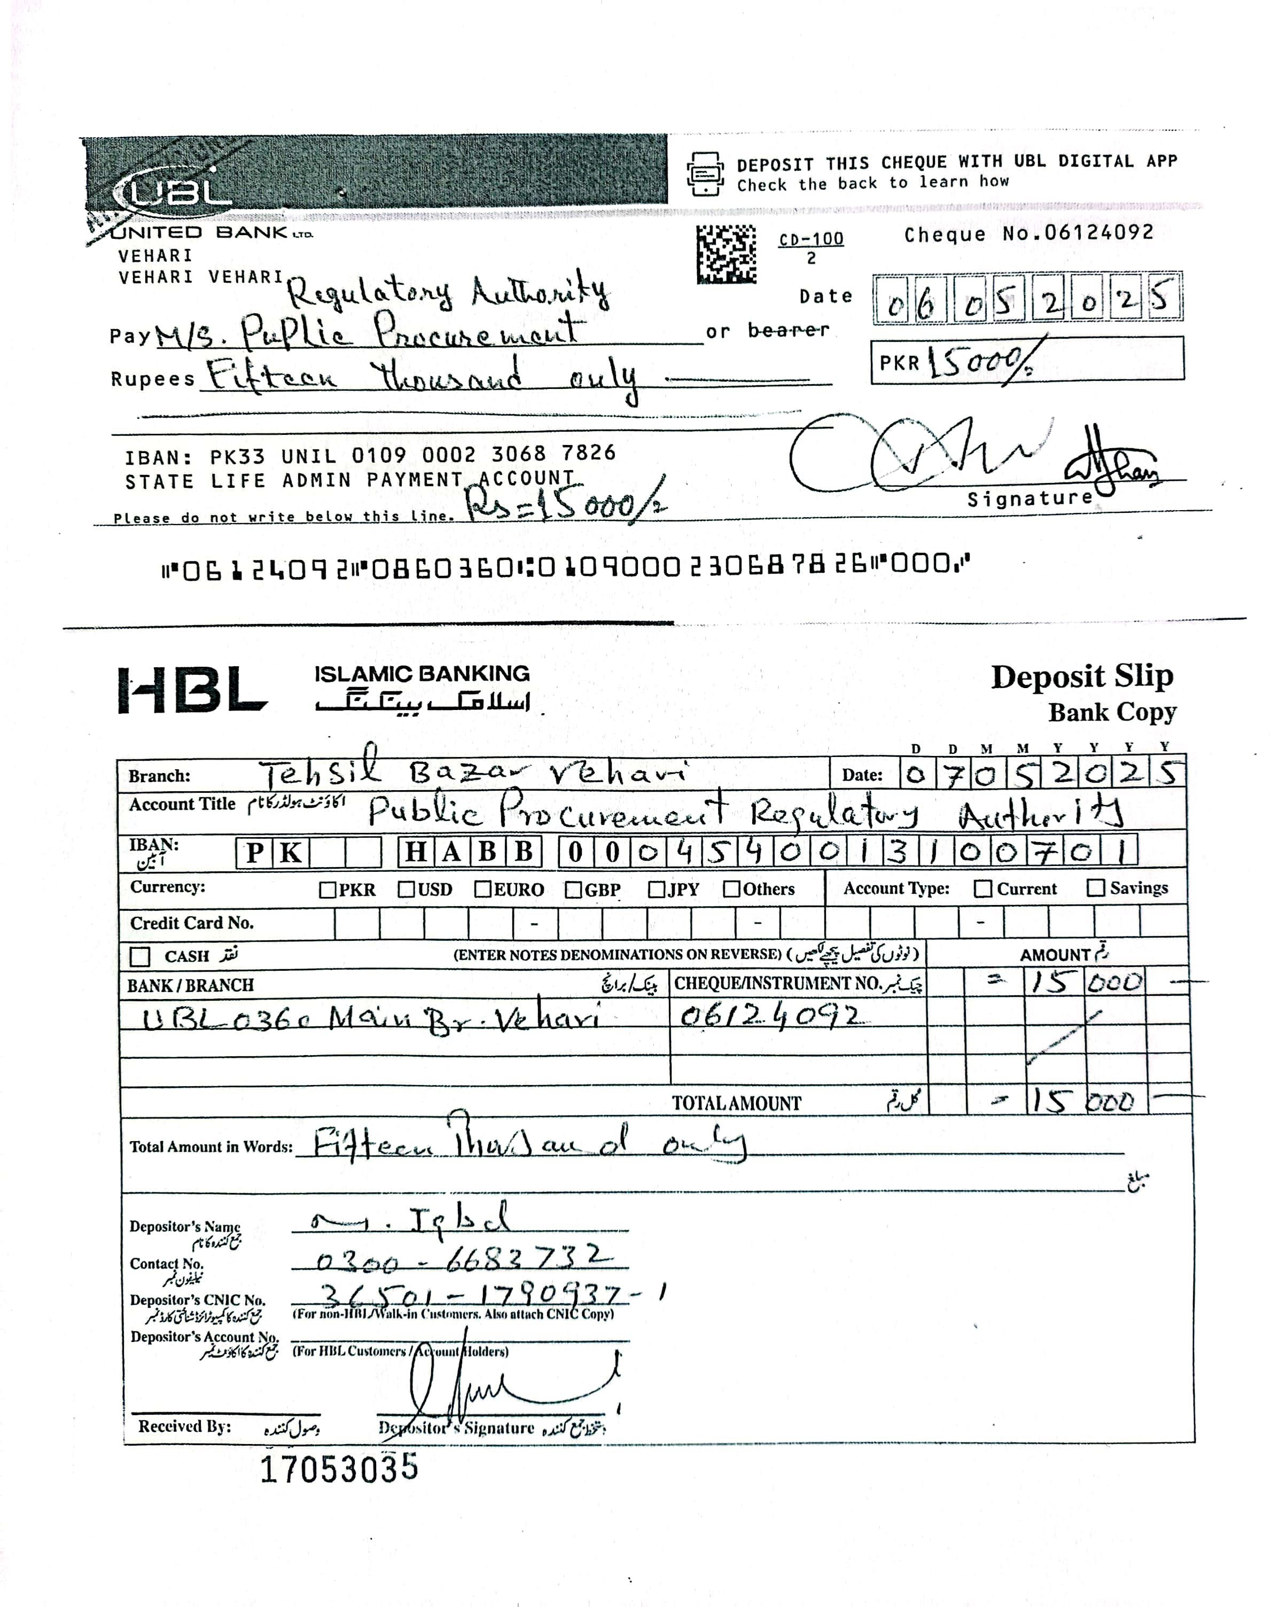


Insurance Corporation of Pakistan Vehari Zone

Ref No. HR&ADMIN/002/2025/VZ Dated. 06.05.2025

FINANCIAL EVALUATION REPORT
(As Per Rule 35 of PP Rules, 2004)

1. Name of Procuring Agency: | State Life Insurance Corp. of Pakistan Vehari Zone
2. Method of Procurement: | Single Stage Two Envelope
3. Title of Procurement: | Purchasing of Office Stationery Items
4. Tender Inquiry No.: | F 250393251
5. PPRA Ref. No. (TSE): | TS 558188 E
6. Date & Time of Bid Closing: | March 25, 2025 at 11.00 am
7. Date & Time of Bid Opening: | March 25, 2025 at 11.30 am
8. No of Bids Received: | (08) Numbers
9. Criteria for Bid Evaluation: | Most Advantageous Bidders
10. Details of Bid(s) Evaluation: | Detail of Bid Evaluation is as under

Name of Bidder | Marks |  |  | Rule/Regulation/SBD*/Policy/ Basis for Technical Rejection / Acceptance as  per Rule 35 of PP Rules, 2004.
Name of Bidder | Technical  (if applicable) | Financial (if applicable) | Evaluated cost
C.S Supplies & Managements | Accepted | Accepted | 34148 | Qualified for item No.7,12,15,25,28,30,37
Five Star Builders & General Suppliers | Accepted | Accepted | 148265 | Qualified for item No. 5,14,26,29
Talal Publishers | Accepted | Accepted | 226425 | Qualified for item No .9,18,19,32
Subhan Technologies | Accepted | Accepted | 467100 | Qualified for item  No. 1,6,8,16,27,35,36
Kareem & Sons Enterprises | Accepted | Accepted | 9385 | Qualified for item No. 10,21
H.S Enterprises | Accepted | Accepted | 690300 | Qualified for item No. 13
Prime Technologies I T Solutions | Accepted | Accepted | 5580 | Qualified for item No. 20,38
Allied Computer Services | Accepted | Accepted | 594004 | Qualified for item No.2,3,4,11,17,22,23,24,31,33,34

11. Any other additional / supporting information, the procuring agency may like to share.

Signature: ………………….

Official Stamp: …………………

