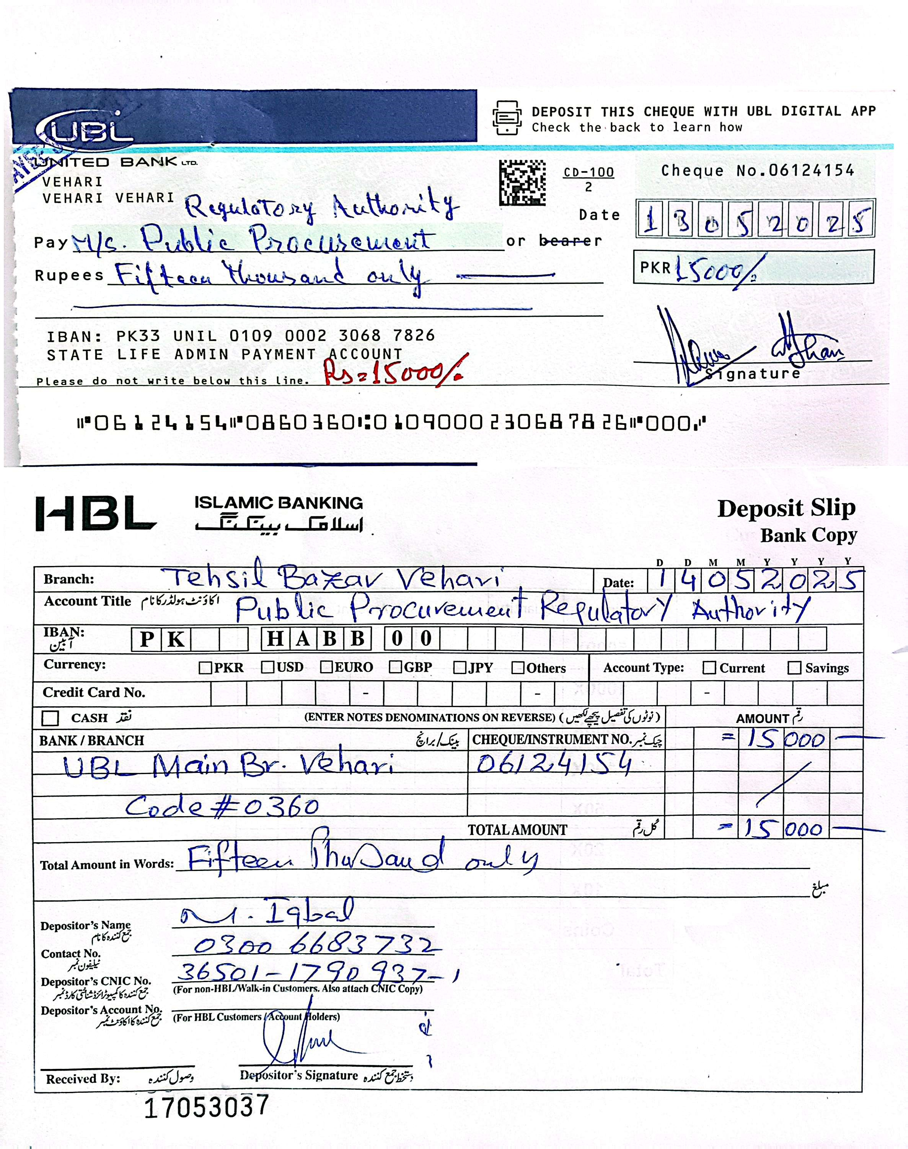

Insurance Corporation of Pakistan Vehari Zone

Ref No. HR&ADMIN/001/2025/VZ Dated. 14.05.2025

FINANCIAL EVALUATION REPORT
(As Per Rule 35 of PP Rules, 2004)

1. Name of Procuring Agency: | State Life Insurance Corp. of Pakistan Vehari Zone
2. Method of Procurement: | Single Stage Two Envelope
3. Title of Procurement: | Purchasing of Office Printing Items
4. Tender Inquiry No.: | F 250393193
5. PPRA Ref. No. (TSE): | TS 558089 E
6. Date & Time of Bid Closing: | March 24, 2025 at 11.00 am
7. Date & Time of Bid Opening: | March 24, 2025 at 11.30 am
8. No of Bids Received: | (06) Numbers
9. Criteria for Bid Evaluation: | AS per Criteria given in Tender Documents
10. Details of Bid(s) Evaluation: | Detail of Bid Evaluation is as under

Name of Bidder | Marks |  |  | Rule/Regulation/SBD*/Policy/ Basis for Technical Rejection / Acceptance as  per Rule 35 of PP Rules, 2004.
Name of Bidder | Technical  (if applicable) | Financial (if applicable) | Evaluated cost
Talal Publishers | Accepted | Accepted | 535327 | Qualified for item Nos.1,3,4,5,6,10,11,  12,17,27,29,32,48,52,57,65,66,67,  68,70.74
Subhan Technologies | Accepted | Accepted | 1754750 | Qualified for item Nos .20,23,24,25,30,  37,44,45,49,50,51,55,56,58,59,60,61,69,71,76
Kareem & Sons Enterprises | Accepted | Accepted | 157715 | Qualified for item Nos. 2,7,8,9,13,14,15,16,18,19,21,22,26,28,31,33,34,35,36,38,39,40,41,42,43,46,47,53,54,62,63,64,72,73,75,
H.S Enterprises | Accepted | Accepted | 0 | With Draw Items Nos. 20,21,23,65,66,67,68
C,S Suppliers & Managements | Accepted | Accepted | 0 | Nil
Five Star Builders & General Suppliers |  |  |  | Bid Rejected
11. Any other additional / supporting information, the procuring agency may like to share.
Signature: ………………….

Official Stamp: …………………

