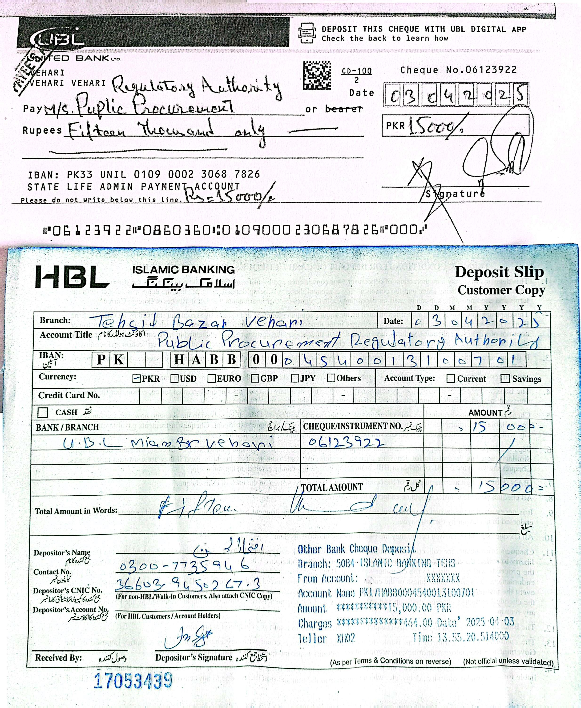


Insurance Corporation of Pakistan Vehari Zone

Ref No. HR&ADMIN/002/2025/VZ Dated. 03.04.2025

TECHNICAL EVALUATION REPORT
(As Per Rule 35 of PP Rules, 2004)

1. Name of Procuring Agency: | State Life Insurance Corp. of Pakistan Vehari Zone
2. Method of Procurement: | Single Stage Two Envelope
3. Title of Procurement: | Purchasing of Office Stationery Items
4. Tender Inquiry No.: | F 250393251
5. PPRA Ref. No. (TSE): | TS 558188 E
6. Date & Time of Bid Closing: | March 25, 2025 at 11.00 am
7. Date & Time of Bid Opening: | March 25, 2025 at 11.30 am
8. No of Bids Received: | (08) Numbers
9. Criteria for Bid Evaluation: | Most Advantageous Bidders
10. Details of Bid(s) Evaluation: | Detail of Bid Evaluation is as under

Name of Bidder | Technical Marks  (if applicable) | Rule/Regulation/SBD*/Policy/ Basis for Technical Rejection / Acceptance as  per Rule 35 of PP Rules, 2004.
C.S Supplies & Managements | 80/100 | Bid Accepted
Five Star Builders & General Suppliers | 85/100 | Bid Accepted
Talal Publishers | 100/100 | Bid Accepted
Subhan Technologies | 100/100 | Bid Accepted
Kareem & Sons Enterprises | 100/100 | Bid Accepted
H.S Enterprises | 80/100 | Bid Accepted
Prime Technologies I T Solutions | 80/100 | Bid Accepted
Allied Computer Services | 75/100 | Bid Accepted

11. Any other additional / supporting information, the procuring agency may like to share.

Signature: ………………….

Official Stamp: …………………..

*Standard Bidding Documents (SBD).

