TENDER DOCUMENT
Procurement of Furniture & Fixture H&AI Multan Zone

Sealed Technical & Financial bids are invited in accordance with PPRA rules, under ‘Single Stage–Single Envelope Procedure” Through https://eprocure.gov.pk (E-Pads) from vendors registered with GST/Income Tax Department, own offices and phone numbers, for the Procurement of Furniture & Fixture H&AI Multan Zone.

The sealed bids should be submitted through EPADS on date as per mentioned on EPADS and PPRA website at 10:00 AM dated September 12, 2024 and bids will be opened on the same day at 10:30 AM in the presence of the bidders or their representatives.

Glass Cabin And Glass Partitioning Work with Specification

Sr. No. | Items | Sample | Qty
01 | Partition / Cabins:  - Glass Partitioning along frosted Paper  (State Life Logo) with aluminum Fitting.  - Paper as per sample  - Frame made of Aluminum (2mm)  - Quality Of Glass (12mm)  - Complete pressing with inner rubber  - With door, door handles, hinges, door stoppers, door locks  - With Door closer & Lock machines  - Steel Handles on our choice  - Rate should be in per square feet  - Providing and fixing 12mm thick imported tempered glass partitions Frame  - using 1-3/4"x1-3/4" aluminum ’Section three sides including edge polish,  - rubber gasket seal, silicon sealant and all the cost of material, fittings,  - Complete in all respects, as per drawing design & Consultant instructions.  - as per sample Installed and ready to use  (Payment will be made on actual measurement after work) | 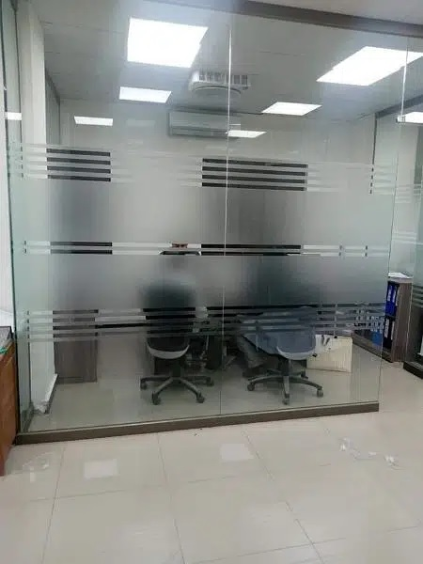 | 420 Sq. Ft.
02 | Low Height Partitioning:  - 4 feet Height Glass Partitioning along with Paper with metal Fitting  - Frame made of metal (18 swg)  - Quality Of Glass (05 mm with frosted paper)  - With Door edges would be with beautiful pillars  - Complete pressing with inner rubber  - Rubber gasket seal, silicon sealant and all the cost of material, fittings,  - any other item necessary for formulation installed and ready to use  - Division 2 Feet Glass with 2 Feet Structure  (Payment will be made on actual measurement after work)  - Color Blue and Silver | 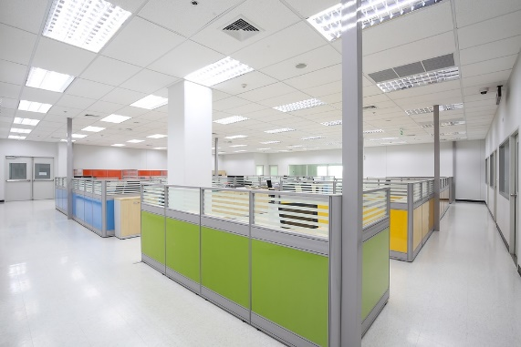 | 480  Sq. Ft

Reminder:

- It is compulsory for the vendor to visit the site in order to get the exact estimate of mentioned work.
- Dismantling and shifting of debris will be done by the successful vendor.
- All work will be done by single vendor who is lowest in overall rates.
- Warranty period of all above mentioned work shall be minimum 01 year.

Incharge HR & Admin
Health & Accident Insurance (H&AI),
Z-A Tower, State Life Building, Chowk Nawan Shaher Multan
Ph. 061-9201116

Terms & Conditions:
- Proposals shall accompany a Pay Order/Bank Draft/CDR of not less than Rs. 20,000/- in favor of State Life Insurance Corporation of Pakistan as earnest money which may be released after Final Evaluation.
- Successful Firm/Company must submit 2% of Quoted bid as Performance Guarantee after award of work order which shall be returned after expiry of warranty period of supplied items and shall be subject to deductions on account of unsatisfactory delivery / performance.
- No bid will be accepted without earnest money/CDR which is Rs. 20,000/-.
- Bid will not be accepted if a vender is under litigation with State Life or blacklisted by any of Provincial or Federal Government Department, Agency, Organization or autonomous body or Private Sector Organization anywhere in Pakistan. Personal influence will also disqualify bidders.
- All the bids must include G.S.T. and all other applicable taxes.
- All Submitted bids must be duly signed and stamped.
- The selected firms will provide items within 20 days from receipt of supply orders as per sample to be approved by SLIC. If supply is not made in due time, a fine of 0.5% of contract value per delayed day will be charged to the firm. If supply/ installation is delayed beyond 40 days from receipt of supply order, the earnest money will be confiscated
- The approved bidder immediately after receipt of Work Order shall provide a sample of the Item to SLIC for scrutiny and approval. After the sample is approved, the bidder shall supply/ install rest of the items as per approved sample.
- SLIC can increase or decrease the quantity of items to be purchased and also reserve the right to accept or reject any or all tenders/Bids in line with PPRA rules.
- Bid validity period shall be 90 days from the date of opening of financial bids. This period can be extended by SLIC with the consent of bidders.
- No advance payment will be made. Payment will be processed upon satisfactory delivery / Installation of items. In case of non-compliance or failure of execution of order within the specified time or supply of sub-standard items and Services, Performance Guarantee shall be forfeited in favor of the Corporation.

Warranty of the supplied items must be valid for minimum one years or above. The supplier will be responsible to assemble/ install /deliver/Ready to use items as per requirement and in case of failure to maintain quality in installation, the same will be fixed at his risk and cost besides penalty as may be imposed by Competent Authority in SLIC.
- The sealed bids envelope should bear the phrase of “Procurement of Furniture & Fixture H&AI Multan Zone.
- Competent Authority reserves the right to reject all bids or proposal any time prior to the acceptance of a bid or proposal. However, State Life shall upon request communicate to any supplier who submitted a bid or proposal, the grounds for its rejection of all bids or proposals.

Undertaking:
We hereby confirm to have read all the terms and conditions carefully mentioned in the tender documents and we agree to abide by all those conditions.

Signature and stamp:

A: - Mandatory Requirements

Verifiable documentary proof for all below requirements is mandatory.
Eligibility/Evaluation Criteria

Sales Tax Registration (Copy of Certificate)
- Income Tax Registration (Copy of Certificate)

Experience certificate of Similar Work (at least 02 Copy of Certificates)
- Affidavit/Undertaking that the firm has never been blacklisted by any organization/Government on Judicial Stamp Paper

Proof of Active Tax Payer List
- Original Bid Security in form of bank draft/Pay order/CDR of Rs. 20,000/- must be submitted to Incharge HR&A H&AI, Z-A Tower, Health & Accident Insurance State Life Insurance, Chowk Nawan Shaher, Multan before the opening of Bid.
- Successful Firm/Company must submit 2% of Quoted Bid Value as Performance Guarantee Which shall be returned after warranty period with approval of inspection committee on satisfactory job completion.

(The bidders who have not complied with the Above-Mentioned Eligibility / Qualification points shall be disqualified)

FINANCIAL PROPOSAL
For Purchase of Furniture and Fixtures
Financial year 2024

Name of Supplier: ______________________________________________

SR.# | Description | Qty. | Per Sq. Ft. rate | GST 16% Rs. | Per Sq. Ft. Rate including Tax | Total Cost (Sq.Ft. X Rate price including all taxes)
1 | Partition / Cabins  (as per specs mentioned above) | 420 Sq. Ft
2 | Low Height Partitioning  (as per specs mentioned above) | 480 Sq. Ft
 | Total Amount

All above work will be evaluated as a whole as a Single Job and contract will be awarded to single Vendor who is lowest overall.

(Filled Financial Proposal to be submitted on your company’s letter head.)

Signature and Stamp:

