TENDER DOCUMENT
Procurement of IT Equipments H&AI Multan Zone

Sealed Technical & Financial bids are invited in accordance with PPRA rules, under ‘Single Stage–Two Envelope Procedure” Through https://eprocure.gov.pk (E-Pads) from vendors registered with GST/Income Tax Department, own offices and phone numbers, for the Procurement of IT Equipments H&AI Multan Zone.

The sealed bids should be submitted through EPADS on date as per mentioned on EPADS and PPRA website at 10:00 AM dated October 17th, 2024 and bids will be opened on the same day at 10:30 AM in the presence of the bidders or their representatives.

Details of I.T Equipments with Specifications

Sr. No. | Items | Sample | Qty.
1. | Laptops:  - Processor & Generation: 12th Generation or higher Intel Core i5  - Processor speed: At least 3.4 to 4.4 Ghz  - RAM: 8 GB Extendable to 16 GB DDR-V  - Hard Disk SSD: 256 GB to 512 GB  - Hard Disk SATA: 1 TB  - Screen Size: 14 to 15.6 inches  - Screen Display: FHD display or higher  - Graphic Card: Integrated Intel UHD graphics or higher  - Connectivity: 10/100/1000 Ethernet card with Gigabit support  + Wifi and Bluetooth.  - Connecters USB: 3.0 (2), HDMI, Head phone output, USB,Type C  - I/O Devices: Backlight keyboard, standard Mouse with Mouse  Pad and webcam  - Operating system: MS Window 11 or Latest operating system (OEM  Release)  - Software: MS Office Current version licensed; antivirus  licensed  - Warranty: 1 year or higher local | 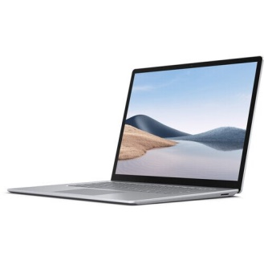 | 06
2. | Personal Computer:  - Processor & Generation: 12th Generation or higher Intel Core i3  - Processor speed: At least 2.5 turbo Boost to 4.4 Ghz  - RAM: 8 GB Extendable to 16 GB DDR-V  - Hard Disk SSD: 256 GB to 512 GB  - Hard Disk SATA: 1 TB  - Screen Size: Minimum 19 inches LCD HD-SVA anti-glare  Display.  - Graphic Card: Compatible with supplied motherboard  - Connectivity: 10/100/1000 Ethernet card with Gigabit support  + Wifi  - Connecters USB: 3.0 (2), HDMI, Head phone output, USB, Type C  - I/O Devices: Branded Keyboard and mouse with mouse pad  - Operating system: MS Window 11 or Latest operating system (OEM  Release)  - Software: MS Office Current version licensed; antivirus  licensed  - Warranty: 1 year or higher local | 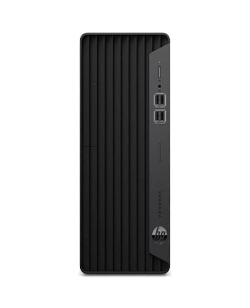 | 20
3. | Laser Printer:  - Print speed black A4: Up to 40 ppm  - Print technology: Laser  - First page out black (A4, ready): As fast as 6.3 sec  - Duty cycle monthly: Up to 80,000 pages  - Duplex printing: Automatic  - Print quality black (best): Up to 1200 x 1200 dpi  - Connectivity: Hi-Speed USB device 10/100Mbps Ethernet.  - Display: 2-line back lit LCD graphic display  - Processor speed: 1200 MHz  - Memory: 256 MB  - Warranty: 01 Year Channel Warranty | 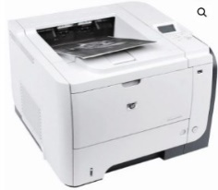 | 15
4. | Colour Printer:  - Printing Technology: Micropiezo Printhead  - Printing Speed ISO/IEC 24734: 8 pages/min Monochrome, 8 pages/min Colour  - Nozzle Configuration: 180 Nozzles Black, 180 Nozzles per Color  - Ink Technology: Dye Ink  - Printing Resolution: 5,760 x 1,440 DPI Category Photo  - Number of colours: 6 colour  - Black yield: 2,600 pages, 4,100 photos  - Colour yield: 5,400 pages, 1,500 photos  - Paper Tray Capacity: 100 Sheets Standard, 100 Sheets Maximum, 20 Photo Sheets  - Interface: USB 2.0, Wi-Fi IEEE 802.11b/g/n, Wi-Fi Direct  - 1 Year Warranty | 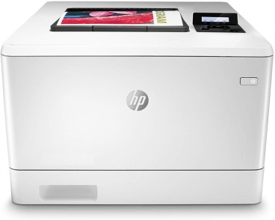 | 01
5. | 1 KVA Computer UPS:  - Capacity: 1200VA/720W  - Battery type & Number: (12V/9Ah x 2)  - Voltage range 162 – 290VAC, single-phase  - Transfer time: Typical 2-6 ms, 10ms max.  - Typical Recharge Time: 6-8 hours (To 90% capacity)  - Fuse Protection: Overload and overcharge protection  - Noise level: <40db (1 meter from surface)  - Fault: Continuously sounding  02 Year Channel Warranty | 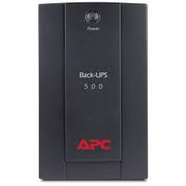 | 20

Incharge HR & Admin
Health & Accident Insurance (H&AI),
Z-A Tower, State Life Building, Chowk Nawan Shaher Multan
Ph. 061-9201116

Terms & Conditions:
- Proposals shall accompany a Pay Order/Bank Draft/CDR of not less than Rs. 160,000/- in favor of State Life Insurance Corporation of Pakistan as earnest money which may be released after Final Evaluation.
- Successful Firm/Company must submit 2% of Quoted bid as Performance Guarantee after award of work order which shall be returned after expiry of warranty period of supplied items and shall be subject to deductions on account of unsatisfactory delivery / performance.
- No bid will be accepted without earnest money/CDR which is Rs. 160,000/-.
- Bid will not be accepted if a vender is under litigation with State Life or blacklisted by any of Provincial or Federal Government Department, Agency, Organization or autonomous body or Private Sector Organization anywhere in Pakistan. Personal influence will also disqualify bidders.
- The Bids Prices shall be lowest quoted on Item-wise basis.
- All the bids must include G.S.T. and all other applicable taxes.
- All Submitted bids must be duly signed and stamped.
- The selected firms will provide items within 20 days from receipt of supply orders as per sample to be approved by SLIC. If supply is not made in due time, a fine of 0.5% of contract value per delayed day will be charged to the firm. If supply/ installation is delayed beyond 40 days from receipt of supply order, the earnest money will be confiscated
- The approved bidder immediately after receipt of Work Order shall provide a sample of the Item to SLIC for scrutiny and approval. After the sample is approved, the bidder shall supply/ install rest of the items as per approved sample.
- SLIC can increase or decrease the quantity of items to be purchased and also reserve the right to accept or reject any or all tenders/Bids in line with PPRA rules.
- Bid validity period shall be 90 days from the date of opening of financial bids. This period can be extended by SLIC with the consent of bidders.
- No advance payment will be made. Payment will be processed upon satisfactory delivery / Installation of items. In case of non-compliance or failure of execution of order within the specified time or supply of sub-standard items and Services, Performance Guarantee shall be forfeited in favor of the Corporation.

Warranty of the supplied items must be valid for minimum one years or above. The supplier will be responsible to assemble/ install /deliver/Ready to use items as per requirement and in case of failure to maintain quality in installation, the same will be fixed at his risk and cost besides penalty as may be imposed by Competent Authority in SLIC.
- The sealed bids envelope should bear the phrase of “Procurement of IT Equipment H&AI Multan Zone.
- Competent Authority reserves the right to reject all bids or proposal any time prior to the acceptance of a bid or proposal. However, State Life shall upon request communicate to any supplier who submitted a bid or proposal, the grounds for its rejection of all bids or proposals.

Undertaking:
We hereby confirm to have read all the terms and conditions carefully mentioned in the tender documents and we agree to abide by all those conditions.

Signature and stamp:

A: - Mandatory Requirements

Verifiable documentary proof for all below requirements is mandatory.
Eligibility/Evaluation Criteria

Sales Tax Registration (Copy of Certificate)
- Income Tax Registration (Copy of Certificate)

Experience certificate of Similar Work (at least 02 Copy of Certificates)
- Affidavit/Undertaking that the firm has never been blacklisted by any organization/Government on Judicial Stamp Paper

Proof of Active Tax Payer List
- Original Bid Security in form of bank draft/Pay order/CDR of Rs. 160,000/- must be submitted to Incharge HR&A H&AI, Z-A Tower, Health & Accident Insurance State Life Insurance, Chowk Nawan Shaher, Multan before the opening of Bid.
- Successful Firm/Company must submit 2% of Quoted Bid Value as Performance Guarantee Which shall be returned after warranty period with approval of inspection committee on satisfactory job completion.

(The bidders who have not complied with the Above-Mentioned Eligibility / Qualification points shall be disqualified)

TECHNICAL EVALUATION:

S No | Description | Max Points | Points Secured | Page Number
1 | Business Entity profile
 | established within 1 to 2 years  (Sole Proprietorship, Partnership, Corporation) | 10
 | established more than 2 years  (Sole Proprietorship, Partnership, Corporation) | 20
2 | After Sales Services ( Product Inspection Visits / Services )
 | 03 times for one year | 15
 | 06 times for two years (3 Times each year) | 20
3 | Number of Orders executed (PKR) (Similar Nature)
 | 0.5 to 1 million | 20
 | 1 to 1.5 million | 30
 | More than 1.5 million | 40
4 | Number and Nature of Clients (Similar Work)
 | 02 or more Private clients only | 15
 | 02 or more Private and Government both clients | 20
 | Total

Total Points = 100
Minimum Qualification Points = 60
FINANCIAL PROPOSAL
For Purchase of IT Equipments
Financial year 2024

Name of Supplier: ______________________________________________
SR.# | Description | Qty. | Per Unit Rate | GST Rs. | Per Unit Rate including Tax | Total Cost (Quantity X Rate price including all taxes)
1 | Laptops  (as per specs mentioned above) | 06
2 | Personal Computer  (as per specs mentioned above) | 20
3 | Laser Printer  (as per specs mentioned above) | 15
4 | Colour Printer  (as per specs mentioned above) | 1
5 | 1 KVA Computer UPS  (as per specs mentioned above) | 20
 | Total Amount

(Filled Financial Proposal to be submitted on your company’s letter head.)

Signature and Stamp:

