TENDER DOCUMENT
Procurement of Furniture State Life H&AI Multan

Sealed Technical & Financial bids are invited in accordance with PPRA rules, under ‘Single Stage–Two Envelope Procedure” Through https://eprocure.gov.pk (E-Pads) from vendors registered with GST/Income Tax Department, own offices and phone numbers, for the Procurement of Furnitur H&AI Multan Zone.

The sealed bids should be submitted through EPADS on date as per mentioned on EPADS and PPRA website at 10:00 AM dated October 16th, 2024 and bids will be opened on the same day at 10:30 AM in the presence of the bidders or their representatives.

Details of Furniture and Fixtures with Specification

Sr. No. | Items | Sample | Qty
01 | Executive Chair:  - Upholstery: Fabric (Black, Grey, Red)  - High-Density Foam Inside  - Multi-Function Mechanism  - Aluminum Chromed Armrest and Base  - PU Castor  - Size 700*810*1205-1270 | 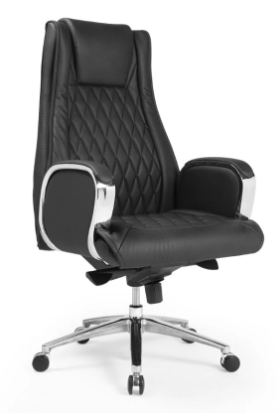 | 01
02 | Table with Side Rack and Cupboard:  - Table Size: 3ˊx 6″x 2ˊ6″  - Side Rack Size: 5ˊ6″ x 16″  - Vanity Size: 6ˊx 6ˊ x 18″  - Drawers with Soft Closing Full Extension Channels  - Cable Cover on Top & Sockets Beneath  - Material: MDF Tactile | 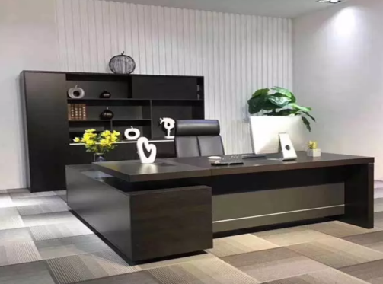 | 01
03 | Office Table with Side Rack:  - Table Size: 3ˊx6ˊx2ˊ6″  - Side Rack : 5ˊ6″ x 16″  - Drawers with Soft Closing Full Extension Channels  - Cable Cover on Top & Sockets Beneath  - Material: MDF /Tactile | 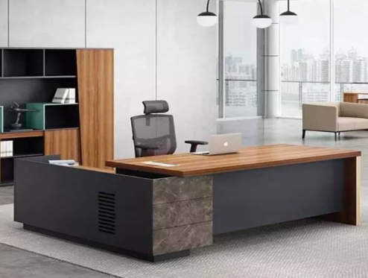 | 06
04 | Conference Room Chairs:  - Size: 25.7 W | 25 D | Max. 48.8 H (Inches)  - Headrest: Height Adjustable Back: Mesh (Grey)  - Upholstery: Fabric (Black, Grey, Blue)  - Armrest: Black PP Height Adjustable Arm Injected Seat Foam  - Base: Nylon  - Castor: Black PU Castor | 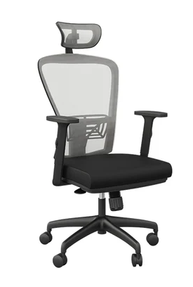 | 14
05 | High back Revolving chair:  - Size: 26 W | 19 D | 46 H (Inches)  - Material: PU Leather  - Finish: Black  - Base: Chrome | 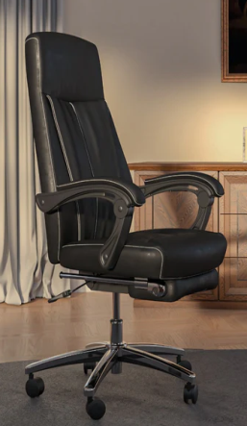 | 06
06 | Visitor Chair:  - Size: 24 W | 24 D | 39 H (Inches)  - Back: PP + Glass Fiber Backrest Cover with Fabric  - Seat: High Density High Resilience Foam  - Armrest: Black PP  - Upholstery: Fabric (Black, Grey, Red)  - Base: MS Pipe with Black Powder Coat | 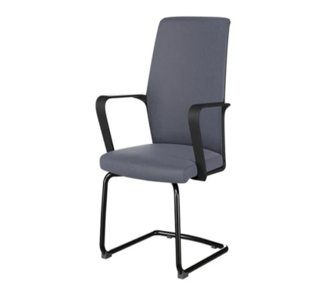 | 30
07 | Sofa Seat:  - Size: 30 W | 32 D | 32 H (Inches)  - Material: Fabric (Caramel Beige) & Leatherette (Brown)  - Structure: Plywood  - Foam: Supreme  - Legs: Mahogany wood with Black Stain | 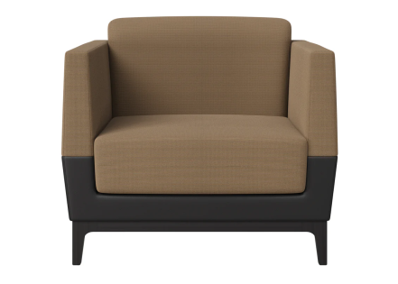 | 10
08 | Central Table:  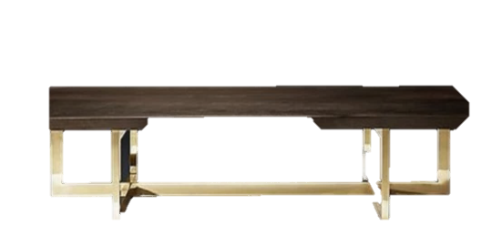  - Modern center table  - Rectangle shape  - Wood & metal  - 2ˊ x 4ˊx17″ |  | 02
09 | Blinds:  - Material: PVC  - Type: Vertical  - Machine  - Non Transparent  - With installation | 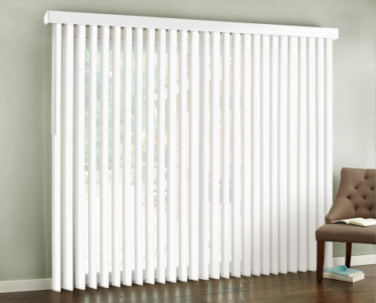 | 600  Sq. ft
10 | File Rack:  - Size: 48 W | 17 D | 36 H (inches)  - Top and Front: White MFC  - Carcass: Aland Pine MFC  - Handle: PVC (White and Grey)  - Shelves: 2  - Glides: Rubber  - Door with locks & Hydraulics | 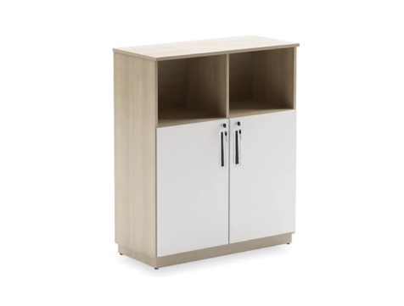 | 30

Terms & Conditions:
- Proposals shall accompany a Pay Order/Bank Draft/CDR of not less than Rs. 90,000/- in favor of State Life Insurance Corporation of Pakistan as earnest money which may be released after Final Evaluation.
- Successful Firm/Company must submit 2% of Quoted bid as Performance Guarantee after award of work order which shall be returned after expiry of warranty period of supplied items and shall be subject to deductions on account of unsatisfactory delivery / performance.
- No bid will be accepted without earnest money/CDR which is Rs. 90,000/-.
- Bid will not be accepted if a vender is under litigation with State Life or blacklisted by any of Provincial or Federal Government Department, Agency, Organization or autonomous body or Private Sector Organization anywhere in Pakistan. Personal influence will also disqualify bidders.
- The Bids Prices shall be lowest quoted on Item-wise basis
- All the bids must include G.S.T. and all other applicable taxes.
- All Submitted bids must be duly signed and stamped.
- The selected firms will provide items within 20 days from receipt of supply orders as per sample to be approved by SLIC. If supply is not made in due time, a fine of 0.5% of contract value per delayed day will be charged to the firm. If supply/ installation is delayed beyond 40 days from receipt of supply order, the earnest money will be confiscated
- The approved bidder immediately after receipt of Work Order shall provide a sample of the Item to SLIC for scrutiny and approval. After the sample is approved, the bidder shall supply/ install rest of the items as per approved sample.
- SLIC can increase or decrease the quantity of items to be purchased and also reserve the right to accept or reject any or all tenders/Bids in line with PPRA rules.
- Bid validity period shall be 90 days from the date of opening of financial bids. This period can be extended by SLIC with the consent of bidders.
- No advance payment will be made. Payment will be processed upon satisfactory delivery / Installation of items. In case of non-compliance or failure of execution of order within the specified time or supply of sub-standard items and Services, Performance Guarantee shall be forfeited in favor of the Corporation.

Warranty of the supplied items must be valid for minimum one years or above. The supplier will be responsible to assemble/ install /deliver/Ready to use items as per requirement and in case of failure to maintain quality in installation, the same will be fixed at his risk and cost besides penalty as may be imposed by Competent Authority in SLIC.
- The sealed bids envelope should bear the phrase of “Procurement of Furniture H&AI Multan Zone on Item wise basis.
- Competent Authority reserves the right to reject all bids or proposal any time prior to the acceptance of a bid or proposal. However, State Life shall upon request communicate to any supplier who submitted a bid or proposal, the grounds for its rejection of all bids or proposals.

Undertaking:
We hereby confirm to have read all the terms and conditions carefully mentioned in the tender documents and we agree to abide by all those conditions.

Signature and stamp:

A: - Mandatory Requirements

Verifiable documentary proof for all below requirements is mandatory.
Eligibility/Evaluation Criteria

Sales Tax Registration (Copy of Certificate)
- Income Tax Registration (Copy of Certificate)

Experience certificate of Similar Work (at least 02 Copy of Certificates)
- Affidavit/Undertaking that the firm has never been blacklisted by any organization/Government on Judicial Stamp Paper

Proof of Active Tax Payer List
- Original Bid Security in form of bank draft/Pay order/CDR of Rs. 90,000/- must be submitted to Incharge HR&A H&AI, Z-A Tower, Health & Accident Insurance State Life Insurance, Chowk Nawan Shaher, Multan before the opening of Bid.
- Successful Firm/Company must submit 2% of Quoted Bid Value as Performance Guarantee Which shall be returned after warranty period with approval of inspection committee on satisfactory job completion.

(The bidders who have not complied with the Above-Mentioned Eligibility / Qualification points shall be disqualified)

Technical Evaluation

SR.# | Description | Max Points | Points Secured | Page Number
1 | GST registration for relevant Item
 | Up to 03 years | 10
 | More than 03 years | 15
2 | After Sales Services (Polishing and Minor Repairing)
 | 02 times for one year | 10
 | 04 Times for two years (2 Times each year) | 15
3 | Number of Orders executed (PKR) Similar Nature
 | 0.5 to 1.0 million | 10
 | 1.0 to 1.5 million | 15
 | More than 1.5 million | 30
4 | Number and Nature of Clients (Similar Work)
 | 03 or more Private clients only | 15
 | 03 or more Private and Government both clients | 20
4 | Furniture Manufacturer
 | Up to 3 years | 15
 | More than 03 years | 20
 | Total

Total Points = 100
Minimum Qualification Points = 60

FINANCIAL PROPOSAL
For Purchase of Furniture
Financial year 2024
Name of Supplier: ______________________________________________
SR.# | Description | Qty. | Unit Price | GST Rs. | Total Price
01 | Executive Chair | 01
02 | Table with Side Rack and Cupboard | 01
03 | Office Table with Side Rack | 06
04 | Conference Room Chairs | 14
05 | High back Revolving chair | 06
06 | Visitor Chair | 30
07 | Sofa Seat | 10
08 | Central Table | 03
09 | Blinds | 600 Sq. Ft
10 | File Rack | 30

Signature and Stamp:

(Filled Financial Proposal to be submitted on your company’s letter head.)

