TENDER DOCUMENT
Procurement of Furniture and Fixtures State Life Rahim Yar Khan

Sealed Technical & Financial bids are invited in accordance with PPRA rules, under ‘Single Stage–Single Envelope Procedure” Through https://eprocure.gov.pk(E-PADS) from vendors registered with GST/Income Tax Department, own offices and phone/fax numbers, for the Procurement of following Furniture Items.

The sealed bids should be submitted through E-pads on date as per mentioned on E-pad sat 10:00AM and bids will be opened on the same day at 10:30 AM in the presence of the bidders or their representatives.

Details of Furniture and Fixtures with Specification

Sr. No. | Items | Sample | Qty
01 | Table 5 x 3  - 03 draws with channel with lock Glass Polish  - Top farmeca with wooden gola all side  - Bottom wooden border all side  Color–dark brown | 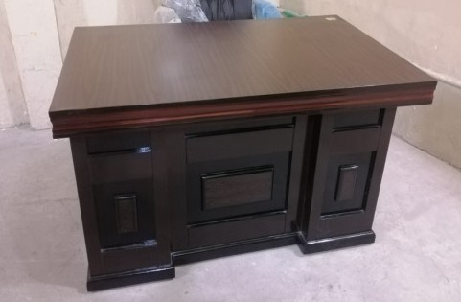 | 02
02 | SideRack:  Top glass 06 mm with glass polish  All side wooden border  Computer tray  One draw, One locker with locks  Length 38ʺ width 22ʺ | 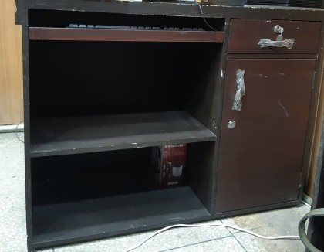 | 02
03 | Revolving Chair Cushioned  Ergonimic Chair Q-57-1R  Comfortable and Relaxing, adjustable Back  Adjustable Neck rest, adjustable Height  Adjustable Lumbar Support Adjustable/ Folding Footrest  HAD aluminum Base, HD Mute wheels  High-Grade SGS Hydraulic  Color Black | 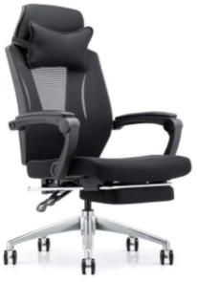 | 02
04 | Visitor Chair:  Back Height: High Back  Back Material: High Quality  High Quality Foam  (Seat & Back covered with high quality fabric or leatherette Sheesham wood sample can be seen in office  Standard size | 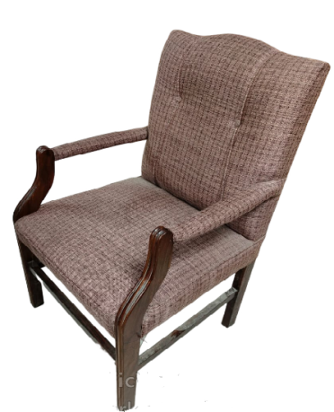 | 40
05 | Table:  Top Formica with wooden gola all side  bottom wooden border all side  Color – Wooden Color  Sheesham wood  (Sample can be seen in office) | 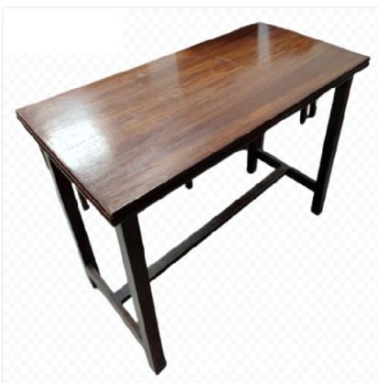 | 16
06 | Center Table-:  Center table high quality wooden coffee table with glass top. | 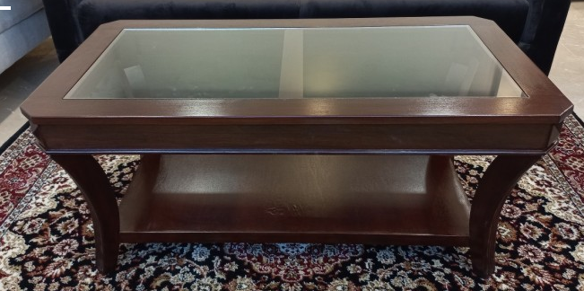 | 02
07 | Sofa Set 5 Seater:  Fabric Upholostery  Solid wooden legs  Solid wood inner Frame  Polyurethane Cushioned seat  Design: Standard  Weight Capacity: 600 lb. | 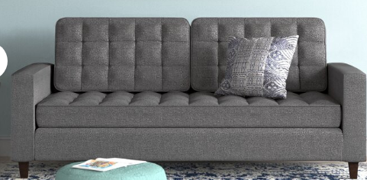 | 02
08 | Office Almirah:-  Thickness 0.8mm in MS CRCA (Powder Coated) adjustable shelves with manual locking at front Gate with safe  W 915 X D 485 X H 1980 mm | 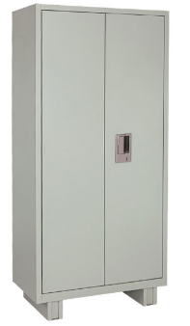 | 02
09 | DAWLANCE or Equivalent:  Excel Model 1.5 Ton  Inverter Split AC, Cooling Capacity 1800BTU  Heating Capacity 1800 BTU  Minimum Energy Mode (Inverter)  Indoor Outdoor Fan Motor DC  Cooling Ruuning Current A 7.4  Heating Running Current A 6.6 | 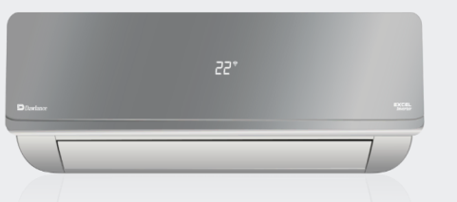 | 04
10 | Steel File Cabinet:  4 Drawer File Cabinet with Lock, Office File Cabinets for Home Office,18" Deep Metal Narrow Vertical Filing Cabinet, White File Cabinet Office Storage Cabinet Organizer fits Letter/Legal Size Black Color  18"D x 15"W x 52"H | 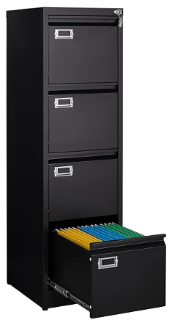 | 02
11 | Front Desk Counter:  High Quality Simple Wooden Reception Counter With 3-drawer Cabinet Wooden Reception Counter, Reception Desk, with State Life Mono  5 X 2.5 | 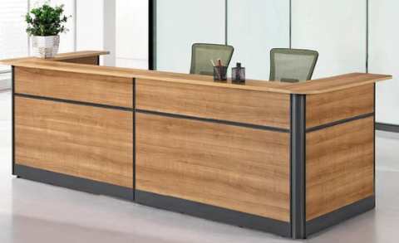 | 02
12 | Revo/Computer Chair or Equivalent:  Mesh Back  Fabric Seat  Tilting Mechanism  Plastic Base with 1 Year Warranty | 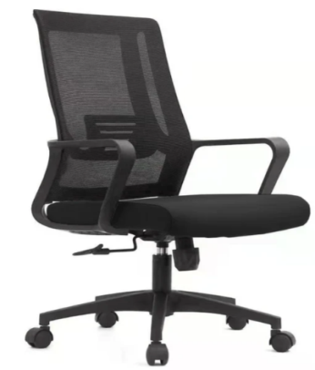 | 02

Terms & Conditions:

- Proposals shall accompany a Pay Order/Bank Draft/CDR of not less than 02% in favor of State Life Insurance Corporation of Pakistan as earnest money which may be released after Final Evaluation of unsuccessful firm/company.
- Successful Firm/Company must submit Rs.60000/- as Performance Guarantee after award of work order which shall be returned after expiry of warranty period of supplied items and shall be subject to deductions on account of unsatisfactory delivery/performance.
- No bid will be accepted without earnest money/CDR which is 02%.
- Bid will not be accepted if a vender is under litigation with State Life or blacklisted by any of Provincial or Federal Government Department, Agency, Organization or autonomous body or Private Sector Organization anywhere in Pakistan. Personal influence will also disqualify bidders.
- All the bids must in clued G.S.T. and all other applicable taxes.
- The Bids Price shall be count as a whole.
- All Submitted bids must be duly signed and stamped.
- The selected firms will provide items within 20 days from receipt of supply
orders as per sample to be approved by SLIC. If supply is not made in due time, a fine of 0.5% of contract value per delayed day will be charged to the firm. If supply/installation is delayed beyond 40 days from receipt of supply order, the earnest money will be confiscated.
- The approved bidder immediately after receipt of Work Order shall provide a sample of the Item to SLIC for scrutiny and approval. After the sample is approved, the bidder shall supply/ install rest of the items as per approved sample.
- SLIC can increase or decrease the quantity of items to be purchased and also reserve the right to accept or reject any or all tenders/Bids in line with PPRA rules.
- Bid validity period up to 31.12.2024.
- No advance payment will be made. Payment will be processed upon satisfactory delivery / Installation of items. In case of non-compliance or failure of execution of order within the specified time or supply of sub-standard items and Services, Performance Guarantee shall be forfeited in favor of the Corporation.
- The supplier will be responsible to assemble/ install /deliver/Ready to use items as per requirement and in case of failure to maintain quality in installation, the same will be fixed at his risk and cost besides penalty as may be imposed by Competent Authority in SLIC.
- The sealed bids envelope should bear the phrase of “Procurement of Furniture & Fixture & A.C for State Life Rahim Yar Khan Zone”.
- Competent Authority reserves the right to reject all bids or proposal any time prior to the acceptance of a bid or proposal. However, State Life shall up on request communicate to any supplier who submitted a bid or proposal, the grounds for its rejection of all bids or proposals.
- The bids prepared in accordance with the instruction in bid documents must reach at the office of Dy. Manager HR&A 4th floor State Life Building RYK on or before 10-10-2024 at 10:00 am.
- Tender closing date 10-10-2024 at 10:00 am Tender opening date 10-10-2024 at 10:30 am positively.

Undertaking:

We hereby confirm to have read all the terms and conditions carefully mentioned in the tender documents and we agree to abide by all those conditions.

Signature and stamp:_________________________
(Sign and stamp by Vendor)

- Verifiable Documentary Proof

Verifiable documentary proof for all below requirements is mandatory.
The bidders who have duly compiled with the Eligibility / Qualification and Evaluation criteria will be eligible for further processing.

Sr. No. | Eligibility / Evaluation Criteria | Requirement | Supporting Documents to be Attached as | Page No.
1 | Sales Tax Registration (copy of certificate) | Mandatory | Annex-A
2 | Income Tax Registration (copy of certificate) | Mandatory | Annex-B
3 | Experience Certificate for similar work (copy of certificate) | Mandatory | Annex-C
4 | Affidavit/ undertaking that the firm has never been blacklisted by any organization/ government on judicial stamp paper. | Mandatory | Annex-D
5 | Proof of Active Taxpayer List | Mandatory | Annex-E
6 | Earnest Money/ Bid Security 2% of total tender amount through bank draft/ pay order (To be attached with Financial Proposal) | Mandatory | Must be attached with Financial Proposal only

Technical Evaluation

SR.# | Description | Max Points | Points Secured | Page Number
1 | GST registration for relevant Item
 | Up to 03 years | 10
 | More than 03 years | 20
2 | After Sales Services ( Polishing and Minor Repairing )
 | 02 times for one year | 15
 | 04 Times for two years (2 Times each year) | 20
3 | Number of Orders executed (PKR) Similar Nature
 | 0.5 to 1.0 million | 20
 | 1.0 to 1.5 million | 30
 | More than 1.5 million | 40
4 | Number and Nature of Clients (Similar Work)
 | 03 or more Private clients only | 15
 | 03 or more Private and Government both clients | 20
 | Total

FINANCIAL PROPOSAL
For Purchase of Furniture and Fixtures
Financial year 2024
Name of Supplier: ______________________________________________

SR.# | Description | Qty. | Unit Price | GST Rs. | Total Price
1 | Office Table
2 | Side Rack
3 | Revolving Chair
4 | Visitor Chair
5 | Table
6 | Center Table
7 | Sofa Set 5 Seater
8 | Almeriah
9 | Split Air Conditioner
10 | Steel File Cabnit
11 | Front Desk
12 | Revo/Computer Chair

Signature and Stamp:

Purchase of Furniture Fixtures & A.C for HRDD, State Life Rahim Yar Khan Zone

With reference to the subject procurement following committees are proposed:

Dr. Khalid Rehman In charge PHS Convener
Shoukat Ali Warind Acting Zonal Accountant Member
Makhdoom Shahrukh In-charge HR & ADMIN Secretary/Member
Muhammad Amjad In-Charge N.B Member

Technical Evaluation Committee

Dr. Khalid Rehman In charge PHS Convener
Shoukat Ali Warind Acting Zonal Accountant Member
Makhdoom Shahrukh In-charge HR & ADMIN Secretary/Member
Muhammad Amjad In-Charge N.B Member

Inspection Committee

Dr. Khalid Rehman In charge PHS Convener
Shoukat Ali Warind Acting Zonal Accountant Member
Makhdoom Shahrukh In-charge HR & ADMIN Secretary/Member
Muhammad Amjad In-Charge N.B Member

____________________ User Department Member

Submitted for information and necessary approvals, please.

