

DOCUMENT FOR

FOR

AVAILABILITY OF SPACE FOR BRAND ADVERTISING AT DIFFERENT STATE LIFE PROPERTIES IN PAKISTAN

REAL ESTATE DIVISION
PRINCIPAL OFFICE,
STATE LIFE BUILDING #. 9
DR. ZIAUDDIN AHMED ROAD,
KARACHI.

AVAILABILITY OF SPACE FOR BRAND ADVERTISING AT DIFFERENT STATE LIFE PROPERTIES IN PAKISTAN

State Life Insurance Corporation of Pakistan invites bids for the availability of space for Brand advertisement at different properties in Pakistan..

- Interested advertising firms may collect the document from the office of the Deputy Manager (Tenancy), 5th floor, Real Estate Division State Life Building No.9 Dr. Ziauddin Ahmed Road Karachi during office hours from 0900 hours to 1630 hours or download the same from E-Pads PPRA website and SLIC website.

- Bids in the given format, duly signed, stamped, sealed and complete in all respect should be submitted in the above office on or before 11.00 AM on 15-01-2025 through E-Pads PPRA. Bids will be opened on same day at 11:30 AM on EPADS. Bids uploaded late will not be entertained and stand rejected.

- Interested Firms / Persons must ensure that all the relevant details / documents are submitted as desired in the tender. Incomplete documents uploaded without undertaking, valid documentary evidence, supporting documents, unsigned or not stamped, late submitted will not be considered. In general, use of blanko, whito is prohibited. The bid can be rejected if blanko, whito is used to correct the financial figures.

Note: STATE LIFE may reject any or all bids at any time prior to the acceptance of award as per provisions of PPRA Rules.

AVAILABILITY OF SPACE FOR BRAND ADVERTISING AT DIFFERENT STATE LIFE PROPERTIES IN PAKISTAN

State Life Insurance Corporation of Pakistan owns large number of properties in different cities of Pakistan. The properties consist of commercial buildings located in heart of different cities and open plots. At present State Life has decided to let out its prime spaces to commercial advertising firms having related experience of Brand advertisement. For this purpose in initial phase, following properties identified are given in Table - A;
TABLE - A
S# | Property Name & address | Size / Area identified* | Suitability of space | No. Of SMDs / Boards to be installed*
1 | State Life Building No. 1 I.I Chundrigarh Road Karachi |  | SMD/ Bill Board
2 | State Life Building No. 2, Wallace Road Karachi |  | -Do-
3. | State life Building No.7 (Plot),  G.Allana Road Karachi |  | -Do-
4. | State Life Building No. 11, Abdullah Haroon Road, Karachi |  | -Do-
5. | State life plot near FTC, Abbasi Shaheed  Road, Karachi. |  | -Do-
6. | State Life Plot Davis Road Lahore |  | -Do-
7. | State Life Building no.11, Davis Road, Lahore |  | -Do-
8. | State Life Building No. 02, Laytton Road, Lahore |  | -Do-`
9. | State Life Building No.1, Mall Road Rawalpindi |  | -Do-

*To be filled by bidder while submitting bid.

GENERAL TERMS & CONDITIONS

      - INVITATION:

All the eligible bidders having valid registrations & experience of Branding can participate in the bidding process for subject work.

      - Eligibility of Bidder:
A firm to be eligible to participate in the bid, must be a registered firm as follows:

          - Have NTN / FBR Registration

          - Have Sales Tax Registration

          - Must have at-least 01 years of experience in the field (The experience will be calculated from date of registration of firm in relevant field)

          - Undertaking that the firm is not blacklisted by any Provincial or Federal Government Department, Agency, Organization or autonomous body or Private Sector Organization anywhere in Pakistan

*If the renewal of registration with serial #( i,) & (ii), is under process, its proof shall be provided in document. Evaluation committee will not consider an undertaking citing the excuses like the registration will be provided or obtained or is under process. Only proof / receipt of concerned department will be considered.

      - Instructions to bidders:

- Bidders who do not meet eligibility criteria need not to participate in the bid process.
- Bidders meeting the eligibility criteria can bid for any one or all spaces available.
- The bid amount quoted must be in Pak rupees. The bidder will quote the amount on per sft basis of the sign(s) to be installed for each location.
- The bids will be opened through E-pads at the given date and time in the presence of bidders who choose to attend.
- After opening of bids, State Life will evaluate the bids for compliance of eligibility criteria and terms of the bid.
- After evaluation; a list of successful bidders will be prepared. Results will be uploaded on E-pads / PPRA website.
- If no grievance is received, State Life will consider the award to highest bidder in each case.
- Successful bidder will have to sign the rent agreement with State Life on the format attached (Annex-A).
- The bidder will have to deposit 06 month’s rent advance and 06 month’s security deposit before the site is handed over.
- Successful bidder will use the site only for Brand advertisement purpose and will comply with all conditions of agreement in letter and spirit.

      - CONFLICT OF INTEREST

        - The bidder shall strictly avoid conflict with other assignments. Bidders have an obligation to disclose any situation of actual or potential conflict that impacts their capacity to serve the interest of STATE LIFE, or that may reasonably be perceived as having such effect. Failure to disclose such situations may lead to the discontinuation of the or the termination of the agreement.

        - Without limitation on the generality of the foregoing, bidder, and any of their affiliates, shall be considered to have a conflict of interest and shall not be considered, under any of the circumstances set forth below;

  - A bidder or any of its affiliates shall not be considered for any subject assignment that, by its nature, may be in conflict with another assignment to be executed for the same or for another Procuring Agency.

  - A bidder that has a business or family relationship with a member of the STATE LIFE staff who is directly or indirectly involved.

  - Agreement may not be signed unless the conflict stemming from this relationship has been resolved.

    - FRAUD OR CORRUPTION

Bidder should observe the highest standard of ethics during the execution of agreement. Bidder should not be involved in fraud or corruption.

    - AMENDMENT IN THE DOCUMENT

      - STATE LIFE may, at any time prior to the deadline for submission of the applications, at its own initiative or in response to a clarification requested by the Applicants, amend the document, on any account, for any reason. All amendment(s) shall be part of this document.

      - STATE LIFE shall notify the amendment(s) in writing to the prospective interested parties who have purchased the document.

      - STATE LIFE may, at its sole discretion, amend the Document or extend the deadline for the submission of the Proposal under PPRA Rules.

    - QUERIES:

Queries of the bidder (if any) for seeking clarifications regarding the services required must be received in writing to STATE LIFE 07 days prior to submission time. All queries shall be responded within due time. Any query received after said date shall not be entertained.

    - PROPOSAL SUBMISSION REQUIREMENT:

For this tender, Single Stage, single envelope bidding procedure shall be adopted for competitive bidding. All the bidders meeting eligibility criteria shall submit their bidding through E-pads of PPRA.

  - Award of Contract

    - STATE LIFE will consider for awarding the Contract to the most advantageous bidder (the bidder offering highest amount) meeting the criteria, terms and conditions of the tender and the same would be communicated on PPRA website.
    - After receiving of award, bidder is required to sign the agreement with State Life on given format at Annex – A, pay security deposit and advance rent, before the site is handed over.
  - Black listing Policy.

In case of non-compliance of agreement responsibilities or causing damage to STATE LIFE, STATE LIFE has the right to take action against the bidder as per State Life Blacklisting policy and PPRA Rules.

AVAILABILITY OF SPACE FOR BRAND ADVERTISING AT DIFFERENT STATE LIFE PROPERTIES IN PAKISTAN

SPECIAL CONDITIONS

01 | Date and time of closing of bids | January 15, 2025 at 11:00 Am
02 | Date and time of opening of bids | January 15, 2025 at 11:30 Am
03 | Pre-bid meeting date | December 26, 2024 at 11:30 Am
04 | Bid Security | Rs. 75,000/- for each site for bid in shape of pay order / Banker’s cheque.
05 | Return of Bid Security | - Upon signing of rent agreement with successful bidder  - To successful bidder upon payment of rent advance and security deposit
06 | Forfeiture of Bid Security | - If the bidder withdraws the bid after opening  - If the successful bidder do not accept letter of award.
07 | Time period of agreement | 03(Three) years renewable as per terms & conditions of agreement
08 | Signing of agreement | On standard format (Annex – A)
09 | Set up period for installation of structure | 03 Months
10 | Cost of erection of structure | Successful bidder will bear all cost
11 | N.O.C & approvals | All N.O.Cs /approvals required from any department viz: local Government, Municipal Corporation, Cantonment Board etc will be responsibility of successful Bidder.
12 | Taxes | Successful bidder will bear all taxes of local / Provincial / Federal authorities.
13 | Escalation | 5 % Per annum

SEAL & SIGNATURE OF CONSULTANT

AVAILABILITY OF SPACE FOR BRAND ADVERTISING AT DIFFERENT STATE LIFE PROPERTIES IN PAKISTAN

BID PRICE

Having read the details of above tender, we hereby submit our bid with following rates;
S# | Property Name & address | No. of SMD / Boards to be installed | Type of Board to be installed (SMD/Board) | Size of SMD / Board (Mark location of Photograph of building) | Bid Price per sft (Rs)
1 | State Life Building No. 1 I.I Chundrigarh Road Karachi
2 | State Life Buildng No. 2, Wallace Road Karachi
3. | State life Building No.7 (Plot),  G.Allana Road Karachi
4. | State Life Building No. 11, Abdullah Haroon Road, Karachi
5. | State life plot near FTC, Abbasi Shaheed  Road, Karachi.
6. | State Life Plot Davis Road Lahore
7. | State Life Building No. 02, Laytton Road, Lahore
8. | State Life Building no.11, Davis Road, Lahore
9. | State Life Building No.1, Mall Road Rawalpindi

- Interested Firm / Bidder can be bid for one or multiple sites separately.
Seal & Signature of Consultant

__________________________________________________________________________

PHOTOGRAPHS OF LOCATIONS
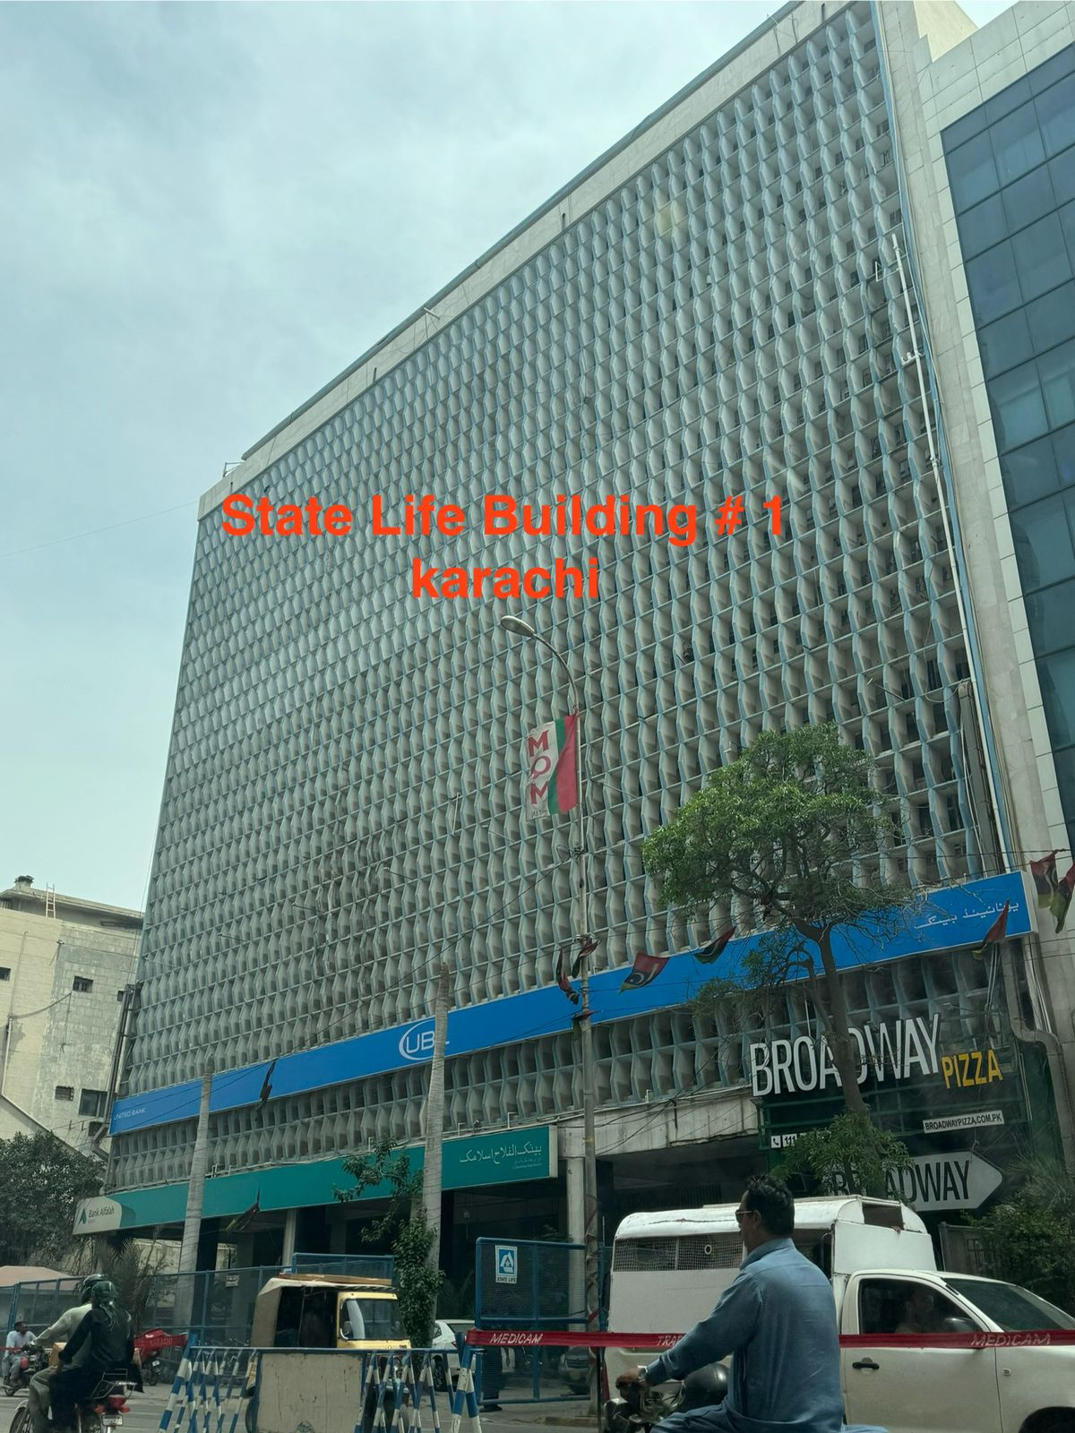

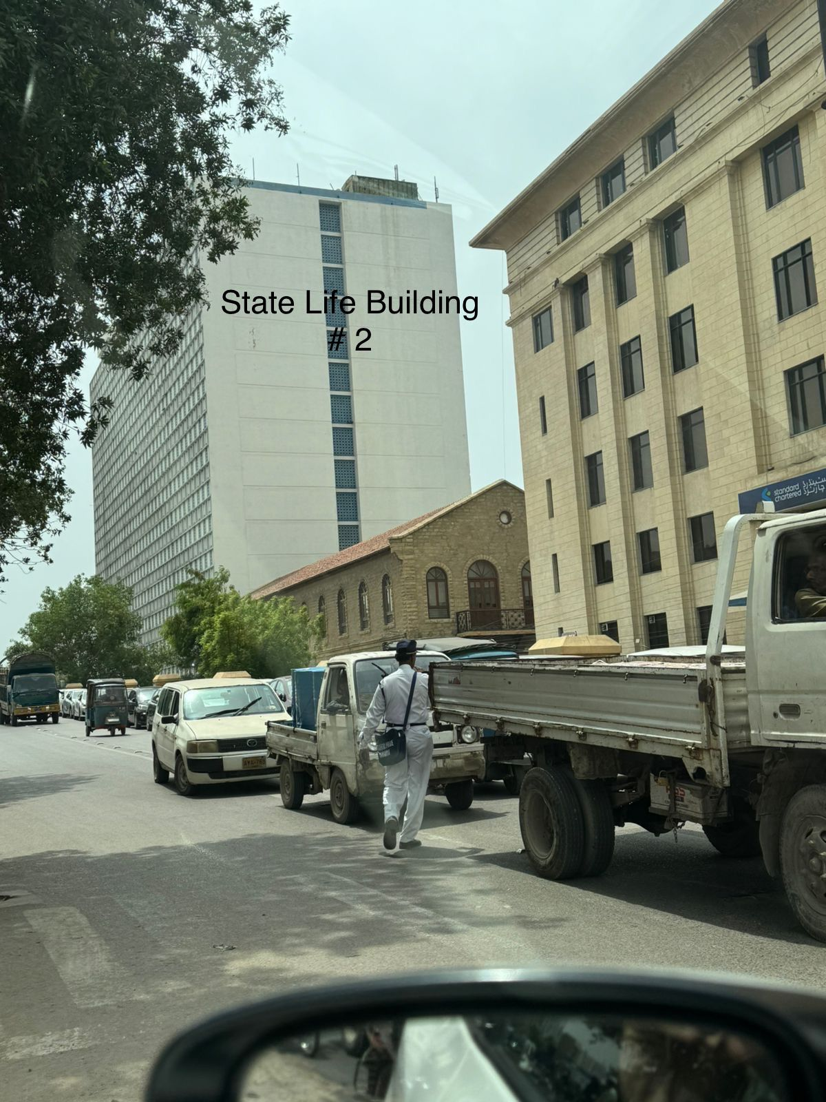

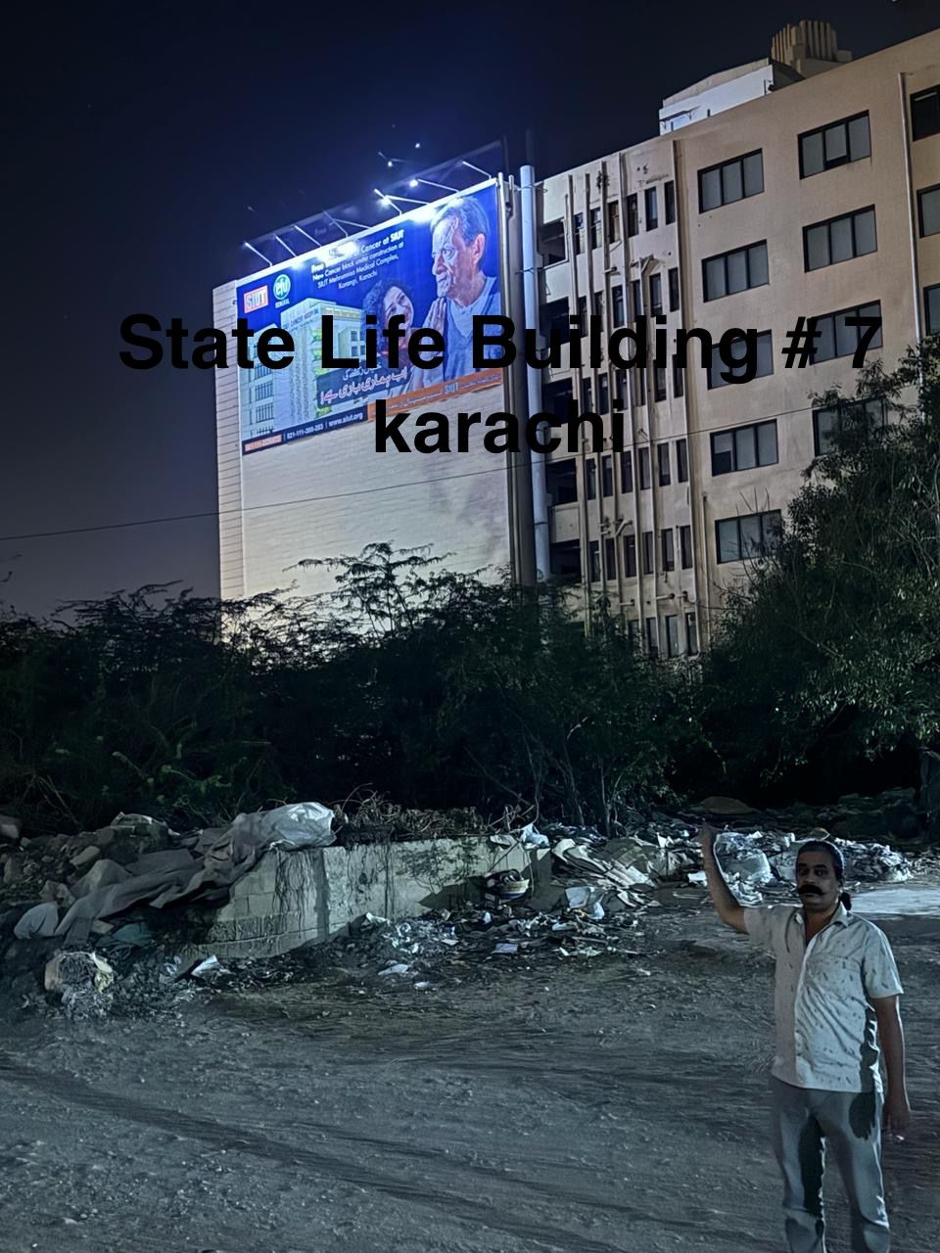

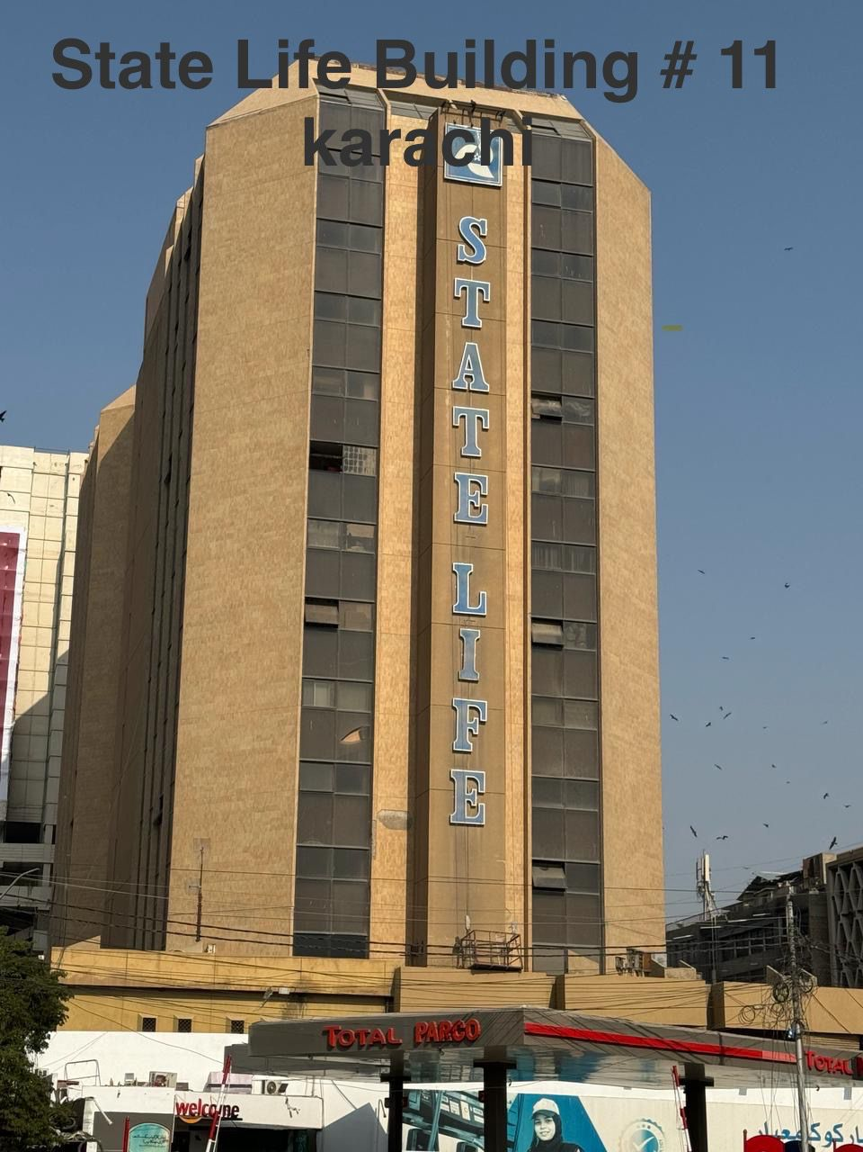

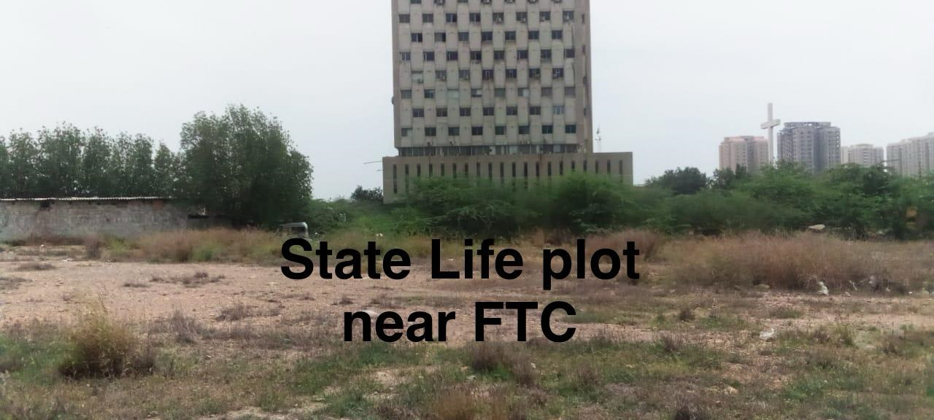

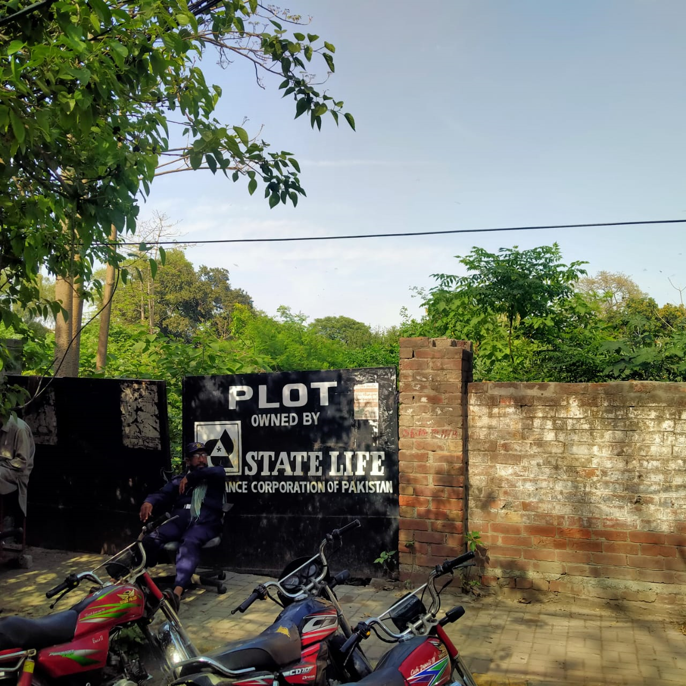

STATE LIFE PLOT DAVIS ROAD LAHORE

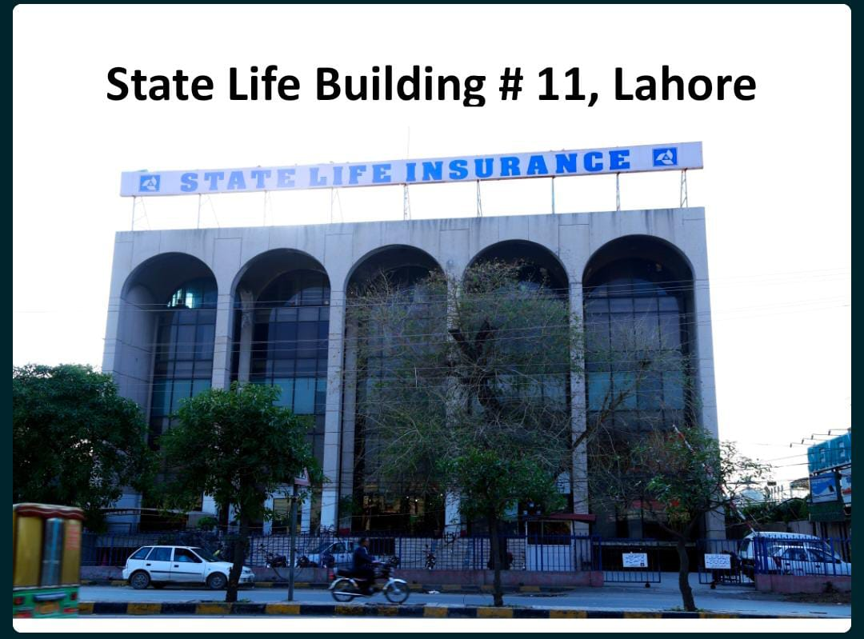

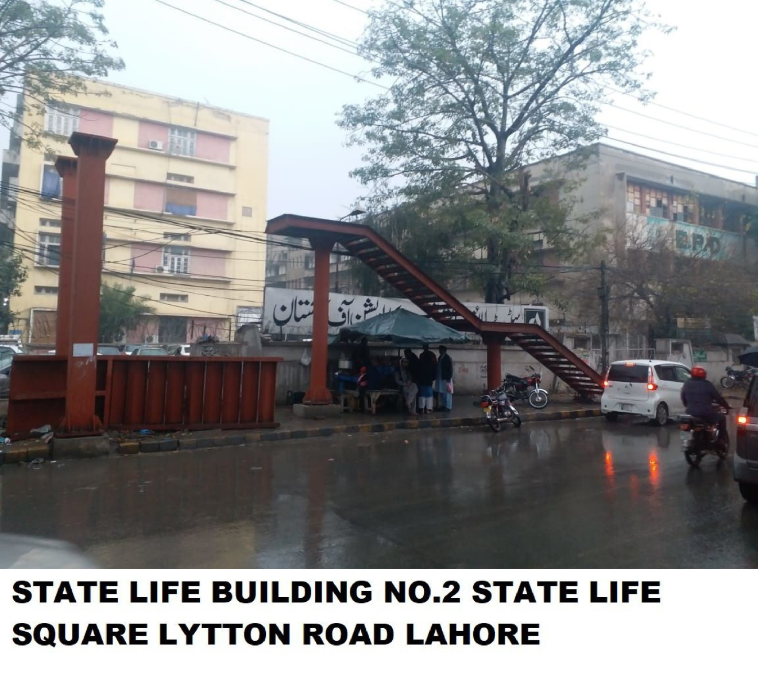

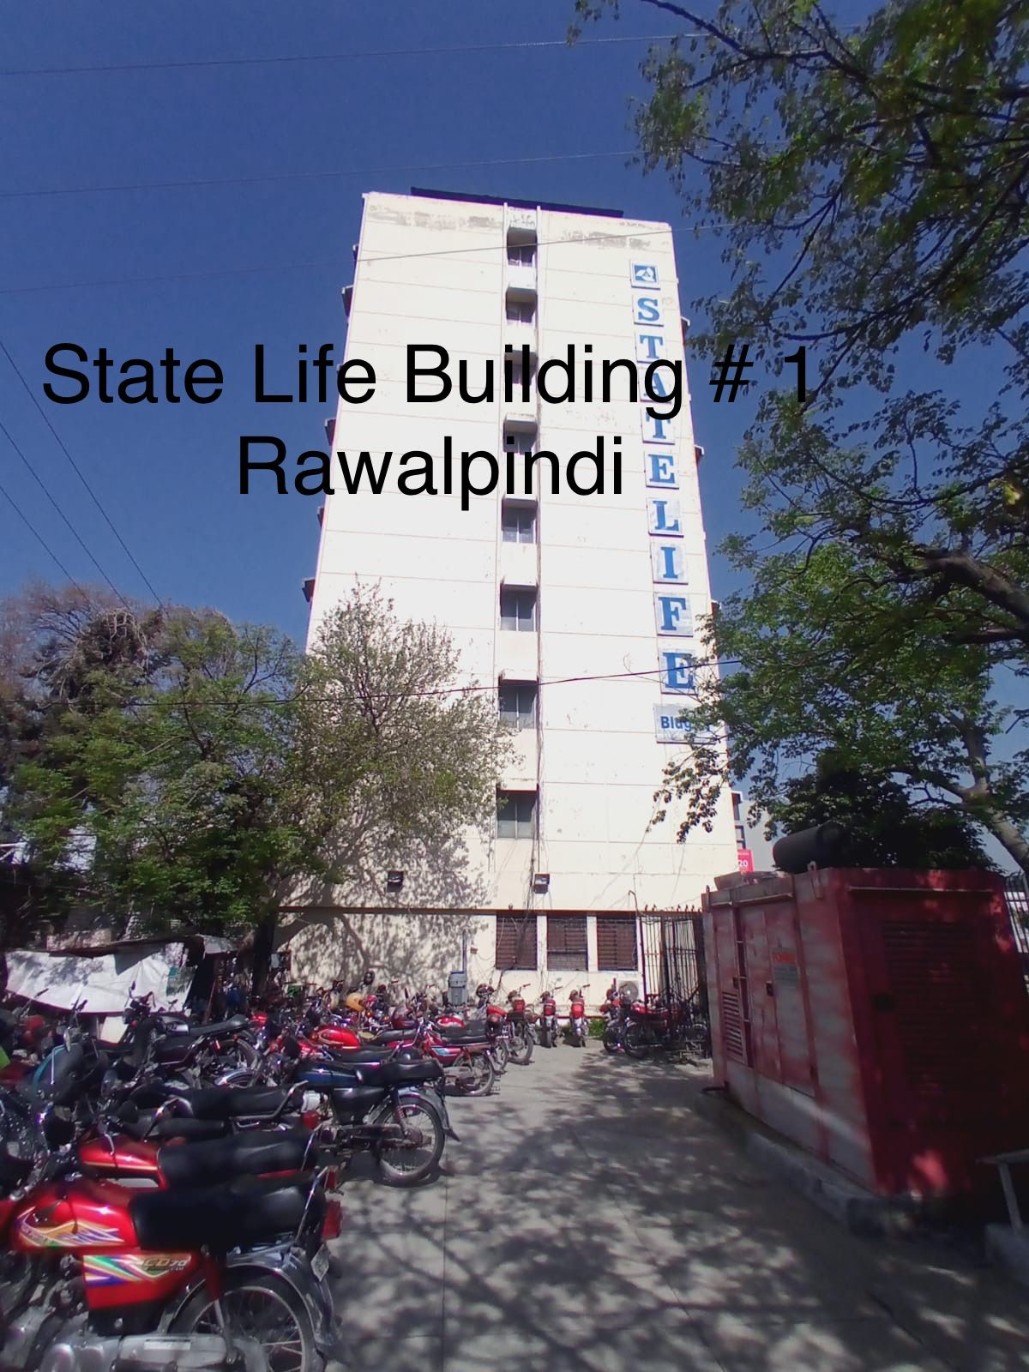

Lease Deed

Between


State Life Insurance corporation of Pakistan
&

M/S. ______________________________________
For
_____________ Sft.

______ Floor

State Life Building No. ____________ ____________________________________

For the period from

_________________ to __________________

Real Estate Division,
5th floor, Principal Office
State Life Building No. 9,
Dr. Ziauddin Ahmed Road,
Karachi


Rent Agreement for installation of SMDs / Bill Boards

This agreement is made at KARACHI this_______day of ___________ 20___BETWEEN STATE LIFE INSURANCE CORPORATION OF PAKISTAN established under the Life Insurance (Nationalization) Order' 1972, and having its Principal Office in State Life Building No. 9, Dr. Ziauddin Ahmed Road, Karachi (hereinafter referred to as the "Lessor" which term, wherever the context so requires or permits, shall include its successors-in-interest and assigns) acting through its constituted attorney ______________________S/o ____________________ appointed under General Power of Attorney date _of the FIRST PART, AND M/s. ___________________________. [ a company incorporated in Pakistan under the Companies Ordinance 1984 and having its registered office at__ floor __________________________________________________ acting through its constituted attorney______________________S/O_______________________holder of NIC No.________________ _______ appointed under General Power of Attorney date_____________. (hereinafter referred so as the "Lessee") of the OTHER PART.

WHEREAS the Lessor is the owner of a building on the plot of land bearing No. __________________ situated at State Life Building No. ____________________________________ in the city of _______________. Registration District and Sub-District Islamabad, generally known as State Life Building No. ________________________________________ Karachi. (hereinafter referred to as the "Building".

AND WHEREAS THE Lessor has, at the request of the Lessee, agreed to grant and the Lessee has agreed to take on lease office space measuring ___________ Sft. or there-abouts of the wall in the Building (hereinafter referred to as the " Premises" on the terms and conditions contained herein.

NOW, THEREFORE, THIS DEED OF LEASE WITNESS AS FOLLOWS:

1 The Lessor hereby demises unto the Lessee all that the demised premises, for a term of (12) Twelve Month commencing on _____________ and ending on ______________, both dates inclusive ("the said term") at a rent of Rs._________________/- (Rupees _________________________________________________________ Only) only computed at the rate of Rs. _____/-per sq. ft. per month payable in advance [every month on or before the fifth (5th) day of the month for which the same shall be due [annually three yearly on or before the 5th day of every year, every three year subject to the continuity of the Lease granted hereunder.]

2. The Lessee hereby covenants with the Lessor as under:

(a) To pay (06) 06 Month advance rent of Rs. __________________/- in terms of Clause 1 above and all other payments of whatsoever nature which the Lessee is obliged to pay under this Deed of Lease without any delay, deduction or set off whatsoever.

(b) To pay (06) Six Month Security deposit a sum of Rs __________________/- to the Lessor by way of Security Deposit for the due and faithful performance by the Lessee of the terms and conditions contained herein. The said Security Deposit shall be repaid by the Lessor to the Lessee after necessary adjustments (including but not restricted to adjustments on account of damage to the property of the Lessor), if any, within a period of thirty (30) days reckoned from the date on which the vacant possession of the demised premises shall be delivered by the lessee to the Lessor upon the expiry of the said term of other-wise under this agreement. No interest, charges or compensation shall accrue on the amount of Security Deposit.

(c) The lessee will use the site only for the purpose of advertisement / branding of goods, materials, product or services but no advertisement shall be indecent, obscene or otherwise of any immoral character in the opinion of the lessor or law of the land.

(d) The lessee shall not do any act or thing appearing on site whereby the lessor will become liable to any legal proceedings by the Government or local authority or any other person. The lessee will be fully responsible for their acts and will face any consequences for breach of law or rules of respective authorities or court orders.

(e) In addition to the rent, to pay all charges in respect of electric power consumed of supplies to the demised premises as determined by the Authorities concerned of the Lessor and in that connection to pay the bills received from the relevant authorities. The Lessor, however, shall not be liable/responsible for the shortage of any of the aforesaid amenities supplied by the agencies or non-supply thereof by them.

(f) To pay within fifteen (15) days of a written demand by the Lessor such charges as are payable by the Lessee hereunder for any amenities, facilities and conveniences provided by the Lessor for the demised premises. The Lessee declares and covenants with the Lessor that the lessee shall not challenge the quantum or the basis of the said charges in any forum whatsoever.

(g) Not to hang / place upon wall, a load in excess of holding capacity. The frames/structure erected shall be strong enough to withstand storm, heavy rains etc and must be design/vetted by Competent Engineering firm.

(h) Not to use the demised premises for any unlawful or immoral purpose and not to do or permit to be done any act or thing which may become a nuisance to or give cause for reasonable complaint from tenants, visitors or public.

(i) Lessee shall not display any branding of Life insurance companies, which are directly in competition with State Life Insurance Corporation.

(j) Not to transfer, assign, under-let, sub-let, license the demised premises or any part thereof, or part with possession of the demised premises or any part thereof without the prior written approval of the Lessor. In the event that any change in the partners/constitution of the partnership firm shall, for the purposes of this agreement created hereunder (or its extended term), be considered as a transfer, assignment, under letting, sub-letting, licensing contemplated above.

(k) Not to use the demised premises for any purpose other than branding.

(l) Not do or to permit or suffer to be done anything whereby the policy(ies) of insurance(s) against damage to the demised premises or the Building may become void or voidable or whereby the premium there-under may be increased and to make good all damage suffered by the Lessor and to pay to the Lessor all sums paid by it by way of increase in the premium and all expenses incurred by it in or about any renewal of such policy(ies) rendered necessary by breach or non-observance of this covenant without prejudice to the other rights of the Lessor.

(m) To abide by the Lessor's rules and regulations as in force or made from time to time relating to the maintenance of the demised premises.

(n) The Lessee shall be responsible to take all measures for the security of the demised premises and property therein and in no case the Lessor would be responsible for any loss of property of the Lessee in the demised premises. The lessee shall be responsible for erection of safe structure for branding, ensure safety and insurance of its workers. In no case Lessor will be responsible for any loss or injury to its workers or any public person affected, injured or died due to any reason of structural failure of branding boards. In such case lessee will bear all consequences for legal / criminal negligence.

(o) If the rent and/or all or any of the other payments to be made (under this agreement) by the Lessee to the Lessor or any other authority or person shall at any time be unpaid for thirty (30) days after becoming payable (whether formally demanded or not) or any covenant on the Lessee's part herein contained shall not be performed or if the Lessee shall become bankrupt or go into liquidation, then, notwithstanding anything contained herein, it shall be lawful for the Lessor at any time thereafter to terminate this lease and to re-possess the demised premises, but without prejudice to the right of legal action of the Lessor in respect to rent and other liabilities/responsibilities of the Lessee or any antecedent breach of the Lessee's covenants herein contained.

(p) In case during the said term, the premises / building or any part thereof shall be destroyed or rendered unfit for use and occupation by fire, flood, tempest, earthquake or any other cause beyond the control of the Lessor, the Lessor shall have the right to terminate the lease. If the Lessor terminates the lease as aforesaid, the lessee shall vacate the demised premises and hand over its possession to the Lessor. If the premises or the Building is damaged or made unfit for use by fire or other cause caused by the Lessee, the Lessee shall be responsible for the cost of reconstruction/repair/reinstatement of the premises to its original condition and to continue to pay the rent at the stipulated rate.

(q) The Lessee shall vacate the demised premises on the last day of the said term and hand over possession of same to the Lessor in the condition the Lessee took over same, natural wear and tear excepted. In the even that the Lessee continues with the possession of the demised premises, then without prejudice to the lessor's rights and entitlements against the Lessee under the law and/or this Deed of Lease, the Lessee shall be obliged to pay rent at a rate escalated by 15% fifteen percent per annum.

(r) The Lessee will be responsible payment of all the taxes of KMC, Cantonment Boards, City Government or any authority. Further Lessee will be responsible for obtaining N.O.Cs from any department concerned for installation of branding board / material.

(s) If available the Lessor will provide electricity for the boards from its building, however if it is not possible, the Lessor may issue N.O.C to Lessee for obtaining electric connection directly from K-Electric. In both cases lessee will be responsible for payment of electricity bill on given dates without any delay.

(t) If the Lessee wants to install a generator for the operation, they will require to obtain a separate permission and rental agreement with Lessor.

(u) Any notices required to be given by one party to other shall be given by registered post A.D. at the addresses mentioned below or such other addresses as the parties notify to each other:

To the Lessor at, | Divisional Head,  Real Estate Division  5th Floor,  State Life Building No. 9,  Dr. Ziauddin Ahmed Road,  Karachi
To the Lessee at, | M/s. ____________________  ________________________.

- The stamp duty, registration fees and other incidental costs and expenses towards the execution and registration of this Deed of Lease shall be borne by the Lessee exclusively.

- The Lessee shall be at its sole cost cause the registration of this Deed of Lease.

- If any party wishes to terminate this rent agreement, they may do so after serving 03 month notice on other party.

_________________________________ | _________________________________
Lessor  (through Attorney) | Lessee

WITNESS:

1.

2.

