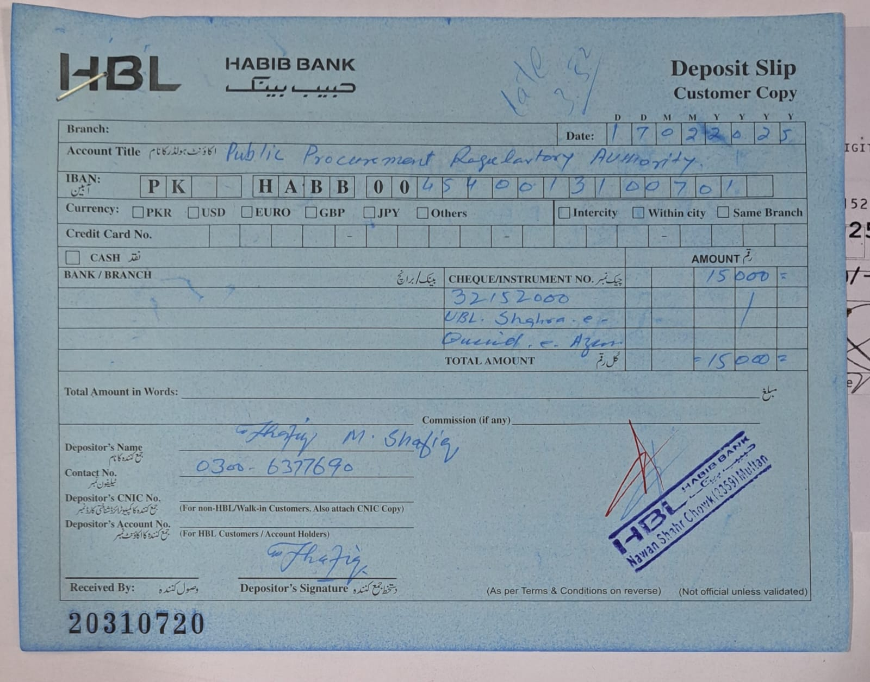

Date.18.02.2025

Deputy Director- (M&IMP)
Public Procurement Regulatory Authority
(Cabinet Division),
1st Floor, F.B.C. Building G-5/2
Islamabad.

Sub: Advertisement of Tender Notice # HR&A/MUL/001/2025.

Dear Sir,

Kindly advertise the State Life’s enclosed Tender Notice # HR&A/MUL/001/2025 on the Website of PPRA. The said caption of tender notice has also been sent to your given E-mail address info@ppra.org.pk. Advance Tender fee deposit slip is also attached herewith.

Thanking You.

Yours truly,

Syed M. Waqas Raza
Incharge ˗ (HR&A)

CC:
Divisional Head (IT)
Please arrange to place this tender on
State Life website earliest.

TENDER NOTICE NO.MUL/P&GS/001/2025
February 18, 2025
PRINTING & STATIONERY ITEMS

Sealed financial bids are invited from original manufacturers (under single stage single envelops) MARK AS ʺTECHNICAL AND FINANCIAL PROPOSAL SEPARATELYʺ from GST/NTN registered firms/Contractor/General order suppliers, who are on Active Taxpayers List of the Federal Board of Revenue (FBR) and who are eligible to supply Stationery & Printing items having own Office Phone/Fax number (if found contrary the tender will be rejected) for the following terms and conditions, as per list attached.

The Firm Supplier Printing/Stationery in question will be mandatory bound to qualify technical criteria specified and attached with tender document.

Those who qualify technical criteria shall be eligible for opening of their financial quotations. The passing marks of technical qualified are 60% out of 100%.

Sr. No. | Item Description | Qty | Delivery Schedule | Closing Date & time for Submission of Bids | Date & Time of opening of the Technical Bids
1 | Stationery Items & Printing Material  List of items can be seen in Tender documents. | As per Tender documents | As per Tender documents | 10-03-2025  at 10.30 AM | 10-03-2025  at 11.00 AM

Bidders should be from experienced and reputed registered firm as per requirement and having at least 02 Two similar work contracts ) of aforesaid procurement and have rendered such service in Government Organizations / Departments/ other companies and / or with State Life insurance corporation of Pakistan having their own offices and phone / Fax No / email for supply of above mentioned items description.

All interested parties, must submit their bid security in original through Courier / Dak / By hand prior to the bid opening failing which the tender will not be considered at all.

All interested parties are also advised to visit the office in order to understand placement and delivery of the printing items.

Any bid submitted other than EPADS will not be considered.

State Life reversed the right to reject any or all bids or proposal at any time prior to the acceptance of bids, or proposal, under provision of PPRA Rule 33.
E-bidding documents are available for registered bidder on PPRA, EPADS website and State Life website also.

In case of any clarification or query the vendors/contractors/suppliers may visit the office and contact the undersigned 061-9200678 during office working hours (9:30a.m to 4:30p.m).

TERMS AND CONDITIONS / TENDER DOCUMENTS

- Bidding documents for each item, containing detail terms and conditions etc… are available and can be downloaded from State Life Insurance Corporation of Pakistan (SLIC) website www.statelife.com.pk as well as from EPADS-PPRA website www.eprocure.gov.pk free of cost.

- Security amount must be deposited equal to 2% of the value of bid amount (ITEM WISE) of the tender in form of “Call Deposit Receipts” in favor of “State Life Insurance Corporation of Pakistan” as earnest money which will be refunded to the un-successful parties, CDR will be detained of the successful parties till the completion of Tender.

- Original Bid Security instrument MUST BE submitted to the under signed before opening of tender.

- Estimated cost of this tender is Rs.8,000,000/-

- The rate validity of tender will be up to December 31, 2025 from the date of opening of tender.

- On finding substandard quality or not equivalent to specification, as and when noticed during process, the security deposit may be forfeited in favor of the Corporation.

- The Firm/Suppliers will be bound to supply the required items of printing and stationery as per delivery schedule mentioned in tender documents.

- State Life Insurance Corporation has right to decrease the quantity without consultation as and when required.

- The bidders will attach their respective copies of NTN and Sales Tax Certificates. A certificate to the effect that the firm is not black listed as per specimen.

- All Tax will be deducted as per Government Rules.

- The Corporation reserves the right to cancel/reject any one or all the Tenders in accordance with rule (33) of Public Procurement regulations. However, State Life shall upon request communicate to any bidder who submitted a bid or proposal the ground for its rejection out of all bids or proposals.

- Sample items should be of same quality as specified in tender or provided. The Committee will not consider any sample attached by the vendor.

- Bidder must ensure to submit separate proposals for printing and stationery items.

- Printing samples are available and can be seen in the office of undersigned.

- Bidders shall not be permitted to withdraw their offer or modify the terms and conditions thereof. In case the bidder fails to observe and comply with the stipulations made herein or backs out after quoting the rates, the aforesaid ʺBid Securityʺ shall be forfeited in the favor of State Life Insurance Corporation of Pakistan.

- In case Purchaser calls the bidder for negotiation then this shall not tantamount to cancellation or withdrawal of original offer which shall be binding on the bidder.

- Penalty @1% of bid against delay in supply will be charge on weekly basis.

- Incomplete bids / conditional bids will be rejected.

- The Firm / suppliers in question will be bound to supply the required items as whole consignment within 15 days. Labour or transport cost will not be payable.

- Only one PRICE for each item is admissible. PLEASE PROVIDE BIDS PER ITEM.

- The successful bidder will have to show a sample of each and every items to the committee or the undersigned as the case may be before finalization of whole order and would be subject to approval.

- State Life Ins. Corporation of Pakistan reserve the right to check the item and its quality, prior to delivery and / or upon delivery. If any item is found substandard the work will be cancelled and bid security will be forfeited.

- Any firm or its representative may visit the office at the time of opening of Bids.

Delivery Schedule

¼^{th} of the whole consignment in 1st Quarter

¼^{th} of the whole consignment in 2nd Quarter

¼^{th} of the whole consignment in 3rd Quarter

¼^{th} of the whole consignment in 4th Quarter

 | Yearly Demand of Stationery Items for the Year - 2025
 | S.NO. | ITEM NAME | Estimated Requirement 2025
 | 1 | Ball Pen Piano Crystal OR Equivalent | 600 (pkt)
 | 2 | Box File | 100
 | 3 | Carbon Paper KCR OR Equivalent | 15
 | 4 | Packing Tape (2" and 30 Meter) Nichiban OR Equivalent | 50
 | 5 | Duster Medium Cloth, Fine Quality (For Dusting) | 150
 | 6 | Paper Rim Legal Size, Not Less than 70 GM, 500 Sheets (AA or Equivalent) | 300
 | 7 | Paper Rim A-4, Not less than 70 GM, 500 Sheets (AA or Equivalent) | 600
 | 8 | Ink for Stamp Pad Dollar OR Equivalent | 60
 | 9 | Rough Pad Large 68 GM Paper 50 Pages | 60
 | 10 | Rubber Band Ring Large Packet (1/2 kg | 70
 | 11 | Ruled Register Large 200 Pages | 100
 | 12 | Stapler Pin Packet – Large for Cash 23/17 (Kangaroo or equivalent) | 120
 | 13 | Stapler Pin Packet - Medium Dollar 24/6 OR Equivalent | 600
 | 14 | Stamp Pad Dollar OR Equivalent | 60
 | 15 | Computer Paper 80 Col I Ply 1000 63 Gram Century Sheets | 600
 | 16 | PAPER BOX 132 COL. I PLY 2000 63 Gram Century Sheets | 200
 | 17 | Ribbon LQ-310 Full Mark OR Equivalent | 400
 | 18 | Ribbon LQ-2180 Full Mark OR Equivalent | 100
 | 19 | Ribbon IBM-6400 Line Printer General Purpose (Original) | 120
 | 20 | RIBBON LINE PRINTER GENERAL PURPOSE P-7000 (Original) | 20
 | 21 | TISSUE PAPER (Rose Patel -pop up) OR Equivalent | 250
 | 22 | SIGNATURE PEN SIGNO OR Equivalent | 300
 | 23 | Gum Stick (medium) | 30
 | 24 | Highlighter | 40
 | 25 | Calculator CANZEN CT-650 M OR Equivalent | 40 or above
 | 26 | Punching Machine OPAL 500 N OR Equivalent | 40 or above
 | 27 | Marker 90 Dollar OR Equivalent | 120
 | 28 | Paper Cutter | 30
 | 29 | Scotch tape 1ʺ | 36
 | 30 | Stapler Machine with Pin remover Standard | 48
 | 31 | Dumper Plastic | 48
 | 32 | Led Pencil with eraser Gold fish) OR Equivalent | 120
 | 33 | Sharpener | 50
 | 34 | Eraser | 50
 | 35 | Gum Bottle (Large) Nafees OR Equivalent | 20
 | 36 | Steel Foot ruler | 20
 | 37 | Ribbon LQ-350 Full Mark OR Equivalent | 120
 | 38 | Name Stamp with Machine shiny S-842 OR Equivalent | 50
 | 39 | Officer Employee card with cover | 100
 | 40 | Dak dispatch Register 300 pages | 20
 | 41 | Table set wooden | 15
 | 42 | Pen Holder set | 15
 | 43 | Calculator 14 Digit CT-9300 or Equivalent | 20
 | 44 | Stapler Machine Heavy Duty for Cash STD-3000 or equivalent | 06
 | 45 | Box File Fiber 1ʺ | 12
 | 46 | Box File Fiber 2ʺ | 12
 | 47 | Box File Fiber 3ʺ | 12
 | 48 | Paper Binder (Clip) | 24
 | 49 | Gem clip Standard (Pkt) | 50
 | 50 | Rough Pad Medium size | 50

 | Yearly Demand of Printing Items for the Year - 2025
 | S.NO. | ITEM NAME |  | Estimated Requirement 2025
 | 1 | Leave Application Pad (Officers/Staff), containing 100 Pages, 68 GM Flying High Finish (A4 Size) |  | 60
 | 2 | Medical Card Officer/Staff as per Specimen |  | 1500
 | 3 | Medical Reimbursement Pad (A), containing 100 Pages, 68 GM Flying High Finish (Legal Size) |  | 40
 | 4 | Medical Reimbursement Pad (B), containing 100 Pages, 68 GM Flying High Finish (Legal Size) |  | 40
 | 5 | Requisition Slip Pad, containing 100 Pages, 68 GM Flying High Finish (A4 Size) |  | 40
 | 6 | Office File Cover as per Specimen |  | 2000
 | 7 | Medical (P&GS-104) as per Specimen |  | 50
 | 8 | Medical (P&GS-105) as per Specimen |  | 50
 | 9 | Medical (P&GS-106) as per Specimen |  | 130
 | 10 | Envelops Window 9"X4" (1000) as per Specimen |  | 40000
 | 11 | Envelops Simple 9"X4" (1000), 90 Gram White paper (as per Specimen) |  | 10000
 | 12 | Envelops Simple 11"X5" (1000), 90 Gram White paper (as per Specimen) |  | 2000
 | 13 | Envelops Simple 10"X12" (1000), 90 Gram White paper (as per Specimen) |  | 3000
 | 14 | Envelops Simple 11"X15" (1000), 110 Gram White paper (as per Specimen) |  | 1000
 | 15 | Envelops Simple 19"X15" (1000), 110 Gram White paper (as per Specimen) |  | 1000
 | 16 | Audit Memo Pad, carbon paper containing 100 Pages, 68 GM Flying High Finish (A4 Size) |  | 40
 | 17 | Audit Entry Pad, containing 100 Pages, 68 GM Flying High Finish (A4 Size) |  | 40
 | 18 | General Voucher Pad, containing 100 Pages, 68 GM Flying High Finish (as per Specimen) |  | 80
 | 19 | Payment Voucher A.M. Imprest Pad, containing 100 Pages, 68 GM Flying High Finish (as per Specimen) |  | 20
 | 20 | Proposal Form Non Medical 80 GM Imported (as per Specimen) |  | 70000
 | 21 | Proposal Form Medical 80 GM Imported (as per Specimen) |  | 30000
 | 22 | Policy Brief Sheet 80 GM Imported (as per Specimen) |  | 40000
 | 23 | Policy File Cover as per Specimen |  | 40000
 | 24 | Policy Register Sheet 80 GM Imported (as per Specimen) |  | 1000
 | 25 | File Cover Agy as per Specimen |  | 3000
 | 26 | Supplementary Pad, containing 100 Pages, 68 GM Flying High Finish (A4 Size) |  | 30
 | 27 | Medical Extra Pad, containing 100 Pages, 68 GM Flying High Finish (A4 Size) |  | 30
 | 28 | ND Pad, containing 100 Pages, 68 GM Flying High Finish (A4 Size) |  | 30
 | 29 | Amendment Pad, containing 100 Pages, 68 GM Flying High Finish (A4 Size) |  | 200
 | 30 | Medical Expense Card (Agency) as per Specimen (Size 11x14) |  | 1500
 | 31 | Fresh Appointment SR/SO/SM Pad, containing 100 Pages, 68 GM Flying High Finish (SET) (as per Specimen 06 Pages) Legal 02pages A-4 04pages |  | 3000
 | 32 | Application for Renewal Pad, containing 100 Pages, 68 GM Flying High Finish (SET) (as per Specimen 03pages) Legal 01page A-4 02pages |  | 3000
 | 33 | Agy Alteration Pad, containing 100 Pages, 68 GM Flying High Finish (A4 Size) |  | 40
 | 34 | DGH Pad, containing 100 Pages, 68 GM Flying High Finish (A4 Size) |  | 250
 | 35 | Adjustment Advice Pad, containing 100 Pages, 68 GM Flying High Finish (as per Specimen) |  | 20
 | 36 | Annuity Claim Pad, containing 100 Pages, 68 GM Flying High Finish (A4 Size) |  | 20
 | 37 | Maturity Claim Form Pad, containing 100 Pages, 68 GM Flying High Finish (Legal Size) |  | 80
 | 38 | Medical Attendance Certificate Pad, containing 100 Pages, 68 GM Flying High Finish (A4 Size) |  | 50
 | 39 | PHS-63 Pad, containing 100 Pages, 68 GM Flying High Finish (A4 Size) double side printing |  | 60
 | 40 | PHS-64 Pad, containing 100 Pages, 68 GM Flying High Finish (A4 Size) |  | 60
 | 41 | PHS-10 Pad, containing 100 Pages, 68 GM Flying High Finish (A4 Size) |  | 200
 | 42 | PHS-15 Pad, containing 100 Pages, 68 GM Flying High Finish (10 ̋ x 8 ̋ Size) |  | 500
 | 43 | Service Zone Change Advice Pad, containing 100 Pages, 68 GM Flying High Finish (8 ̋ x 6 ̋ Size) |  | 20
 | 44 | Policy Card as per Specimen |  | 4000
 | 45 | Loan Processing Sheet Pad, containing 100 Pages, 68 GM Flying High Finish (Legal Size) |  | 200
 | 46 | Address Change Advice Pad, containing 100 Pages, 68 GM Flying High Finish (8 ̋ x 6 ̋ Size) |  | 20
 | 47 | PS Non Medical 80 GM Imported (as per Specimen) |  | 12000
 | 48 | PS Medical 80 GM Imported (as per Specimen) |  | 8000
 | 49 | PHS - 80 Pad, containing 100 Pages, 68 GM Flying High Finish (A4 Size) |  | 20
 | 50 | Performa SV motivation Pad, containing 100 Pages, 68 GM Flying High Finish (A4 Size) |  | 200
 | 51 | Loan, SV Detail Performa update record of policy containing 100 Pages, 68 GM Flying High Finish (A4 Size) |  | 200
 | 52 | Application for SV Pad, containing 100 Pages, 68 GM Flying High Finish (A4 Size) |  | 200
 | 53 | Notice DP-04 Letter Pad, containing 100 Pages, 68 GM Flying High Finish (A4 Size) |  | 40
 | 54 | Re-Nomination Form Pad, containing 100 Pages, 68 GM Flying High Finish (A4 Size) |  | 20
 | 55 | Medical Comparative Pad, containing 100 Pages, 68 GM Flying High Finish (A4 Size) |  | 20
 | 56 | KYC Individual double side printing Page Set 100 Pages, 68 GM Flying High Finish (A-4 Size) |  | 80
 | 57 | S.M Report individual Pad 100 Pages, 68 GM Flying High Finish (A-4 Size) |  | 150
 | 58 | S.M/A.M/ S.H Report 100 Pages, 68 100 Pages GM Flying High Finish (A-4 Size) 03page set 34 set per pad |  | 600
 | 59 | Risk Performing Sheet Pad 100 Pages, 68 GM Flying High Finish (A-4 Size) |  | 600
 | 60 | Medical Health Card (Agency), as per specimen (size 9½ x 11) |  | 1500
 | 61 | CRS Form 68 GM Flying High Finish (A4 Size) |  | 50
 | 62 | Medical Extra Performa (Renewal) 68 GM Flying High Finish (A4 Size) |  | 10
 | 63 | Re-Nomination Form when the Existing Nominees is expired 68 GM Flying High Finish (A4 Size) |  | 10
 | 64 | special Re-instatement of policy 68 GM Flying High Finish (A4 Size) |  | 20
 | 65 | Check list pad for AML/CFT Policy 68 GM Flying High Finish (A4 Size) |  | 100
 | 66 | Alteration advice pad, containing 100 Pages, 68 GM Flying High Finish (A4 Size) |  | 20
 | 67 | PHS-65 - Pad, containing 100 Pages, 68 GM Flying High Finish (Legal Size) |  | 10
 | 68 | P&GS 101- Pad, containing 100 Pages, 68 GM Flying High Finish (A4 Size) |  | 10
 | 69 | Medical examination report Pad, containing 100 Pages, 68 GM Flying High Finish (A4 Size) |  | 10
 | 70 | Declaration of family member Pad, containing 100 Pages, Finish (A4 Size) |  | 10
 | 71 | Medical declaration card Agency ( Size 9½ x 11ʺ ) |  | 1000
 | 72 | Salary debit Pad, containing 100 Pages, 68 GM Flying High Finish (A4 Size) |  | 10
 | 73 | P.F. form pad, containing 100 Pages, 68 GM Flying High Finish (Legal Size) |  | 20
 | 74 | High Risk pad-NB containing 100 Pages, 68 GM Flying High Finish (A4 Size) |  | 50
 | 75 | Visiting Card Officer (UV) Per thousand Rate |  | 100

For further details the undersigned may be contacted during working hours in person or telephonically on phone No.061-9200678.

Syed M. Waqas Raza
Secretary Zonal Procurement Committee
Personnel & General service Department
State Life Building 2nd floor Chowk nawan Shaher
Abdali Road Multan Zone

TECHNICAL EVALUATION CRITERIA-PRINTING ITEMS
 | Total Nos. | 10
Income Tax Registered | 05
Sales Tax Registered | 05
No. of Clients | Total Nos. | 10
From 5 to 10 | 05
From 10 to 15 | 10
Type of Clients | Total Nos. | 20
Private Clients up to 5 | 5
Above 5 one point for each client | 10
Govt. Client up to 5 | 5
Above 5 one point for each client | 10
No. of Printing
(Machines off set) | Total Nos. | 20
One Colour | 5
Two Colour | 10
Four Colour | 20
Printing
Experience | Total Nos. | 20
Minimum 5 Years Compulsory | 10 Nos.
above 5 years 01Point for each 1 Year Completed
Financial Turn Over | Total Nos. | 20
Up to 10 Million | 5
10 to 20 Million | 10
Above 20 Million shall be eligible for 20 marks | 20

TECHNICAL EVALUATION CRITERIA FOR STATIONERY
 | Total Nos. | 20
Income Tax Registered | 10
Sales Tax Registered | 10
No. of Clients | Total Nos. | 20
From 5 to 10 | 5
From 10 to 15 | 10
one Points for each 1 Year complete above 15 client
Type of Clients | Total Nos. | 20
Private Clients up to 5 | 5
Above 5 one point for each client | 10
Govt. Clients up to 5 | 5
Above 5 one point for each client | 10
Financial Turn Over | Total Nos. | 20
Up to 10 Million | 5
10 to 20 Million | 10
Above 20 Million shall be eligible for 20 marks | 20
Previous Experience | Total Nos. | 20
1 to 5 Years | 5
5 to 10 Years | 10
one points for each 1 complete Year above 10 Years

