 STATE LIFE PABX : 061-9200771-3

Insurance Corporation of Pakistan FAX : 061-9200778

Multan Zone

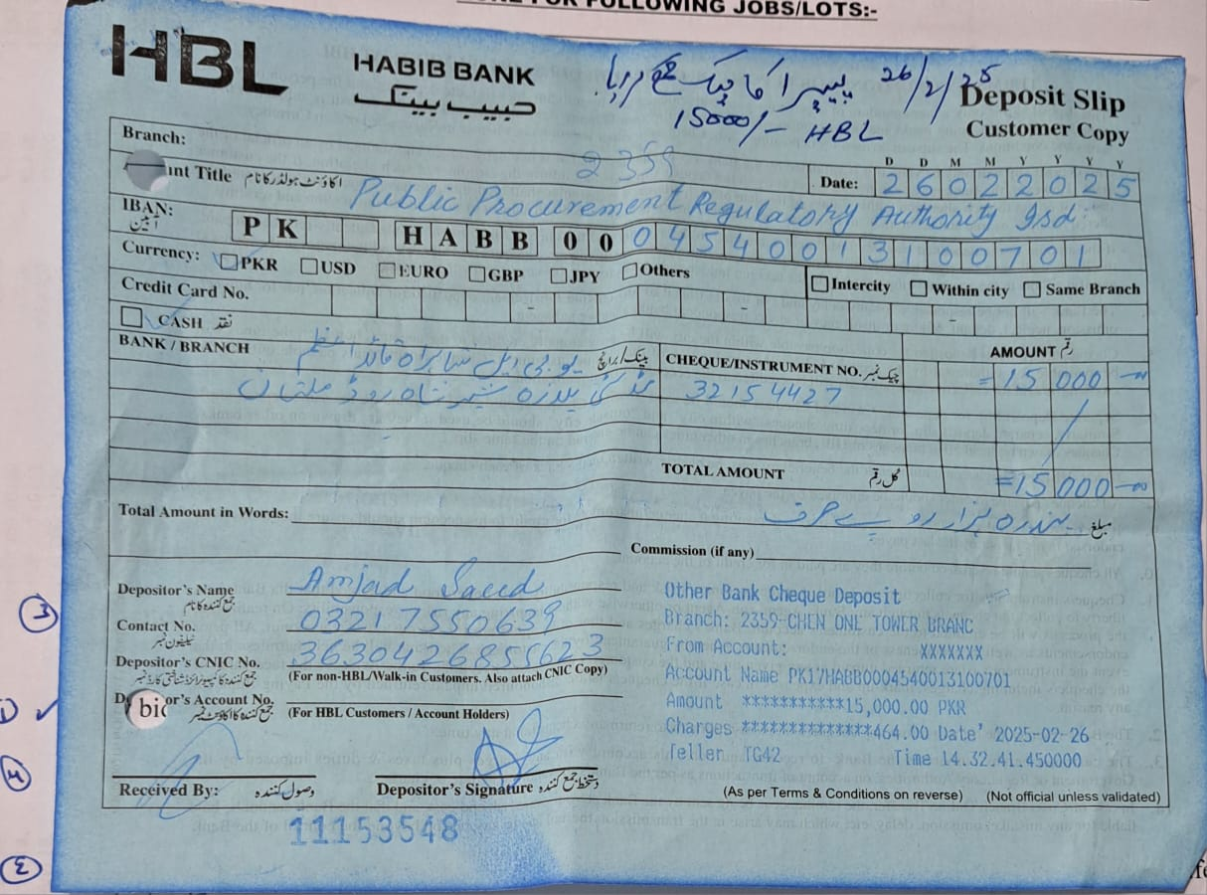

 STATE LIFE PABX : 061-9200771-3

Insurance Corporation of Pakistan FAX : 061-9200778

Multan Zone

Date.27.02.2025

**Deputy Director- (M&IMP)**

Public Procurement Regulatory Authority

(Cabinet Division),

1st Floor, F.B.C. Building G-5/2

**Islamabad.**

Sub: Advertisement of Tender Notice # HR&A/MUL/002/2025.

Dear Sir,

Kindly advertise the State Life’s enclosed Tender Notice # HR&A/MUL/002/2025 on the Website of PPRA. The said caption of tender notice has also been sent to your given E-mail address [info@ppra.org.pk](mailto:info@ppra.org.pk). Advance Tender fee deposit slip is also attached herewith.

Thanking You.

Yours truly,

Syed M. Waqas Raza

Incharge ˗ (HR&A)

CC:

Divisional Head (IT)

Please arrange to place this tender on

State Life website earliest.

 STATE LIFE PABX : 061-9200771-3

Insurance Corporation of Pakistan FAX : 061-9200778

Multan Zone

**TENDER NOTICE NO MUL/HR&A/002/2025**

**February 27, 2025**

**State Life Insurance Corporation, Multan Zone**, invites sealed bids **(through EPADS)**, Under **Single Stage, Single Envelope procedure**, from vendors/General Order Suppliers duly **INCOME TAX and GST registered firms (Active taxpayers), also registered at EPADS**, who are eligible to manage the following:-

SUPPLY OF PARTS/ COMPONENTS/ ACCESSORIES & EQUIPMENTS TO SLIC, MULTAN ZONE FOR FOLLOWING JOBS/LOTS:-

|  |  |
| --- | --- |
| Job/Lot Sr. 1 | Job Description |
| **Job No. 1** | Maintenance of Computers & Printers (including refilling/replacement of toners) **(list is available in Tender Documents as Annex-1)** |
| **Job No. 2** | Supply of Electric related hardware items  **(list is available in Tender Documents as Annex-2)** |
| **Job No. 3** | Supply of Parts and service of Air Conditioners  **(list is available in Tender Documents as Annex-3)** |
| **Job No. 4** | Supply of Furniture related hardware items and service  **(list is available in Tender Documents as Annex-4)** |

**Closing Date & Time (Bid Submission deadline): 20-03-2025 at 03:00 p.m**

**Bid Opening Date & Time: 20-03-2025 at 03:30 p.m**

1. Any bid submitted other than EPADS will not be considered.
2. E-bidding Tender documents are available for registered bidder on PPRA, EPADS and State Life website.
3. Vendor should be in a position to provide parts/ service on the same working day on emergent basis. Local vendor will be preferred.
4. All interested parties, must submit their bid security in original through Courier / Dak / By hand prior to the bid opening, failing which the tender will not be considered at all**.**
5. State Life reserves the right to reject any or all bids or proposal at any time prior to the acceptance of bids, or proposal, under provision of PPRA Rule 33.
6. In case of any clarification or query the vendors/contractors/suppliers may visit the office or contact the undersigned **061-9200678** during office working hours (9:30a.m to 4:30p.m).

**Syed M. Waqas Raza**

**Secretary Zonal Procurement Committee**

**HRA&P Department State Life Building 2nd floor**

**Chowk Nawan Shaher Abdali Road Multan Zone**