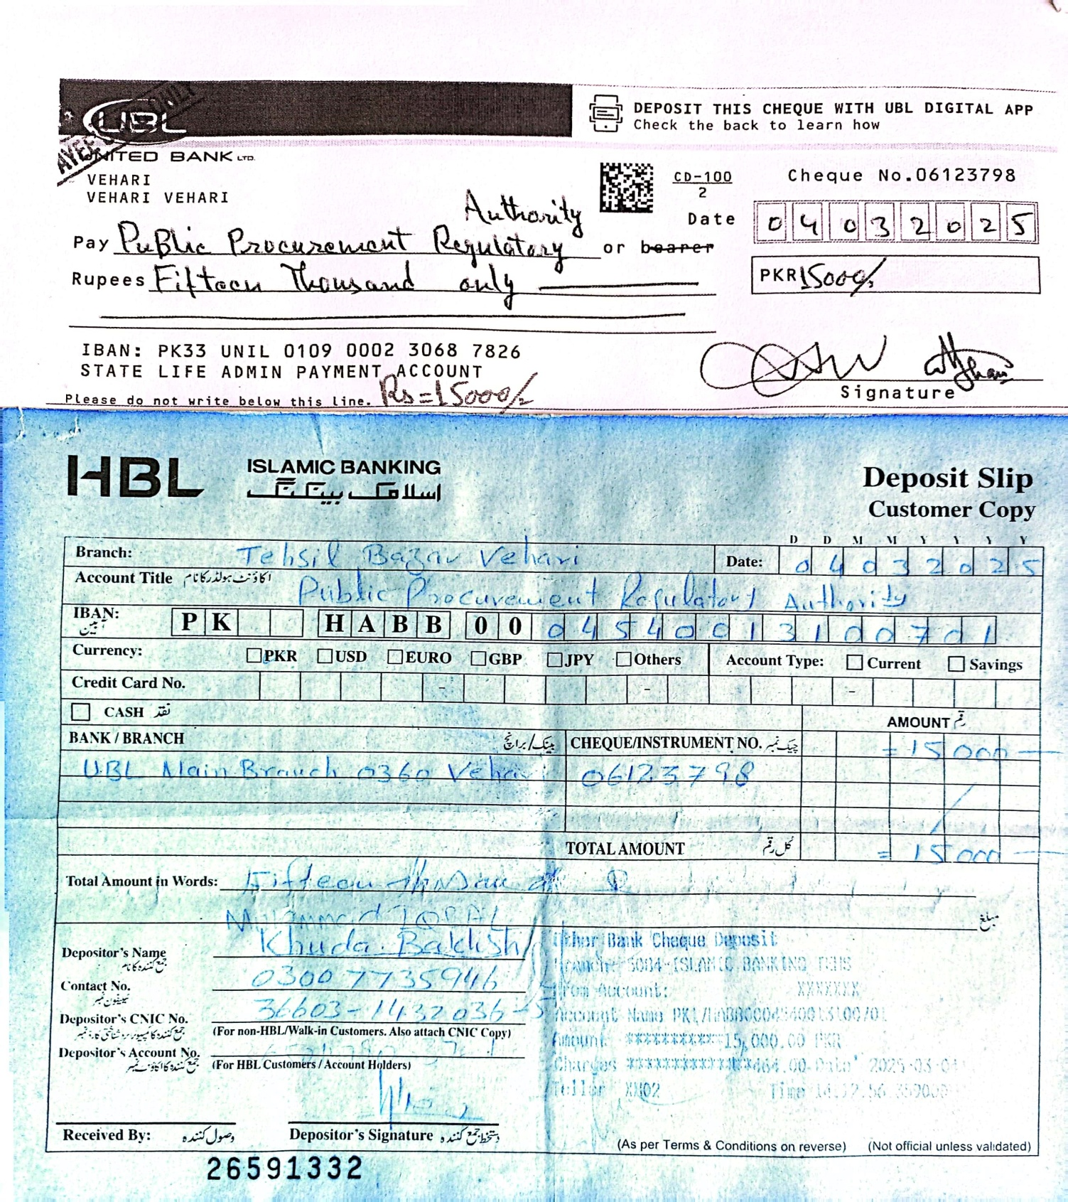



State Life Insurance Corporation Zonal Office, V Chowk, ZTBL Building, 2nd Floor, Vehari. Phone: 067-9201135
INVITATION TO BID
TENDER NOTICE NO.HR&Admin/003/2025 /VZ –March 06, 2025

SUB: CLEANING & JANITORIAL SERVICES AT STATE LIFE “V” CHOWK, ZTBL BUILDING,2ND FLOOR VEHARI

Sealed Technical & Financial bids are invited in accordance with PPRA rules, under ‘Single Stage–Two Envelopes Procedure “Through https://eprocure.gov.pk(E-PADS) from firms registered with FBR, GST and not black listed by any Govt./ Semi Govt. / MNCs and private organizations, dealing with cleaning & janitorial work with relevant material used for cleaning and janitorial services .

The Tender Documents containing detailed terms and conditions etc can be obtained by interested bidders on cash Rs. 2000/- or DD in favour of “ State Life Insurance Corporation of Pakistan”from the office of the undersigned on production of written request during 10:00 am to 02:00 pm except Saturday & Sunday.

Total covered Area is 14000 sqft with 07 wash rooms and opened space is 3000 sqft.

Tender Closing Date 27-03-2025 at 10:30 A.M. Tender Opening Date 27-03-2025 at 11:00 A.M. in the office of Incharge HR& Admin Secretary Procurement Committee Vehari Zone, in the presence of the bidders who wish to be present. This advertisement is also available on PPRA website at www.ppra.org.pk.

Contract can be cancelled by giving one month notice period.

The contract will be given for one year and it would be effective from the date of approval of Zonal Procurement Committee. In future the said contract can be renewed and would be extendable with same terms & conditions if mutually agreed by the both parties.

Abdul Rauf Ahmad
Secretary Zonal Procurement Committee
Incharge HR&Admin,State Life Office,2nd Floor,
ZTBL Building, Vehari.
Phone No. 0679201135 Cell No. 0300 7735946

State Life Insurance Corporation Zonal Office, V Chowk, ZTBL Building, 2nd Floor, Vehari. Phone: 067-9201135

TENDER DOCUMENTS FOR CLEANING & JANITORIAL SERVICES AT STATE LIFE, V CHOWK 2ND FLOOR ZTBL BUILDING, VEHARI.

MANDATORY REQUIREMENTS.

- National Tax Number from FBR with certificate
- SST Registration Certificate. .
- Undertaking on stamp paper for not black listed.
- The local Firm will be preferred.

SCOPE OF WORKS

- Sweeping and cleaning of all rooms, halls, lobbies, terraces, stairs, courtyards, parking areas, foot paths etc of complete Area as per schedule.
- Dusting and cleaning of all interior and exterior surfaces of building including stairs railing, glass doors, windows, internal partition walls, bracket fans, sign boards etc as per approved schedule.
- Cleaning and washing of bathrooms including WCs, commodes, urinals, wash basins, taps with proper disinfectant phenyl etc. as per schedule.
- Disposal of the debris, junks, fallen, litter / garbage from the offices and building compound as per municipal / KMC rules. In case any mishap, fire etc. broke out due to debris, junk not been timely disposed off the firm shall be held responsible for all the damages and its related issues and same shall be recovered from the firm at its risk and cost.
- Cleaning, clearing of manholes, sewerage lines and keeping them in running condition as and when required.
- Clear blockages in drains and toilet whenever required.
- Dusting and cleaning pictures, glazing, shelves, venetian blinds, windows as per approved schedule.
- Dusting and washing of main gates of the building (monthly).
- Maintaining / maneuvering greenery, plants of the building wherever available.

TERMS & CONDITIONS

- Security amount must be deposited equal to 2.5% of the approximate value (noted above) of the tender in shape of pay order in favor of State Life Insurance Corporation of Pakistan as earnest money which will be refunded to the un-successful parties on the spot and the refundable cash payment or CDR will be detained of the successful parties till the completion of Tender. The tenders without bid security will be rejected.
- The Janitorial contractor will be required to employ, on full time basis all the Labor required for subject work at their own cost.
- All material required for cleaning, servicing shall be provided by the contractor at their own cost on monthly basis before 5th of every month. The material shall be of best approved quality.
- All required equipment, tools and other items required to carry out the services shall be arranged by the contractor at their own expense.
- All Taxes, Government levies and charges including GST & PST shall be borne by the Contractor.
- Contractor shall be responsible for any breaking/stealing of the office material during the servicing by their staff. In case of any such happening the contractor will pay all the damages / compensations.
- The Corporation will supervise and regulate the work of the Janitorial contractor through HR&A. The contractor shall follow all instructions issued to them by the HR&A in respect of all the work as mentioned in Scope of Work.
- State Life reserves the right to accept or reject any or all Tender(s) as per PPRA Rules.
- All the payments to the workers shall be made by the contractor himself as per Govt. Laws presently in force or amended in future and the Corporation shall not be responsible in any way.
- The Corporation shall not be responsible for any loss / damage and / or injury sustained by the workers employed by the contractor during the performance of this contract.
- Contractor shall be exclusively responsible to tackle any demand raised by his workers whether financial or administrative any time.
- The Corporation reserves the right to terminate this contract at any time without assigning any reason what so ever by giving one month notice.
- The Corporation reserves the right to stop entry of any person deputed by the contractor for performance of the contract.

- If any employee of contractor found not suitable for job by concerned SLIC officer, that employee should be replaced and removed by the contractor within one day.
- The staff of contractor shall not interfere with the property or goods of the Corporation. If any damage / loss are caused to the property / goods of the Corporation by the staff of the contractor the same shall be replaced / repaired by the contractor at his own cost.
- The contractor’s staff shall follow the Corporation’s security rules strictly.
- In case of shortage in staff strength provided by the contractor, the same shall have to be covered immediately, otherwise Rs. 1.5 times of wages quoted, will be deducted per short worker /staff per day from the bill.
NOTE. The contract will be given for one year and it would be effective from the date of approval of Zonal Procurement Committee. If the services are satisfactory then the contract can be renewed and would be extendable with same terms & conditions if mutually agreed by the both parties.

MATERIAL
Phenyl, Vim, Surf, Harpic, Glass Cleaner, Viper Large and small, Phenyl Tablet, Dust Bin Large and Small, Toilet Brush, Mope, Duster, Phool Jharo, Sulphuric Acid.

SCHEDULE OF JANITORIAL SERVICES.

- Sweeping and dust mopping cleaning Minimum 02 time daily.
- Floor wet mopping with disinfectant Minimum 01 time daily.
- Garbage removal daily.
- Toilets washing (Toilets & Wash Rooms) Minimum 02 times daily.
- Area Cleaning i.e. Sweeping Footpaths & Courtyards, Parking Areas, all stairs, halls, stair railing etc. Removing of posters, banners etc. as per direction of In-charge HR&A.
- Cleaning of windows glazing (internal & external) Weekly.
- Dusting all partitions, curtains and removal of cobwebs etc. Weekly.
- Cleaning of all stains, sign boards, walls, fans, decorative pictures and fittings etc. Weekly.
- Cleaning of Manholes /Sewerage lines twice a month or whenever required.

STAFF DETAIL
Cleaner | Sweeper | Total Staff
03 | 01 | 04

Note. State Life reserve the right to vary (increase or decrease) the above strength of staff as per its requirement.

Abdul Rauf Ahmad
Secretary Zonal Procurement Committee
Incharge HR&Admin,State Life Office,2nd Floor,
ZTBL Building, Vehari.
Phone No. 0679201135 Cell No. 0300 7735946

