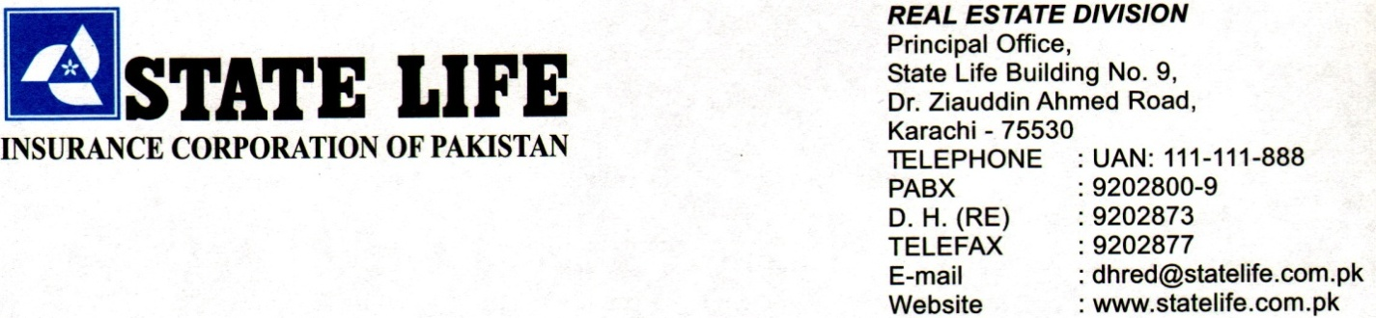

**Invitation to Bid**

**Sub: Repair Works of Air Conditioning Reciprocating Chiller (Upper Plant) in State Life Building No. 1, Karachi**

***Tender Ref # ME/O&M/CT&Compressor/SLB-1/Khi***

State Life Insurance Corporation of Pakistan (Real Estate Division) invites Electronic bids from the Contractors / Firms, registered with Income Tax and Sindh revenue Board for SST and active taxpayer of the Federal Board of Revenue.

2.Electronic Bidding Document~~s~~ containing detailed requirements,terms and conditions is available for the registeredbidders on EPADS at **(**[**www.eprocure.gov.pk**](http://www.eprocure.gov.pk)**)**

3*.* The e-bids, prepared in accordance with the instructions in the bidding document~~s~~,must be submitted through EPADSon or before 09th July 2025 at 11:00 am. Manual bids, shall not be accepted. The e-bids will be opened on the same day by using EPADS at 11:30 am.

4. Contractor (s) is advised to submit original bid Security along with copy of Bidding Documents on or before closing time on tender i-e 11:00AM on dated: 09-07-2024.

5. In terms of Rule 48 of Public Procurement Rules, 2004 Grievance Redressal Committee (GRC) is constituted for subject procurement. Notification of said GRC is provided on the procuring agency’s [*www.statelife.com.pk*](http://www.statelife.com.pk) and on EPADS at **(**[**www.eprocure.gov.pk**](http://www.eprocure.gov.pk)**).**

**Engr. Hasan Kashif (Deputy Manager-RE)**

5th Floor, State Life Building# 9, Karachi.

Office: 02199204939