Date.25.06.2025

Deputy Director- (M&IMP),
Public Procurement Regulatory Authority, (Cabinet Division),
1stFloor,F.B.C.BuildingG-5/2,

Islamabad.

Sub: Advertisement of Tender Notice# HR&A/DGK/003/2025.

Dear Sir,

Kindly advertise the State Life’s enclosed Tender Notice # HR&A/DGK/003/2025 on the Website of PPRA. The said caption of tender notice has also been sent to your given E-mail address info@ppra.org.pk.Advance Tender fee deposit slip is also attached herewith.
Thanking You. Yours truly,

Muhammad Akhtar Bhatti
Incharge˗ (HR&A)

CC:

Divisional Head (IT)
Please arrange to place this tender on State Life website earliest.

TENDERNO.HR&A/DGK/003/2025 DATED 25-06-2025

Supply of Furniture at State Life Pull Datt Dubai Plaza Dera Ghazi Khan

Sealed bids are invited from well-reputed firms registered with GST/NTN, under Single-Stage Single-Envelope Procedure (technical &Financial), for the “Supply of following items at State Life Building DG Khan.

S.No. | Item Name | Qty
1 | Revolving Chair | 14
2 | Visitor Chair Cushioned | 42
3 | Office Table 5x3 With Rack | 14
4 | Side Rack | 14
5 | Sofa Set 5-Seater (single seat) (5x14) | 70
6 | Centre Table | 14
7 | Steel Filing Cabinet with 4 drawers | 14

Detail of Date &Time of Tender is as under:

Last Date & Time for Submission of Tender Document son E-PADS | Tender’s Opening Date & Time | Bid Security
15-07-2025  10:30 am | 15-07-2025  11:30 am | 5% of Bid Amount

TERMS ANDCONDITIONS
State Life Insurance Corporation of Pakistan invites quotations through E-PADS, under Single Stage Single Envelope Procedure, from the experienced firms / contractors of the filed registered with Income Tax Department & who are an Active Taxpayers List of the Federal Board of Revenue (FBR) and eligible to provide the ʺFurniture itemsʺ for State Life Insurance Dera Ghazi Khan Zone Dubai Plaza Pull Datt Dera Ghazi Khan.
Bidding Documents, containing detailed terms & conditions etc. are available for download on EPADS website http://eprocure.gov.pkfree of cost.

The bids prepared in accordance with the instructions in the bidding documents, must be submitted through EPADS on or before 15-07-2025 up to 11:00 A.M. Bids will be opened on same day at 11:30 A.M.

Contractor is advised to submit original bid security & copy of bidding documents on or before 15-07-2025 at 11:00 A.M. in the office of undersigned.

This advertisement is also available on State Life Website www.statelife.com.pk, however the bids shall be submitted through EPADS. Any bid submitted other than EPADS will not be considered.

State Life Insurance Corporation of Pakistan reserves the rights to accept / reject all bids in accordance with PPRA rules.

For further details the undersigned may be contacted during working hours in person or telephonically on phone No. 064- 9260036.

Muhammad Akhtar Bhatti
Secretary–Procurement Committee HR&A - Department
Room No-4
Dubai Plaza Dera Ghazi Khan

TENDERDOCUMENT

Procurement of Furniture and Fixtures State Life DGK Zone
Sealed Technical& Financial bids are invited in accordance with PPRA rules, under ʺSingle Stage–Single Envelope Procedure (Technical& Financial)ʺ Through https://eprocure.gov.pk(E-PADS)from vendors registered with GST/Income Tax Department, own offices and phone/fax numbers, for the Procurement of following Furniture Items.

The sealed bids should be submitted through E-pads on date as per mentioned on E- pads at 11:00 AM and bids will be opened on the same day at 11:30 AM in the presence of the bidders or their representatives.

Details of Furniture and Fixtures with Specification

Sr.  No. | Items | Sample | Qty
01 | Revolving Chair Cushioned:  - Color: Brown  - Leather seat and back  - Adjustable height  - Tilt mechanism  - HD Aluminum wooden base ,HD mute wheels  - HighqualitycylinderGaslifter120mm  - Seatdepth20ʺ,Seatwidth21ʺ | 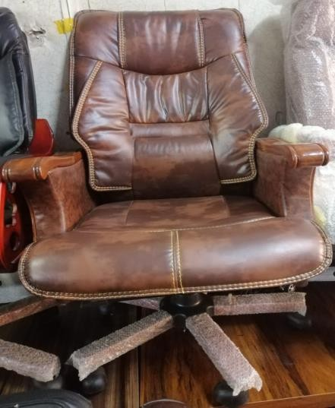 | 14
02 | Side Rack:  - Mede with Shesham Veneer  - Top Formica same color  - Computer tray with draw and locker  - Wooden golasheshamonall side  - Sample available in office | 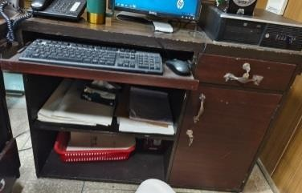 | 14

03 | OfficeTable 5 x 3  - Made with Veneer Sheesham top Formica Same Color  - 03drawswithchannel with lock Fine quality  - footrest  - Sheesham wooden gola on all side  - Sample available in office | 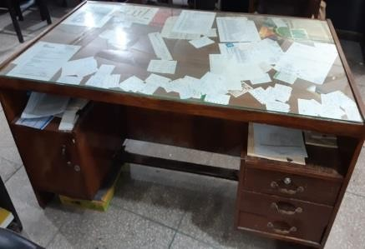 | 14
04 | Sofa Set(01-Seater)  - Poshish Regzine (Imported)(Brown)  - Jaman Frame  - Foam:Molty4ʺ1stquality  - Foot: wood with Brown Stain  - Tyre Pattit thick jal with tat with spring heavy duty  - Sample available in Office. | 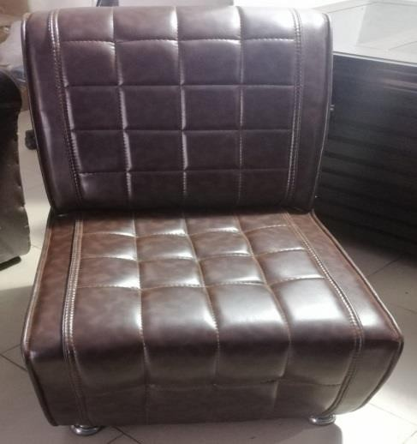 | 20

05 | Steel FilingCabinetwith4Drawers:  - Made using Prime MS Sheets  - Equipped Central Locking system  - Each draweris fitted with acard frame  - High-Quality Paint Finish  - Powder Coat Paint Finish  - Combination lock instead of key lock  - High-Quality Industrial Paint Finish for Durability  - Customizable configuration(4Drawers) | 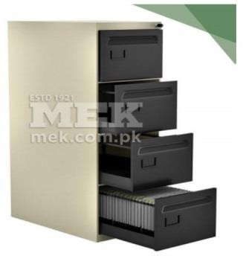 | 4
06 | Centre Table  - Made with shesham wood  - Tinted top glass 6mm  - Glass polish same wood color  - High-Quality | 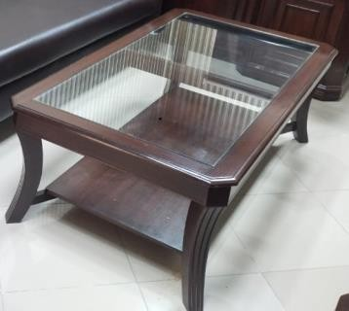 | 04
07 | Visitor Chair Cushioned  - Made with shesham wood Frame  - Leather Poshish brown  - Glass polish same color  - Molty foam seat 3ʺ 1stquality  - Tyre patti thick jal with Tat | 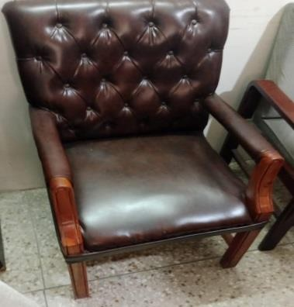 | 12

Terms& Conditions:

- Proposals shall accompany a Pay Order/Bank Draft/CDR of not less than 05%in favor of State Life Insurance Corporation of Pakistan as earnest money which may be released after Final Evaluation of unsuccessful firm/company.
- Successful Firm/Company must submit Rs.10, 000/-as Performance Guarantee after award of work order which shall be returned after expiry of warranty period of supplied items and shall be subject to deductions on account of unsatisfactory delivery / performance.
- No bid will be accepted without earnest money/CDR which is05%.
- Bid will not be accepted if a vender is under litigation with State Life or blacklisted by any of Provincial or Federal Government Department, Agency, Organization or autonomous body or Private Sector Organization anywhere in Pakistan. Personal influence will also disqualify bidders.
- All the bids must include G.S.T. and all other applicable taxes.
- The Bids Prices shall be lowest quoted on Item wise.
- All Submitted bids must be duly signed and stamped.
- The selected firms will provide items within 30 days from receipt of supply orders as per sample to be approved by SLIC. If supply is not made in due time, a fine of 0.5% of contract value per delayed day will be charged to the firm. If supply/ installation are delayed beyond 30 days from receipt of supply order, the earnest money will be confiscated.
- The approved bidder immediately after receipt of Work Order shall provide a sample of the Item to SLIC for scrutiny and approval. After the sample is approved, the bidder shall supply/ install rest of the items as per approved sample.
- SLIC can increase or decrease the quantity of items to be purchased and also reserve the right to accept or reject any or all tenders/Bids in line with PPRA rules.
- Bid validity period up to 31.12.2025.
- No advance payment will be made. Payment will be processed upon satisfactory delivery/ Installation of items. In case of non-compliance or failure of execution of order within the specified time or supply of sub- standard items and Services, Performance Guarantee shall be for feitedin favor of the Corporation.

The supplier will be responsible to assemble/ install /deliver/Ready to use items as per requirement and in case of failure to maintain quality in installation, the same will be fixed at his risk and cost besides penalty as may be imposed by Competent Authority in SLIC.
- The sealed bids envelope should bear the phrase of “Procurement of Furniture & Fixture for State Life DGK Zone”.
- Competent Authority reserves the right to reject all bids or proposal any time prior to the acceptance of a bid or proposal. However, State Life shall upon request communicate to any supplier who submitted a bid or proposal, the grounds for its rejection of all bids or proposals.

Undertaking:

We here by confirm to have read all the terms and conditions carefully mentioned in the tender documents and we agree to a bid by all those conditions.

Signature and stamp:
(Sign and stamp by Vendor)

