**STATE LIFE INSURANCE CORPORATION OF PAKISTAN, LAHORE ZONE CENTRAL**

**TENDER DOCUMENTS**

**TENDER ENQUIRY # 07/LZC/FIELD/2025**

**FURNITURE ITEMS & AIR CONDITIONERS**

|  |  |  |  |  |  |  |
| --- | --- | --- | --- | --- | --- | --- |
| **Lots** | **Job Description** | **Qty** | **Sample for quoting rates** | | | |
| **Cost per unit in Rs.** | **GST per unit in Rs.** | **Total Cost per unit with Taxes (in Rs.)** | **Total Cost with all Taxes**  **(in Rs.)** |
| 01 | **Furniture Set** **(SMALL)**  **One Set includes:-**  01 Office Table 4'x3' with side rack (with top glasses),  01 Revolving Chair,  01 File Cabinet (4 Drawers),  02 Visitor Chairs | **25 set** |  |  |  |  |
| 02 | **Furniture Set** **(LARGE)**  **One Set includes:-**  01 Office Table 5'x3' with side rack (with top glasses),  01 Revolving Chair,  01 File Cabinet (4 Drawers),  03 Visitor Chairs,  01 Central Table with top glass,  01 Sofa Set-five seater (3+1+1) | **05 set** |  |  |  |  |
| 03 | **Split Air Conditioner** 1.5 Ton  PEL, DAWLANCE or equivalent | **36**  **units** |  |  |  |  |
|  | **Total Amount Rs. (in Figures)** |  |  | | |  |

**Total Amount Rs.** (in words) _ _ _ _ _ _ _ _ _ _ _ _ _ _ _ _ _ _ _ _ _ _ _ _ _ _ _ __ _ _ _ _ _ _ _ _ _ _ _ _

**Technical Evaluation Criteria/Evaluation Sheet**: Attached as (Annexure-1)

**Technical Specifications**: Attached as (Annexure-2) with sample pictures

**Terms & Conditions:**

1. Bidders are required to upload their bids on EPADS system as per laid down PPRA procedure for **Single Stage Single Envelope** method.
2. Bids will be opened and downloaded from EPADS on the opening date and time as given above. Proposals of technical qualified and found most advantageous bidders will be announced on EPADS system accordingly and will be accepted after completion of all codal formalities.
3. Total estimated Cost is Rs. 9,900,000/-. (Lot 1 Rs.2,575,000/-, Lot 2 Rs. 920,000/- Lot 3 Rs. 64,05,000/-)
4. Bid Security amount (Earnest money) including tax Rs.495,000/- as per lots

**(Lot 1 Rs. 128,750/-, Lot 2 Rs. 46,000/-, Lot 3 Rs. 320,250/-)**

in the shape of CDR/Pay order favoring  **“State Life Insurance Corporation of Pakistan”** must be submitted by bidders at the address below before closing time, else bid will be rejected.

1. The Bid Security will be returned to un-successful bidders after completion of formal procedure and to successful bidder immediately after completion of work. However, successful bidder will be required to submit performance guarantee of 5% (value of Job Order) in shape of bank guarantee (valid for at least 6 months) in favor of State Life Insurance Corporation of Pakistan which shall be released after expiry of six month after completion of job.
2. In case wherein on bid opening day, holiday announced by prevailing Government or Zonal Office could not operate due to unavoidable reasons, then bid opening meeting shall be held on very next working day.
3. **SINGLE STAGE, SINGLE ENVELOPE PROCEDURE** will be followed as per PPRA Rules 2004 for evaluation of bidders.
4. Approximate time of procurement process is 45 days. Order shall be placed to successful bidder after completion of all codal formalities. Approximate payment time shall be 2 weeks after successful delivery as per tender requirements.
5. Each Lot of item (Lot Sr. 1 to Lot Sr. 3) shall be evaluated separately.
6. However, Lot Sr. no 1 (One Job) and Lot Sr. 2 (One Job) are complete set of jobs, no bidder shall be allowed to exclude or skip any item from furniture Lot 1 and 2. Bidder quoting for Lot Sr. 1, must quote for complete set (Small Furniture set) and same for Lot Sr. 2. Otherwise in case of income quotation, the bidder shall be technically disqualified for entire furniture set.
7. Overall lowest bidder for complete furniture set if found technically qualified shall be successful for that furniture set. (Lot 1 and Lot 2)
8. Successful bidder will have to start supply/job within 3 days after confirmed work order and must complete the supply in all respects within 10 working days; otherwise retention money (CDR) will be forfeited. In addition to this liquidity damages as penalty may be imposed after expiry of 10 working days, at 1% per day of the total purchased order value.
9. Warranty of items must be accordingly as mentioned in Annex-2 for any type of defect, with free repair/replacement of item/parts within warranty period.
10. Quote only **single rate for each item**, which must be irrevocable, unconditional & inclusive of all taxes & expenses (if any).
11. Validity of the rates/bid must be at least 90 days from the date of opening of bid, which may be extendable with mutual consent.
12. Competent Authority reserves the right to reject/cancel/withdraw any/all bid(s) or proposals at any time before award of contract without assigning any reason thereof.
13. Lowest vendor must supply samples of furniture items to State Life before issuance of purchase order without fail. Sample may include frames (semi-completed) or finished (fully completed).
14. In case vendor failed to perform as per requirements or provide other than required items, or found any document as false or fabricated, State Life reserves the right to blacklist the vendor.
15. Quantity of items may be increase/decrease by competent authority before placement of order.
16. Eligibility criteria mentioned below must be observed and fulfilled. An Affidavit of Rs. 100 (non judicial stamp paper) in this regard must be attached with the bid.

**Eligibility of Applicants**

We **M/s ______________________________________** undertake that,

1. We are registered company/firm as per FBR Record, having active filling status.
2. We are solvent company/firm and not in the process of bankruptcy.
3. We have never been convicted for an offence concerning the professional conduct.
4. We have fulfilled all obligations related to payment of taxes to the Govt of Pakistan.
5. We were never found guilty of serious mis-interpretation/mis-representation of facts in supplying information in past nor providing herewith as such.
6. We assure that quoted item will be brand new; parts of offered model shall be available in open market for at least 3 years.

**[SECRETARY]**

Zonal Procurement Committee (ZPC),

HRA&P Department,

State Life Insurance Corporation of Pakistan

Central Zone Lahore, 4th Floor Building No.6,

4-Ghazi Ilm -ud- Din Shaheed Road (Lytton Road), Lahore.

Phone # 042-99210594, Cell no. 0335-1412976

**Technical Evaluation Criteria (Annexure-1)**

Technical bids shall be evaluated on the basis of following points:-

1. Specifications of item mentioned in bid will be compared with specifications mentioned in tender documents along with specifications of required model/brand. In case of incomplete information, clarification shall be obtained from bidders. A bid having lower of specifications or lower of required brand’s specifications then it shall be rejected technically.
2. Warranty must be according to requirement.
3. Satisfactory reports or work orders from the previous reputed clients (at least 2) of the quoted item must be provided with bid.
4. After sales services and parts availability of quoted product/item in open market shall also be considered for technical evaluation of Air Conditioners.
5. Bidder has NTN & GST Registration Certificate.
6. Bidder has provided affidavit of Rs. 100/- (Non-blacklisted etc) in the light of Para 20 of Terms & Conditions of Tender Documents.
7. All points of Technical Evaluation Criteria, Terms & Conditions are compulsory. Failing in any point/criteria, may result in rejection of the bidder technically.

**Technical Evaluation Sheet/Check list**

|  |  |  |
| --- | --- | --- |
| **Sr.** | **Criteria of Technical Evaluation** | **Yes / No** |
| 1 | Tax Registration Certificates provided with bid as per Tender Documents. |  |
| 2 | Satisfactory reports/work orders from previous 2 clients for same nature of work. |  |
| 3 | Affidavit of Rs. 100 observing eligibility criteria as per Tender Requirements |  |
| 4 | Warranty certificate as per tender documents. |  |
| 5 | Certified that quoted items shall be brand new and parts of offered item shall be available in open market for at least 3 years. (Especially for ACs) |  |
| 6 | Sign and stamp against specifications mentioned for each quoted item, which means bidders understand the need of Procuring Agency (SLIC) and agrees to provide required item as per need. |  |
| 7 | Certificate Provided that bidder accepts all the terms & conditions of this Tender for completion of job as per job description of tender documents. |  |
| 8 | CDR Submitted as per required amount lot wise. |  |

**Single NO may result is rejection of bidder technically.**

***Note: Provide all required information with Bid on letter-head pages with sign & stamp.***

**[SECRETARY]**

Zonal Procurement Committee (ZPC),

HRA&P Department,

State Life Insurance Corporation of Pakistan

Central Zone Lahore, 4th Floor Building No.6,

4-Ghazi Ilm -ud- Din Shaheed Road (Lytton Road), Lahore.

Phone # 042-99210594

Cell no. 0335-1412976

**Technical Specifications (Annexure-II)**

**ITEM SR. # 01, FURNITURE SET (SMALL)**

**Office Table Size (4' x 3') with Side Rack includes top glass**

***As per sample picture provided (Executive look), with following features:-***

* 8 mm top glass grinded at side edges and completely polished.
* **Strong connected structure of Solid Sheesham wood** deep engraved lines as in sample picture.
* Top made of Sheesham winner board (double side) 1.5'' or (1x1/2'') thickness. Other structure made of sheesham winner board (double side) 3/4'' thickness.
* Use of best quality stainless steel nails, glue imported quality etc for manufacturing.
* Three drawers of standard size at right side with freely moveable channels of best quality heavy duty/stainless steel.
* Standard height, Durable Strong base with extra sheesham base for strength.
* Squared space for monogram (10 inch x 10 inch) specifically to be made at front side middle with deep engraved 4mm, edges of that space to be covered with 1/2 inches thick gola patti (fancy takkar gola).
* State Life monogram made of standard aluminum plate (10 inch x 10 inch) to be fixed at front side middle (inside specifically allocated space) with round cap nail properly drilled.
* Imported quality heavy duty lock for top drawer.
* Drawer handle made of stainless steel heavy with fancy design.
* Color shall be dark brown best quality polish glossy finishing (Shining) as per sample picture, shall be finalized at the time of supply order.
* Warranty: At least 3 years onsite free repair & labor warranty.

**Specifications of Side Rack (Standard size) with top glass**

* + Side Rack compatibility eg. Design/shape/height and color must be similar to Office Table.
  + covered with 8 mm glass , grinded at side edges and completely polished ,
  + **Strong connected structure of Solid Sheesham wood**
  + Contain Keyboard Tray with railing imported quality & tray made of pure Sheesham wood.
  + Contain CPU Box with wires holes at back side for Keyboard, CPU & Mouse.
  + Should be comfortable and easy for computer operations i.e., reasonable gap between top and keyboard tray and space for CPU etc
  + Contain one shelf at center other than CPU box.
  + Warranty: At least 3 years onsite free repair & labor warranty.

**Bidder’s sign with stamp_____________________**

**Revolving Chair BOSS-B-514 or Equivalent**

As per sample picture

* Mash back as per sample
* standard size seat & back with fency style arms,
* Comfortable and fancy design of back of chair.
* Hydraulic machine, heavy duty S/S base with imported five wheels.
* Standard height of as per sample shown.
* Warranty: At least 3 years onsite free repair & labor warranty. Free replacement of base warranty.

**Bidder’s sign with stamp_____________________**

**File Cabinet 4 Drawers**

As per sample shown.

* ***Gauge 18 or better***, 4 drawers standard size (as per sample) with smooth heavy duty railing system,
* Single heavy duty lock or Separate Locks heavy duty for each drawer having two keys each.
* Best quality gray hammered paint as per sample,
* Strong bottom/base & accurate balance on floor.
* Dimensions as per sample shown. (sample also available at site)
* Warranty: At least 3 years onsite free repair & labor warranty. Free replacement of damage locks within warranty period.

**Bidder’s sign with stamp_____________________**

**Visitor Chairs SOGO or equivalent**

As per sample picture

* ***Silver coated iron frame*** glossy look with standard size seat and back with arms rest,
* Pipe 16 gauge or better SS Pipe,
* Pipe 1" round shape
* Use of extra apron/spindles/cross stretcher & corner brackets for strong frame,
* Accurate balance of chair on floor with standard height.
* Seat and back foam 1st quality cushioned (molty or equivalent) with fine quality leatherette with at least 3 inch width of seat and 2 inch width of Back. Design as per sample.
* Dimension as per sample shown.
* Warranty: At least 3 years onsite free repair & maintenance & labor warranty.

**Bidder’s sign with stamp_____________________**

**Item Sr. # 02, Furniture Set (Large)**

**Office Table 5'x3' with Side Rack (with top glass)**

***As per sample picture provided (Executive look), with following features:-***

* 8 mm top glass grinded at side edges and completely polished.
* **Strong connected structure of Solid Sheesham wood** deep engraved lines as in sample picture.
* Top made of Sheesham winner board (double side) 1.5'' or (1x1/2'') thickness. Other structure made of sheesham winner board (double side) 3/4'' thickness.
* Use of best quality stainless steel nails, glue imported quality etc for manufacturing. Readymade table shall not be accepted.
* Having three drawers of standard size at right side with freely moveable channels of best quality heavy duty/stainless steel.
* Standard height, Durable Strong base with extra wooden larrs for strength.
* Squared space for monogram (12 inch x 12 inch) specifically to be made at front side middle with deep engraved 4mm, edges of that space to be covered with 1/2 inches thick gola patti (fancy takkar gola).
* State Life monogram made of standard aluminum plate (12 inch x 12 inch) to be fixed at front side middle (inside specifically allocated space) with round cap nail properly drilled.
* Imported quality heavy duty lock for top drawer.
* Drawer handle made of stainless steel heavy with fancy design.
* Color shall be dark brown best quality polish finishing (Shining) as per sample picture, shall be finalized at the time of supply order.
* Warranty: At least 3 years onsite free repair & labor warranty.

**Specifications of Side Rack (Standard size) with top glass**

* + Side Rack compatibility eg. Design/shape/height and color must be similar to Office Table.
  + covered with 8 mm glass , grinded at side edges and completely polished ,
  + **Strong connected structure of Solid Sheesham winner board**
  + Contain Keyboard Tray with railing imported quality & tray made of pure Sheesham wood.
  + Contain CPU Box with wires holes at back side for Keyboard, CPU & Mouse.
  + Should be comfortable and easy for computer operations i.e., reasonable gap between top and keyboard tray and space for CPU etc
  + Contain one shelf at center other than CPU box.
  + Warranty: At least 3 years onsite free repair & labor warranty.

**Bidder’s sign with stamp_____________________**

**Revolving Chair BOSS-B-543 or Equivalent**

As per sample picture

* Mash back as per sample
* standard size seat & back with fency style arms,
* Comfortable and fancy design of back of chair.
* Hydraulic machine, heavy duty S/S base with imported five wheels.
* Standard height of as per sample shown.
* Warranty: At least 3 years onsite free repair & labor warranty. Free replacement of base warranty.

**Bidder’s sign with stamp_____________________**

**File Cabinet 4 Drawers**

As per sample shown.

* ***Gauge 18 or better***, 4 drawers standard size (as per sample) with smooth heavy duty railing system,
* Single heavy duty lock or Separate Locks heavy duty for each drawer having two keys each.
* Best quality gray hammered paint as per sample,
* Strong bottom/base & accurate balance on floor.
* Dimensions as per sample shown. (sample also available at site)
* Warranty: At least 3 years onsite free repair & labor warranty. Free replacement of damage locks within warranty period.

**Bidder’s sign with stamp_____________________**

**Visitor Chairs SOGO or equivalent**

As per sample picture

* ***Silver coated iron frame*** glossy look with standard size seat and back with arms rest,
* Pipe 16 gauge or better SS Pipe,
* Pipe 1" round shape
* Use of extra apron/spindles/cross stretcher & corner brackets for strong frame,
* Accurate balance of chair on floor with standard height.
* Seat and back foam 1st quality cushioned (molty or equivalent) with fine quality leatherette with at least 3 inch width of seat and 2 inch width of Back. Design as per sample.
* Dimension as per sample shown.
* Warranty: At least 3 years onsite free repair & maintenance & labor warranty.

**Bidder’s sign with stamp_____________________**

**Centre Table with top glass**

As per sample picture design include following features.

* Size with glass (4 feet x 2 feet) with frame size as standard.
* Frames made of solid sheesham wood with fancy designing.
* Finishing of Frames must be smooth with best quality wooden polish/varnish.
* Top covered with 8 mm glass, grinded at side edges and completely polished, use of good quality rubber catchers below glasses for holding.
* Color/polish same as of Office table and side rack.
* Warranty: At least 3 years onsite free repair & labor warranty.

**Bidder’s sign with stamp_____________________**

**Sofa Set, Five Seater (3+1+1)**

As per sample picture, must include following features.

* One Set include (one) three seater, (two) single seaters.
* **Solid frame/structure made of solid Sheesham wood without arms,**
* Standard height, standard size seat and back,
* Use of best quality durable tyre patti for cushion seat base.
* Use of sheesham corner brackets for inside frame,
* **Best quality cushion** (Molti foam or equivalent) on Seat and back covered with best quality leather rite properly stitched on entire sides.
* Base of Sofa Set to be made with solid Sheesham wood with four legs covered with Rexene professional and smooth finishing.
* Warranty: At least 3 years onsite free repair & labor warranty.
* Color of Rexene shall be Dark Brown exactly similar to Revolving Chair and visitor chairs.

**Bidder’s sign with stamp_____________________**

**Item Sr. no 03. (Split Air Conditioners 1.5 ton)**

PEL, Dawlance or equivalent with following specifications:-

* 18000 BTU
* Wall mounted with Remote Control
* Color white
* Heat And Cool Features-5D Inverter technology
* T3 Compressor
* Refrigerant Type as per company policy.
* Standard Installation kit i.e., 10 feet pure copper pipe, 10 feet pure copper wire as per company policy.
* With Indoor and outdoor brackets.
* Installation of ACs at site(s) shall be responsibility of bidder at their own cost.
* Fresh Stock/latest model Air Conditioner.
* Warranty as per company policy subject to minimum 1 year parts, PCB kit 4 year, 1 year service & 10 years compressor warranty, 3 years PCB Kit warranty.
* Warranty shall be claimed through bidder, free of cost.

**Bidder’s sign with stamp_____________________**

**[SECRETARY]**

Zonal Procurement Committee (ZPC),

HRA&P Department,

State Life Insurance Corporation of Pakistan

Central Zone Lahore, 4th Floor Building No.6,

4-Ghazi Ilm -ud- Din Shaheed Road (Lytton Road), Lahore.

Phone # 042-99210594

Cell no. 0335-1412976

**Sample Pictures**

**Item Sr. 1 Furniture Set (Small)**

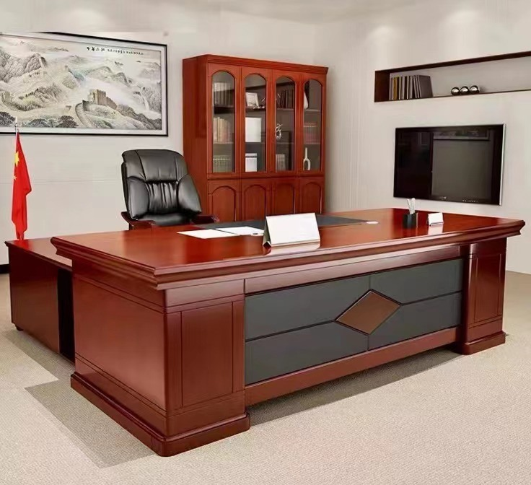

Table 4' x 3' with side rack with top glass

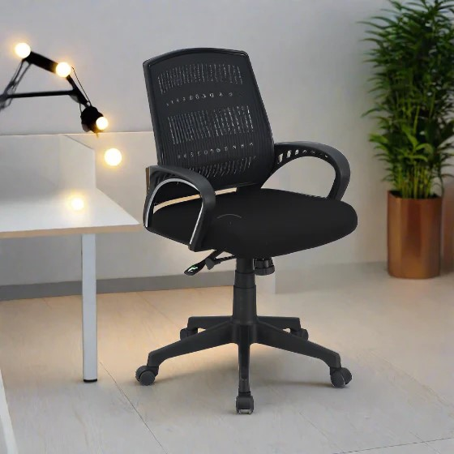

Revolving Chair BOSS-B-514 or equivalent

**Visitor Chairs SOGO or equivalent (Small furniture set)**

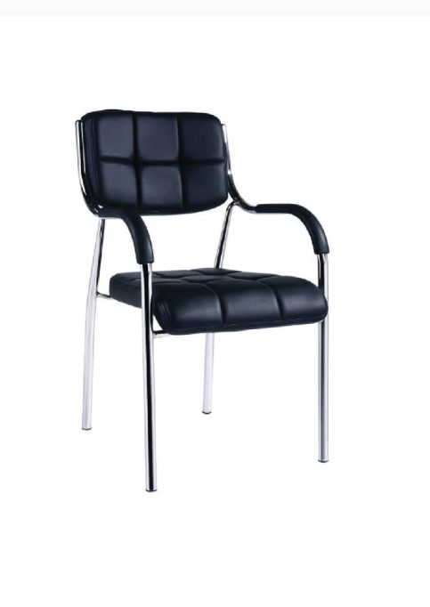

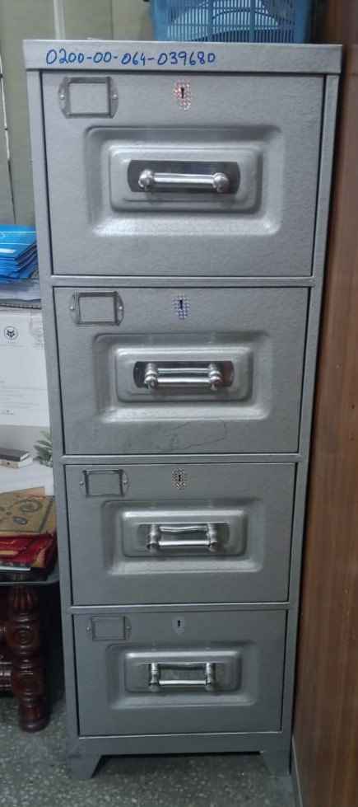

File Cabinet

**Item Sr No 2. Furniture Set (Large)**



Table 5' x 3' with side rack with top glass

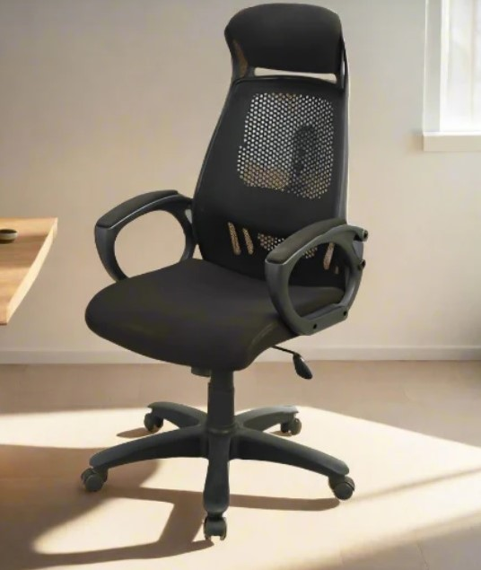

Revolving Chair Cushioned (BOSS-B-543 or Equivalent)

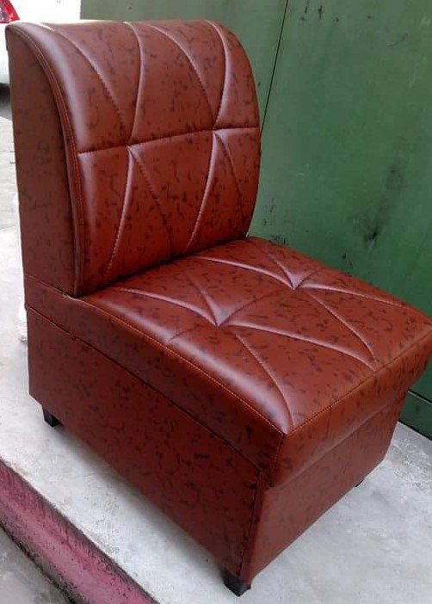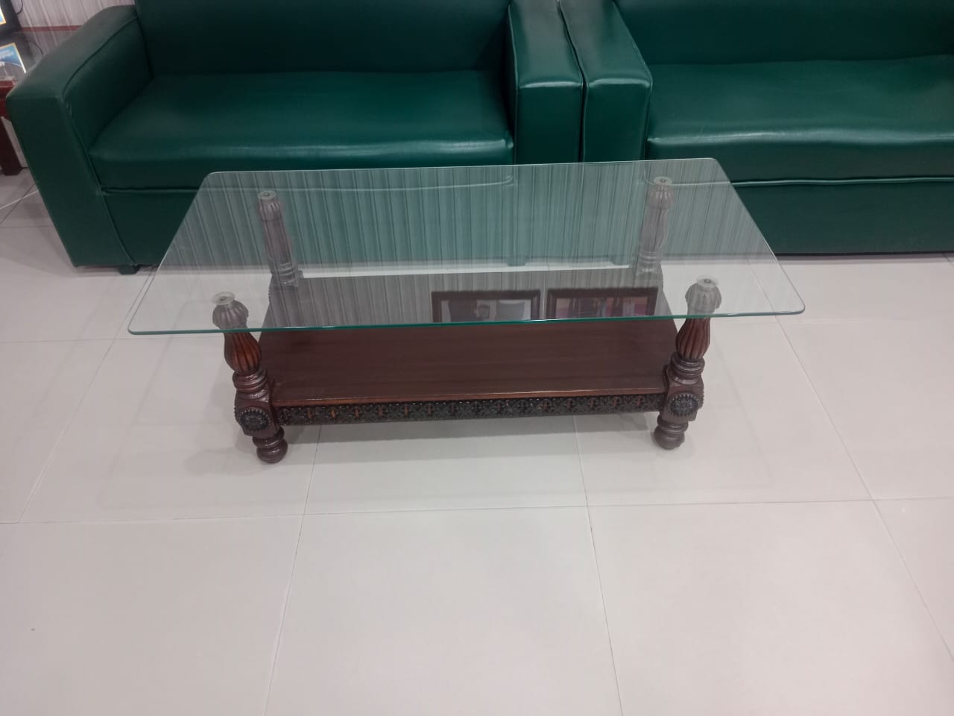

**Centre Table with top glass**

**Sofa Set 5 Seater (3+1+1)**



**Visitor Chairs SOGO or equivalent**

**(Large furniture set)**



**File Cabinet**

**[SECRETARY]**

Zonal Procurement Committee (ZPC),

HRA&P Department,

State Life Insurance Corporation of Pakistan

Central Zone Lahore, 4th Floor Building No.6,

4-Ghazi Ilm -ud- Din Shaheed Road (Lytton Road), Lahore.

Phone # 042-99210594

Cell no. 0335-1412976