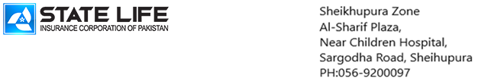 Zonal Office Narowal

Tender Notice # SLIC/NWL/FURNITURE/A.MS & Sector Heads/01/2025
State Life Insurance Corporation of Pakistan (SLIC) Narowal Zone, invites bids for Furniture Items supply at State Life Zonal Office, Sardar Plaza, College Road Narowal in accordance with EPADS procurement system of PPRA from well recognized firms/contractors having past experience of Furniture Supplies. Intended bidders must be registered with relevant Federal/ Provincial tax Departments and having its own offices and telephone/Fax no (if found contrary Bid will be rejected).
Title of Work | Last date & time for submission of bids | Date & Time for Opening of Bids
Furniture Items –Office Tables, Revolving Chairs Cushioned High back, Visitor Chairs Cushioned, Sofa Seats, Center Table, File Cabinets (Steel) 4-Drawers. | 14-11-2025  up to  11:00 am | 14-11-2025  at  11:30 am
- Bids may accompany a Pay Order / Bank Draft of Rs.60,000/- in favor of State Life Insurance Corporation of Pakistan as earnest money, no Bid will be accepted without earnest money.
- Bids will be received only through PPRA’s E-PADS System/Portal .

- Single Stage - Single Envelope procedure will be followed.

- Bids will be opened on given date and time and will be evaluated as per Terms and Conditions mentioned in the Tender Documents, Bids will be rejected if not confirm to specified requirements according to Tender Documents

- The validity period of Bid will be 90 Days from the date of bids opening date and may be extendable on mutual consent

- The quoted rates should be inclusive of all applicable Government Taxes

- Bidder must be active GST Registered as well as Active Income Tax Payer. GST and W.H Tax will be deducted as from the Source as per the Government rules.

- Bidding documents are available on EPAD and PPRA official website also on State Life Insurance Corporation’s Official website which can be downloaded by the interested parties.

- Competent Authority reserves the right to reject all bids or proposals at any time prior to acceptance of a bid or proposal. However State Life on request shall communicate to any supplier or contractor who submitted a bid or proposal, the grounds for its rejections of all bids or proposals.

Sh. Tariq Mehmood)
Zonal Incharge (HR&Admin)
State Life Insurance Corporation of Pakistan Zonal Office,
Sardar Plaza College Road Narowal
Phone: 0542-920096

Zonal Office Narowal

TENDER DOCUMENTS
Tender Notice NO.
SLIC/NWL/FURNITURE/A.Ms & SECTOR HEADS/01/2025

Supply of Furniture Items (Office Tables, Chairs, Sofa Sets, Steel File Cabinets 4-Drawers) at State Life Zonal Office, Sardar Plaza, College Road, Narowal City, as detailed below

S# | Specification of Items | Qty | Sample Picture
1 | Office Table with Side Rack:  Specifications: Table Size 5x3ft. as per sample picture provided (executive look), with following features -  - 8 mm top glass grinded at side edges and completely polished.  - Strong connected structure of A- Grade Solid Sheesham Vineer board deep engraved lines as in sample picture.  - Top made of Sheesham Vineer board (double side) 1.5" or (1x1/2") thickness. Other structure made of Sheesham Vineer board (double side) 3/4" thickness.  - Use of best quality stainless steel nails, glue imported quality etc for manufacturing. Readymade table shall not be accepted. Our Committee will visit the workshop during construction of Furniture Items  - Having three drawers of Size Length 20 Inches, Width 16 Inch size at right side freely moveable on heavy duty channels of stainless steel.  - Standard height, Durable Strong Base with extra Wooden Slabs.  - Rectangle space for monogram (size as below) specifically be made at front side middle with deep engraved 4mm, edges of that space to be covered with 1/2 inches thick “gola patti” (fancy Takkar Gola).  - A monogram made of standard aluminum plate (length = 18 inch and width = 12 inch) to be fixed at front side (specifically allocated space) with round cap nail properly drilled. Sample of monogram shall be provided at time of supply order.  - Imported quality heavy duty separate locks for top two drawers.  - Drawer handle made of stainless steel heavy with fancy design.  - Color shall be dark brown as per sample picture, shall be finalized at the time of supply order.  - Side Rack Size: 3X1.5ft. height should be according to Table Height having 02 Portions with Two Shelves, one with door with lock and one open portion. Colour, polish matching with Table. | 12 | 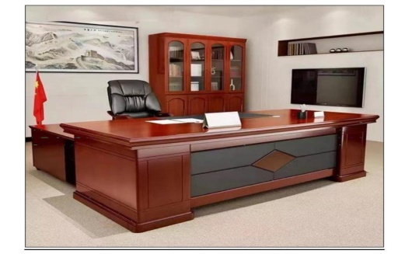
2 | Revolving Chair  Specifications: Dimensions: Width 27 Inch, Depth 22 Inch, Seat Height 29 Inch, Adjustable Height Range: 20 inches (minimum) to higher level as per adjustment.  Design: High backrest for enhanced head and back support.  Color Options: Brown and Grey.  Durable dual wheel casters for smooth mobility. Single ply construction.  Machine, Base and Wheels of Revolving Chair should be A-Grade Durable Quality.  Armrest should be cushioned. | 12 | 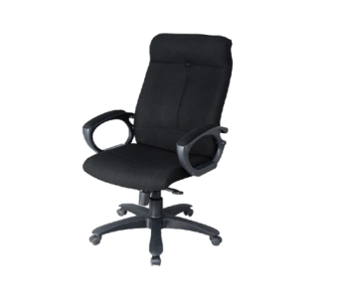
3 | Single Seat Sofa: As per sample picture, must include following features.  - Solid frame/structure made of solid Sheesham wood  - Standard height, standard size seat and back,  - Covered with best quality durable leather rite at entire sides professional stitched.  - Use of best quality durable Tyre Patti for cushion seat base.  - Use of sheesham wood aprons & corner brackets for inside frame,  - Best Quality Cushion (Molti foam or equivalent) on Seat and back covered with dark brown best quality leather rite entirely and properly stitched on entire sides as mentioned above. | 60 | 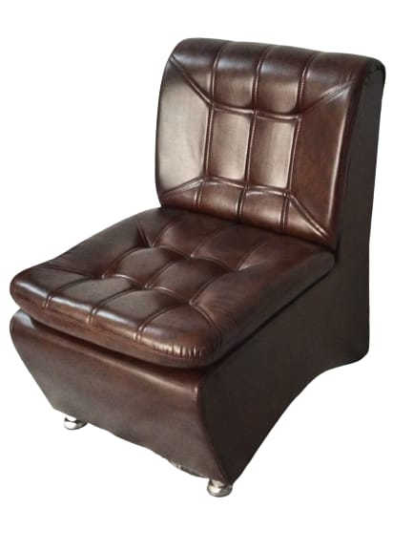
4 | Visitor Chairs:  - As per sample picture attached, with following features (which may or may not appear in picture):  - Solid frame/structure made of solid sheesham wood polished/varnished,  - Use of sheesham wood Structure at all sides below aprons for extra strength.  - Use of corner brackets inside for strong frame structure,  - Best quality cushion (Molty foam or equivalent) both on seat and back, properly cushioned with Tyre Patti  - Flexible and durable leather Rite, properly stitched/tacked on entire sides with back design as shown in picture sample.  - Accurate balance of chair on floor. | 36 | 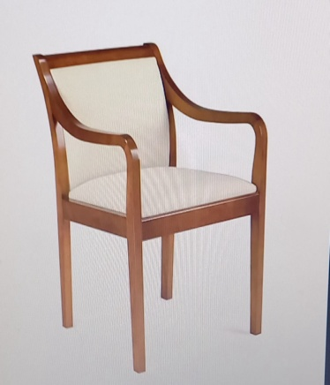
5 | Center Table  - Size: 4X2 ft., Design as per sample Picture.  - 5 mm top glass completely polished shall be fitted inside of Wooden frame on top.  - Structure made of Sheesham Wood, Sides and Lower Top made of Sheesham Veneer, Colour of polish should matched to Table Colour/Polish of Fine Quality. | 12 | 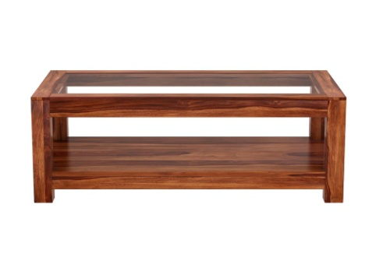
6 | File Cabinet (4-Drawers) Steel  Made of 22 Gauge Steel Sheet with Central Durable Lock, and Separate Handles for each Drawer.  Size: 56 inch X 19 Inch, 4 Drawers, with Good Quality Channels, Brown Color Paint. | 12 | 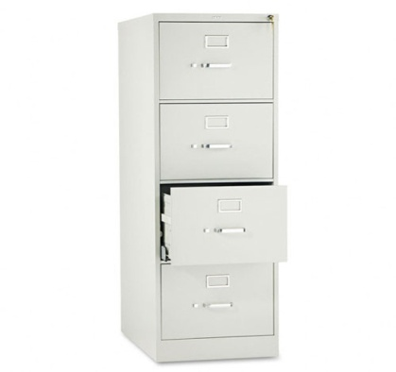

Date and Time of Bid Closing / Opening

Tender enquiry No | SLIC/NWL/FURNITURE/A.Ms &SECTOR HEADS/01/2025
Closing date & time for submission of Bids | 14-11-2025  up to  11:00 am
Date & Time of Opening of Bids | 14-11-2025  at  11:30 am
TERMS AND CONDITIONS

- Bidders should provide the name of firm, complete postal address, Telephone No, email address and web address (if any).

- Bidders are required to upload their proposals on EPADS systems as per laid down PPRA procedure, Bid security in shape of pay order must be submitted at the address given below by the Bidders before the closing date and time. However, only qualified bidder will be required to submit performance guarantee of 05% of the total quoted rates at the time of Supply Order/Contract Award.

- Bid Proposals will be opened and downloaded from EPADS on the opening date and time as given in Tender Notice. Comparative Statement of Quoted rates will be uploaded on PPRA website and EPADS system as well.

- The Bids Prices shall be evaluated on the basis of lowest rate and Quality Based

- Supply of Furniture should be completed within 20 Days of time period after issuance of Supply Order/Contract Award. Payment will be made after satisfactory Supply of Furniture as per Terms and Conditions of Tender Documents.

- Registration with Relevant Tax Authorities NTN, SRB (mandatory, else bid will be rejected.
Continued!

(Sign and Stamp by Vendor)_________________________

Page (4 of 5)

- Bidders must have to submit the Bids as per Sample Pictures and Specification of all Furniture Items mentioned in Tender Documents.

- The Quality of the Furniture will be observed strictly according to Specifications mentioned in the Tender Documents. Substandard supply of Furniture will be rejected.
- The Most Advantageous Bid would be accepted.

- Warranty (onsite) of the supplied items must be valid for minimum One year or above.

- Bid Security will be returned to un-successful bidders after completion of formal procedure bidder after issuance of Supply Order. Bid Security of 2nd Lowest Bidder will also be retained till completion of the Job.
- No bid will be accepted without Earnest Money.

- No advance payment will be made. Payment will be processed upon satisfactory delivery / Installation of items. In case of non-compliance or failure of execution of order within the specified time or supply of sub-standard items and Services, Performance Guarantee shall be forfeited in favor of the State life Insurance Corporation of Pakistan.

- All the bids must include all applicable Government Taxes.

- Most Advantageous bidder will be required to handle Supply of Furniture as per given time period.

- If the Qualified bidder fails to complete the Supply of Furniture as per Supply Order, the performance security will be confiscated. Further, administrative punitive action may also be taken.

- Competent Authority reserves the right to reject all bids or proposal at any time prior to the acceptance of a bid or proposal in the light of PPRA rules.

- All the information provided by the bidder must be verifiable.

- Performance Guarantee of the successful bidder will be forfeited if the Supply of Furniture not completed in all respect within due time or extended time (if mutually agreed with genuine reason). In case of a genuine reason regarding delay in Supply of Furniture the successful bidder shall inform immediately and the Supply of Furniture items time period may be extended at the discretion of State Life Management.

Continued!

(Sign and Stamp by Vendor)_________________________

Page (5 of 5)

- If the 1st lowest evaluated/ Most Advantageous fails to Complete the Supply of Furniture within due time, the bid security will be confiscated by the State Life and the Supply Order will be cancelled and new Supply Order will be issued to the 2nd lowest Evaluated Bidder/ Most Advantageous.

- Mandatory Documents to be attached with Financial Proposal
- An Affidavit on e-Stamp Paper confirming that the Vender/Firm is not blacklisted from any Government Department.
- Copy of last year Tax Return.

(Sh. Tariq Mehmood)
Zonal Incharge (HR&Admin)
State Life Insurance Corporation of Pakistan Zonal Office,
Sardar Plaza College Road Narowal
Phone: 0542-920096

(Sign and Stamp by Vendor)_________________________

