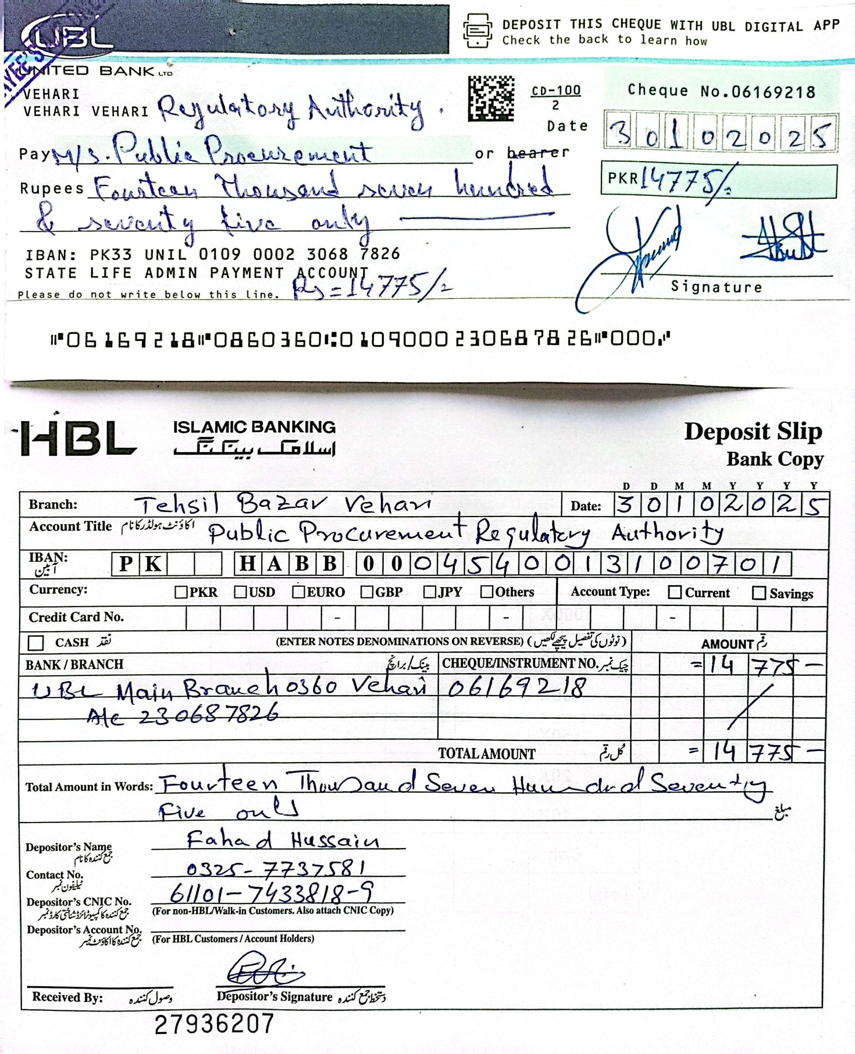

VEHARI ZONE DATED: 30.10.2025

INVITATION FOR BIDS
TENDER NOTICE NO.HR&ADMIN/006/2025/VZ OCTOBER 30, 2025

State Life Insurance Corporation of Pakistan, Vehari Zone invites bids on E-PADS, under Single-Stage Single Envelope Procedure (Financial) from reputable experienced firms having Sales Tax & Income Tax registration by Federal Board of Revenue to provide Furniture & Fixture at above referred office located at State Life Office, ZTBL Building “V” Chowk, Vehari.
Interested & eligible firms having own offices & Contact numbers can submit their quotations/ bids in sealed envelopes under “Single Stage-Single Envelope Procedure (Financial Proposal)” Through https://eprocure.gov.pk (E-PADS) under PPRA rules 2004.
Tender Schedule is as follows:-
S.# | Description of Job | Closing Date & Time for submission of Tender | Opening Date & Time of Tender
01 | Furniture & Fixture | 18-11-2025, 11:00 AM | 18-11-2023, 11:30 AM
Location: Incharge HR & Admin Deptt, State Life Insurance Corporation, Zonal Office ZTBL Building “V” Chowk, Vehari.
Bids shall be opened at above specified date & time in presence of those Bidders or their authorized agents who wish to be present at occasion.
Bidding/Tender Documents are available at EPADS, PPRA & State Life websites.

Abdul Rauf Ahmad
(SECRETARY) Zonal Procurement Committee,
State Life, Vehari Zone.(067-9201135,03037878738)

Specifications

S # | Name of Item | QTY | Specifications
1 | Office Table | 11 | Office Table (5x3), three sides, Closed bidding shesham Wood. 03 drawers with channel with lock, Glass Polish, Top Formica with wooden gola all side, bottom wooden border all side.
2 | Revolving Chairs | 11 | High Back, Adjustable Seat, Steel Frame, Hydraulic high quality system, High Quality Foam cushioned seat & Back.
3 | Steel File Cabinet | 11 | Steel file Cabinet gauge 20 with 4 drawer Central  Locking system. Size 18”X60”

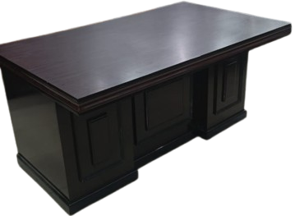

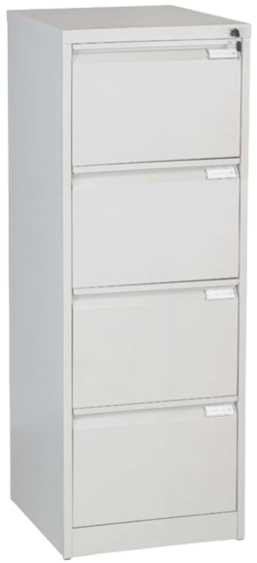

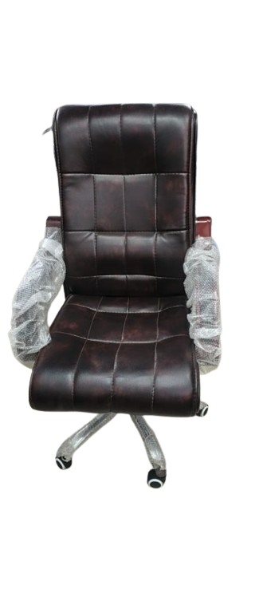

Terms and Conditions: -
- Security amount must be deposited Rs.50000/- in form of Call Deposit Receipt / Pay Order / Demand Draft in favour of “State Life Insurance Corporation of Pakistan Vehari Zone” as earnest money which will be refunded to the un-successful parties on the spot and the refundable or CDR will be detained of the successful party till the completion of Tender.
- If the firm / supplier provide / supplies sub-standard product, the Security Deposit will be forfeited in favor of the Corporation.
- The firm / supplier will be bound to supply/affix the required items on above mentioned address of State Life Vehari Zone, within prescribed time to be notified.
- The bidders will have to attach copies of their NTN, GST Payer Number with the Tender.
- Income Tax and GST or as per Government Policy will be deducted on the total value of the Tender.
- No change will be acceptable of required items. Such bid(s) will be rejected.
- Samples/ pics of each item are attached and same are required. No change in quality and specifications would be acceptable.
- The successful Vendor is bound to supply the sample of each item if required by the Procurement Committee.
- Security deposit will be refunded after the completion of successful supply.
- The quotations must be uploaded on PPRA website E-PADS for supply of subjected items within stipulated date & time till closing of the date.
- State Life Insurance Corporation of Pakistan reserves the right to accept or reject all bids or proposal in accordance with PPRA Rule (33).
- Sealed Tenders duly completed in all respect must reach to the undersigned by Courier Service/by post during office hours i.e. 9:00 am to 5: 00 pm except Saturday and Sunday.
- Quantity can be decreased or increased.
- As a whole Lowest bid would be considered as a most advantageous bid.

Abdul Rauf Ahmad
Secretary Zonal Procurement Committee
Incharge HR&A,State Life Office,2nd Floor,
ZTBL Building, Vehari, (067-9201135, 03007735946)

