
TENDER NO. SLIC/RE/ISB/ADMIN/CPD/11/2024
TENDER DOCUMENT FOR PURCHASE/PROCUMENT OF SMART FURNITUR ITEMS
FOR
RED OFFICE STATE LIFE ISLAMABAD.

The State Life Insurance Corporation of Pakistan, Real Estate Islamabad, is extending an invitation for EOI through E-PAD, using “single stage single envelop system." We seek submissions from NTN & GST Registered Contractors/Firms/General Order Suppliers, with a minimum five years of experience, spanning across Pakistan. Eligible entities should be proficient in mentioned work, duly registered with PPRA on account of E-PAD system.
TENDER DOCUMENT SPECIFICATIONS.
Sr.# | Description of SMART Furniture Items | QTY. | REMARKS
01 | Smart Executive Office Tables with side rack. | 1 | As per approved Schematic/ Design
02 | Smart Office Tables with side rack. | 10 | --do--
03 | Smart Workstation -I | 2 | --do--
04 | Smart Workstation-II | 14 | --do--
05 | Corian Top Conference Table 12 Ft. | 1 | --do--
06 | Executive High Back Revolving Chair | 1 | --do--
07 | Smart High Back Revolving Chair | 16 | --do--
08 | Smart Office Chairs | 10 | --do--
`THE SPECIFICAITONS OF EACH ITEM ARE OUTLINED IN THE TENDER DOCUMENT.
The bid validity is 90 days. The estimated cost of the tender is Rs.1,995,000/-
Tender documents with full terms and guidelines are available on the PPRA site (www.eprocure.gov.pk) and the State Life website (www.statelife.com.pk).,
(No bid Received by hand/courier will be entertained. However, CDR of Rs.99,000/- For earnest money must be submitted in hard form at the office of Undersigned before the Closing time of tender)
Bids must be prepared as per the bidding document instructions and PPRA Rules and submitted via EPADS by 11:00 am on 22-11-2025. The bids will be opened at 11:30 am on the same date at the address below:
For detailed specification, you may visit State life website, www.statelife.com.pk or www.eprocure.gov.pk , or contact to the undersigned within office hours. Any Bid submitted other than e-PADS would not be considered.

INCHARE RE
Convenor REFC
State Life Insurance Corp. of Pakistan,
Real Estate,
Building No.5-II, Basement, Blue Area,
Islamabad 44000 – 051-9203347

TERMS AND CONDITIONS

- Bidders are required to upload their BIDS/EOI on e-PADS as per laid down PPRA procedure for single stage single–envelope method that should invariably quoted as “FURNITUR (MISCELLENIOUS) ITMEMS. However, bid security, of Rs.99,000/- in shape of Pay Order/ Demand Draft/ CDR etc. must be submitted in favor of State Life Insurance Corporation of Pakistan Real Estate Islamabad at the address given in tender notice before closing time, and scan copy of the same should be uploaded on E-Pad else tender will be rejected.
- Post qualification and Technical evaluation will be held first. Financial bid of only technically qualified bidders who also meet the mandatory requirements would be considered for further processing.
- Post qualification requirement (mandatory requirements), Technical evaluation is available with bidding document (Annex-A &B).
- Bid Security will be returned to un-successful bidders after completion of formal procedure and to successful bidder after issuance of purchase order/ signing of contract. Retention Money already deducted from monthly bills in the form of installments and equivalent to 5% of the annual contract worth will be released on completion/ expiry of contract term/ Period.
- No bid will be accepted without bid security.
- All the bids must include all government taxes.
- Most Advantageous bidder will be required to deliver items within (01) week after issuance of Purchase Order.
- The bids submitted shall be valid for a minimum period of 90 days from the date of bid opening.
- The quantity of items may increase/ decrease at the time of issuing purchase order.
- The contractor/ supplier will be liable for any mistakes in calculation of price/rate and amount and shall be liable to suffer the loss arises at any stage of contract, due to mistakes in calculation or tax rates.
- Warranty of the items will start from the date of delivery.
- If the successful bidder fails to supply the items as per purchase order, the bid security will be forfeited.
- Competent Authority reserves the right to reject all bids or proposal any time prior to the acceptance of a Bid or proposal in the light of PPRA rules.
- All the information provided by the bidder must be verifiable.
- Performance guarantee of the successful bidder will be forfeited if the items are not delivered within due time or extended delivery time. In case of a genuine reason regarding delay in delivery the successful bidder shall inform immediately and the delivery time may be extended at the discretion of state Life.
- If the 1st lowest evaluated/ Most Advantageous fails to supply the items sign the contract and bid money is confiscated by the State Life then the old Purchase order will be cancelled and new Purchase Order will be issued to the 2nd lowest Evaluated Bidder/ Most Advantageous bidder with approval of the Competent Authority.
- The works under this quotation shall be carried out in accordance with the bill of quantities/ specifications. Your rates must be inclusive of all cost of materials, labor, overheads, delivery of items at RED office premises, profits, taxes surcharges and preparatory works as required and no escalation or extra payment shall be considered on any of these account or reason.

INCHARGE (Real Estate),
The Convenor (REFC),
State Life Insurance Corp. of Pakistan, Real Estate, SLB No.5-II (Basement),
BLUE AREA, ISLAMABAD.

A:- Verifiable Documentary Proof
B:- Technical Specification Criteria

A:- Verifiable Documentary Proof

Verifiable documentary proofs for all above requirements are mandatory.

Annexure-A

Sr.  No. | Eligibility / Evaluation Criteria | Requirement | Supporting Documents to be Attached as | Page No.
1 | Sales Tax Registration  (copy of certificate) | Mandatory | Annex-A
2 | Income Tax Registration  (copy of certificate) | Mandatory | Annex-B
3 | Prove for similar work  (completed within the last three years) | Mandatory | Annex-C
4 | Affidavit/ undertaking that the firm has never been blacklisted by any organization/ government on judicial stamp paper. | Mandatory | Annex-D
5 | Proof of Active Taxpayer List | Mandatory | Annex-E
6 | Earnest Money/ Bid Security not less than Rs. 108000 through bank draft/ pay order to be send to the office before closing date. | Mandatory | Must be attached with Financial Proposal only

****Mandatory requirements must be uploaded (pdf) with required documents to each Annex with serial No as list above.

B:- Technical Specification Criteria

“* The Bids which do not conform to the Technical Specifications or Bid conditions or Bids from the Bidders without adequate capabilities for supply of Goods/Items/Services will be rejected.

“* Model Number/Pictures (where required) of quoted furniture items must be mentioned.
SMART FURNITURE FOR RED OFFICE AT GROUND RED SLB-5 PHASE-I BLUE AREA ISLAMABAD
Sr. # | Item | GRAPHIC Representation | Qty. | Conform to the Specifications  Yes/ No.
1 | Executive Table Standard with side Rack as per approved Photograph | 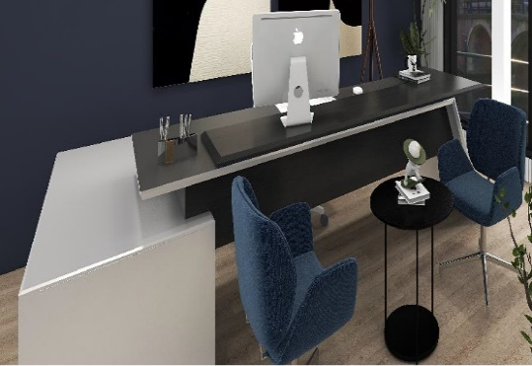 | 1
2 | Office Table Standard with Side Rack  Corian Top | 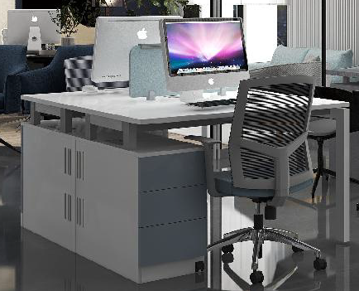 | 10
3 | Workstation-I  Corian Top | 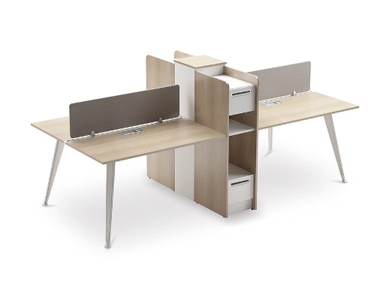 | 2
4 | Workstation-II  Corian Top | 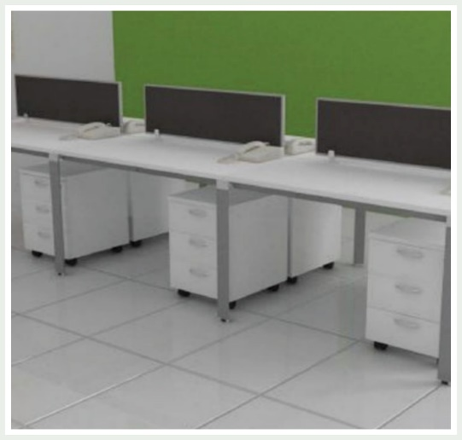 | 14
5 | 12 Ft. Conference Table White Corian Top/ SS Base as per approved Design | 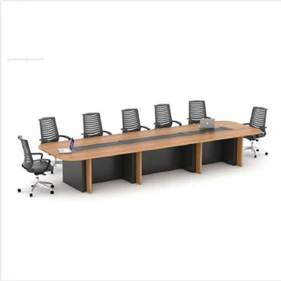 | 1
6 | Executive High Back Boss Aqua Mesh B-543 Revolving Chair | 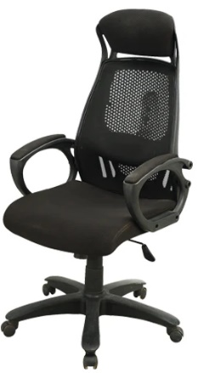 | 1
7 | Smart Office Chairs | 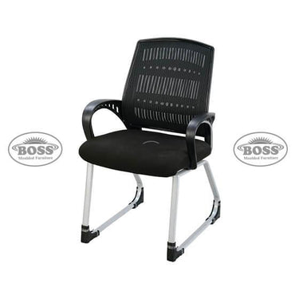 | 10
8 | Boss B-514 Mesh Revolving Chair | 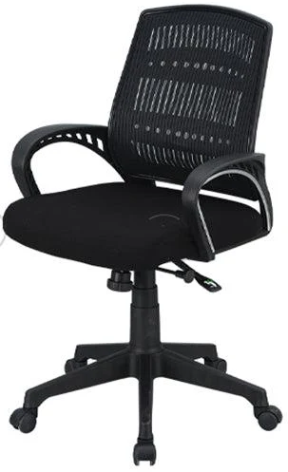 | 16
TOTAL

Smart Office table preferably size 4’.6" x 2’.6" made of corian top high density chip board pressed with fine grained shishem veneer on both sides, shishem wood molded lipping 3° wide all around the top and plain lipping of other edges with 3 drawers on fine quality drawer slides, one drawer is lockable with fine quality 2 mm lock. Finished with NC Lacquer Glass finished. Design may slightly differ from the sample.

Boss B-524 Horizon High Back Revolving Executive Computer Chair has weight capacity of 250 pounds. (ii) Superior quality material and ergonomic design. (iii) Five-star base with dual-wheel carpet casters. Boss model No. Boss B-543.

Visiting Chairs: with arms rest (Height 3 ft, D= 17.5, W '19, Arm Height from bottom '18, ‘Seat height ‘17 ). good quality Rexene on seat and back, made with sheesham wood or Eq. molty foam or Eq. filled on seat and back, curve shape ams, back and rear legs.

AWARD OF WORK:
The procurement is a whole complete job and will not be split. Work shall be
Awarded to the most advantageous bidder subject to the bid that is-“Complying with Pictures and specifications requirements at Best price and Fulfillment of other terms & Conditions for mentioned procurement.”
ACCEPTANCE/ REJECTION OF TENDER:
- The corporation does not bind itself to accept the lowest tender.
- For all Furniture items, High-resolution images, showcasing the furniture in three dimensions (front, side and back), accompanied by detailed specifications for each item, are required for the bidding process. Bids without pictures or containing low-quality pictures will be rejected. ii) The corporation also reserves the right to accept or reject any tender in part or full without assigning any reason whatsoever.
- The corporation also reserves the absolute right to reject any or all the tenders at any time solely based on the past unsatisfactory performance by the bidder(s) the opinion/decision of SLIC regarding the same shall be final and conclusive.

Annexure-C
Financial Bid Of Furniture items
SMART FURNITURE FOR RED OFFICE AT GROUND RED SLB-5 PHASE-I BLUE AREA ISLAMABAD
BILL OF QUANTITIES [SCHEDULE OF PRICES]
Sr. # | Item | GRAPHIC Representation | Qty. | RATE | GST@18% | TOTAL
ELECTRICAL ITEMS
1 | Executive Table Standard with side Rack as per approved Photograph |  | 1
2 | Office Table Standard with Side Rack |  | 10
3 | Workstation-I |  | 2
4 | Workstation-II |  | 14
5 | 12 Ft. Conference Table White Corian Top/ SS Base as per approved Design |  | 1
6 | Executive High Back Boss Aqua Mesh B-543 Revolving Chair |  | 1
7 | Smart Office Chairs |  | 10
8 | Boss B-514 Mesh Revolving Chair |  | 16
TOTAL |  | PKR ____________/-
NOTE: While making financial bid evaluation each bidder should follow Annexure-C format.
Place HD Picture of the Proposed Item for Scrutiny at “GRAPIC Representation” column..

TO BE ATTACHED/ SUBMITTED BY THE FIRM / SUPPLIER ON THEIR LETTER HEAD

INCHARGE (Real Estate),
The Convenor (REFC),
State Life Insurance Corp. of Pakistan,
State Life Building No. 5-II, Blue Area,
ISLAMABAD.

SUB: TENDER NO. SLIC/RE/ISB/ADMIN/CPD/11/2025–SUPPLY OF SMART FURNITURE ITEMS FOR RED OFFICE AT STATE LIFE BUILDING NO.5-II, BLUE AREA, ISLAMABAD.

Dear Sir,

Having gone through the tender document, terms & conditions, we hereby offer to execute the above job for a total amount of Rs. (Rupees ) as per Tender Document attached.

A Pay Order No. Drawn on __________________Bank for Rs. /- is enclosed as Earnest Money.

Yours faithfully,

