STATE LIFE INSURANCE CORPORATION OF PAKISTAN, LAHORE ZONE CENTRAL
TENDER DOCUMENTS
TENDER ENQUIRY # 05/LZC/FIELD/2026

FURNITURE ITEMS & AIR CONDITIONERS

Lots | Job Description | Qty | Sample for quoting rates
Lots | Job Description | Qty | Cost per unit in Rs. | GST per unit in Rs. | Total Cost per unit with Taxes (in Rs.) | Total Cost with all Taxes  (in Rs.)
Lot 1 | Office Tables with side racks & top glasses:-
Lot 1 | - Office Table 5'x3'x2.5' with side rack & top glass | 16 set
Lot 1 | - Office Table 4'x3'x2.5' with side rack & top glass | 36 set
Lot 2 | Revolving Chairs
Lot 2 | - BOSS B-543 or equivalent | 16 unit
Lot 2 | - BOSS B-514 or equivalent | 36 unit
Lot 3 | File Cabinets 4 Drawers | 52 unit
Lot 4 | Visitor Chairs | 120 unit
Lot 5 | Central Table with top glass | 16 unit
Lot 6 | Sofa 5 Seater (3+1+1) | 16 set
Lot 7 | Split Air Conditioner 1.5 Ton  Haier, PEL or equivalent | 42 unit
 | Total Amount Rs. (in Figures)

Total Amount Rs. (in words) _ _ _ _ _ _ _ _ _ _ _ _ _ _ _ _ _ _ _ _ _ _ _ _ _ _ _ __ _ _ _ _ _ _ _ _ _ _ _ _

Important Notes:
- Participation in all Furniture & Fixtures items (Lot 1 to Lot 6) is compulsory for those bidders who are interested to participate in the Furniture supply.
- Each Lot shall be evaluated separately on quality and cost basis.
- Technical Evaluation Criteria/Evaluation Sheet: Attached as (Annexure-1)
- Technical Specifications: Attached as (Annexure-2) with sample pictures
- Closing date & time for Bids Submission: 07-09-2026 at 10:30 AM
- Date & Time for Technical Bids Opening: 07-09-2026 at 11:00 AM

Terms & Conditions:
- Bidders are required to upload their bids on EPADS V.2 system as per laid down PPRA procedure for Single Stage Two Envelope method of PPRA Rules 2004. Wherein Technical Bids shall be evaluated first as per Technical Evaluation Criteria (Annexure-1) and financial bids of only technically qualified bidders shall be opened as per schedule announced by Secretary ZPC.
- Technical Bids will be opened and downloaded from EPADS V.2 on the opening date and time as given above. Proposals of technical qualified and found most advantageous bidders as per cost will be announced on EPADS system accordingly and will be accepted after completion of all codal formalities.
- Total estimated Cost is Rs. 14,700,000/- as follows:- (Lot 1 Rs. 2,104,000/-, Lot 2 Rs. 1,584,000/- Lot 3 Rs. 1,976,000/-, Lot 4 Rs. 900,000, Lot 5 Rs. 160,000/- Lot 6 Rs. 416,000/-, Lot 7 Rs. 7,560,000/- )
- Bid Security amount (Earnest money) including tax as per lots as:
Lot 1 Rs. 105,200/-, Lot 2 Rs. 79,200/-, Lot 3 Rs. 98,800/-, Lot 4 Rs. 45,000/-, Lot 5 Rs. 8,000/-
Lot 6 Rs. 20,800/-, Lot 7 Rs. 378,000/-
in the shape of CDR/Pay order favoring “State Life Insurance Corporation of Pakistan” must be submitted by bidders at the address below on the day of bid opening within office hours, else bid will be rejected.
- The Bid Security will be returned to un-successful bidders after completion of formal procedure and to successful bidder immediately after completion of work. However, successful bidder will be required to submit performance guarantee of 5% (value of Job Order) in shape of bank guarantee (valid for at least 6 months) in favor of State Life Insurance Corporation of Pakistan which shall be released after expiry of six month after completion of job.
- In case wherein on bid opening day, holiday announced by prevailing Government or Zonal Office could not operate due to unavoidable reasons, then bid opening meeting shall be held on very next working day.
- Approximate time of procurement process is 60 days. Order shall be placed to successful bidder after completion of all codal formalities. Approximate payment time shall be 2 weeks after successful delivery in all respects and as per tender requirements.
- Successful bidder will have to start supply/job within 3 days after confirmed work order and must complete the supply in all respects within 10 working days; otherwise retention money (CDR) will be forfeited. In addition to this liquidity damages as penalty may be imposed after expiry of 10 working days, at 1% per day of the total purchased order value.
- Warranty of items must be accordingly as mentioned in Annex-2 for any type of defect, with free repair/replacement of item/parts within warranty period.
- Quote only single rate for each item/lot/set, which must be irrevocable, unconditional & inclusive of all taxes & expenses (if any).
- Validity of the rates/bid must be at least 90 days from the date of opening of bid, which may be extendable with mutual consent.
- Competent Authority reserves the right to reject/cancel/withdraw any/all bid(s) or proposals or entire tender process at any time before award of contract without assigning any reason thereof.
- Lowest vendor must supply samples of furniture items to State Life before issuance of purchase order without fail. Sample may include Structural frames (semi-completed) or finished (fully completed).
- In case vendor failed to perform as per requirements or provide other than required items, or found any document as false or fabricated, State Life reserves the right to blacklist the vendor.
- Quantity of items may be increase/decrease by competent authority before placement of order.
- Eligibility criteria mentioned below must be observed and fulfilled. An Affidavit of Rs. 100 (non judicial stamp paper) in this regard must be attached with the bid.

Eligibility of Applicants

We M/s ______________________________________ undertake that,
- We are registered company/firm as per FBR Record, having active filling status.
- We are solvent company/firm and not in the process of bankruptcy.
- We have never been convicted for an offence concerning the professional conduct.
- We have fulfilled all obligations related to payment of taxes to the Govt of Pakistan.
- We were never found guilty of serious mis-interpretation/mis-representation of facts in supplying information in past nor providing herewith as such.
- We have no complaint against our company/firm for defective supplies, in the past 3 years, in any Federal/Provincial organization.
- We assure that quoted item will be brand new; parts of offered model shall be available in open market for at least 3 years.
- We understand the requirements of this Tender No. 05/LZC/FIELD/2026 and also assure that we shall complete the task as per requirements in letter & spirit.

[SECRETARY]
Zonal Procurement Committee (ZPC),
HRA&P Department,
State Life Insurance Corporation of Pakistan
Central Zone Lahore, 4th Floor Building No.6,
4-Ghazi Ilm -ud- Din Shaheed Road (Lytton Road), Lahore.
Phone # 042-99210594, Cell no. 0335-1412976

Technical Evaluation Criteria (Annexure-1)
Technical bids shall be evaluated on the basis of following points; bidders are required to mark as “Yes” or “No” against each criteria.
Sr | Criteria | Remarks  (YES / NO)
1 | Bidder has provided NTN & GST Registration Certificate, having active taxpayer status in FBR.
2 | Specifications of quoted item must meet required specifications. In case of incomplete information submitted in EPADS or whereas a bid having lesser than the required specifications, shall be rejected technically. Fresh items of furniture and latest model of AC to be quoted.  Does the Quoted brand/model meets specifications as per required?
3 | Warranty offered according to Tender Documents? Warranty shall be claimed through bidder, without any cost.
4 | Full time properly hired technical staff of vendor/bidder with at least 2 technical workers having technical experience of at least 6 months with vendor?
5 | Vendor must have at least 5 year experience of Furniture/ACs Supplies.
6 | For Furniture & fixture items qualification (Lot 1 to 6), Annual turnover must be at least Rs. 10 million during last financial year. (Year 2025)  For AC qualification (Lot 7), Annual turnover must be at least Rs. 25 million during last financial year. (Year 2025).  Vendor must submit clear statements mentioning figures of turnover.
7 | (For AC Qualification only)  Multiple proper operative service centers of quoted model along with parts availability in Lahore City (Open market) are mandatory for technical evaluation of bidder.  Service centers must be proper and company maintained and Parts of quoted model must be easily available in Lahore Abid Market or similar markets of Lahore.  Does vendor meet such criteria?
8 | Bidder has provided affidavit of Rs. 100/- in the light of Para 16 of Terms & Conditions of Tender Documents. Such affidavit must be this Tender specific.
9 | Bidder has certified that quoted items shall be brand new and not fabricated or refurbished. And furniture items shall be of fresh stock as per specifications.
10 | Bidder certified that they accept all the terms & conditions for completion of job (Supply with Installation of ACs) and (Supply of furniture) at required site (s) as per requirements of Tender Documents. Installation of ACs at different sites and supply of furniture shall be responsibility of bidder at their own cost and expenses as per schedule provided. Does vendor agrees to it?
11 | Bidder has provided at least 3 Satisfactory reports or purchase orders related with quoted model/brand from previous well reputed Govt/Semi Govt/Commercial Clients OR related to supply of similar furniture items during last 3 years.
12 | Sign and stamp against at below specifications for each quoted item.
13 | CDR Submitted as per required lot wise.?

Important Notes:-
- Single NO may result is rejection of bidder technically.
- All points of Technical Evaluation Criteria, Terms & Conditions are compulsory. Failing in any point/criteria, may result in rejection of the bidder technically.
- Provide all required information with Bid on letter-head pages with sign & stamp.

[SECRETARY]
Zonal Procurement Committee (ZPC),
Technical Specifications (Annexure-II)

LOT # 01, Office Tables with side rack and top glasses

Office Table 5'x3'x2.5' with side rack & top glass Qty- 16 Set
and
Office Table 4'x3'x2.5' with side rack & top glass Qty 36 Set

As per sample picture provided (Executive look), with following features:-
- 8 mm top glass grinded at side edges and completely polished.
- Strong connected structure of Solid Sheesham wood deep engraved lines as in sample picture.
- Top made of Sheesham winner board (double side) 1.5'' or (1x1/2'') thickness. Other structure made of sheesham winner board (double side) 3/4'' thickness.
- Use of best quality stainless steel nails, glue imported quality etc for manufacturing.
- Three drawers of standard size at right side with freely moveable channels of best quality heavy duty/stainless steel.
- Standard height, Durable Strong base with extra sheesham base for strength.
- Squared space for monogram (10 inch x 10 inch) specifically to be made at front side middle with deep engraved 4mm, edges of that space to be covered with 1/2 inches thick gola patti (fancy takkar gola).
- State Life monogram made of standard aluminum plate painted (10 inch x 10 inch for 16 set) and (8 inch x 8 inch for 36 set) respectively to be fixed at front side middle (inside specifically allocated space) with round cap nail properly drilled.
- Imported quality heavy duty lock for top drawer.
- Drawer handle made of stainless steel heavy with fancy design.
- Color shall High-quality wood/mahogany colour finish and polish glossy finishing (Shining) as per sample picture.
- Warranty: At least 3 years onsite free repair & labor warranty.

Specifications of Side Rack (Standard size) with top glass
  - Side Rack compatibility eg. Design/shape/height and color must be similar to Office Table.
  - covered with 8 mm glass , grinded at side edges and completely polished ,
  - Strong connected structure of Solid Sheesham wood
  - Contain Keyboard Tray with railing imported quality & tray made of pure Sheesham wood.
  - Contain CPU Box with wires holes at back side for Keyboard, CPU & Mouse.
  - Must contain at least one shelf inside as per standard designs.
  - Should be comfortable and easy for computer operations i.e., use of keyboard tray and space for CPU etc
  - Warranty: At least 3 years onsite free repair & labor warranty.

Bidder’s sign with stamp_____________________

LOT # 02, Revolving Chairs

Revolving Chair BOSS-B-543 or Equivalent (Qty-16)
As per sample picture with at least following features:-
- Mash back as per sample
- standard size cushioned seat & back with fency style and solid plastic arms,
- Comfortable and fancy design of back of chair.
- Hydraulic machine, heavy duty S/S base with imported five wheels.
- Standard height of as per sample shown.
- Warranty: At least 1 year onsite free repair & labor warranty. Free replacement of base warranty.
- In case of quoted equivalent, an equivalency certificate shall be required from vendor about equivalency in respect of quality, cost and manufacturing material of both brands, such certificate shall also be verified from relevant brands, and decision of procuring committee shall be final in this regard.

Revolving Chair BOSS-B-514 or Equivalent (Qty-36)
As per sample picture with at least following features:-
- Mash back as per sample
- standard size seat & back with fency style arms,
- Comfortable and fancy design of back of chair.
- Hydraulic machine, heavy duty S/S base with imported five wheels.
- Standard height of as per sample shown.
- Warranty: At least 1 year onsite free repair & labor warranty. Free replacement of base warranty.
- In case of quoted equivalent, an equivalency certificate shall be required from vendor about equivalency in respect of quality, cost and manufacturing material of both brands, such certificate shall also be verified from relevant brands, and decision of procuring committee shall be final in this regard.

Bidder’s sign with stamp_____________________
LOT # 03, File Cabinets (4 Drawers) Qty-52

As per sample shown. With at least following features:-
- Gauge 18 or better, 4 drawers standard size (as per sample) with smooth heavy duty railing system,
- Single heavy duty lock or Separate Locks heavy duty for each drawer having two keys each.
- Best quality gray hammered paint as per sample,
- Strong bottom/base & accurate balance on floor.
- Dimensions as per sample shown. (sample also available at site)
- Warranty: At least 1 year onsite free repair & labor warranty. Free replacement of damage locks within warranty period.

Bidder’s sign with stamp_____________________
LOT # 04, Visitor Chairs (Qty-120)
As per sample picture with Mesh Back and Fixed Arms, chair shall be new, high quality, durable and suitable for office use, generally conforming to the following specifications:
- Back: Ergonomically shaped back with good-quality, breathable mesh fabric and strong supporting frame.
- Seat: Comfortable padded seat with good-quality, high-density foam and durable upholstery.
- Upholstery: Good-quality black fabric or leatherette, properly fitted and neatly finished.
- Armrests: Fixed armrests on both sides with comfortable and durable arm-support surfaces.
- Frame: Strong metal frame with properly welded joints and smooth finishing.
- Legs: Four sturdy tubular metal legs, properly balanced and firmly attached to the frame.
- Finish: Powder-coated or chrome-plated metal finish, resistant to rust and normal office wear.
- Foot Caps: Rubber/plastic protective caps on all legs to prevent floor damage and slipping.
- Dimensions: As per standard, professional and suitable for use in an office environment
- Workmanship: All welds, joints, edges and fittings shall be properly finished. No sharp edges, loose parts, cracks or visible defects shall be acceptable.
- Quality: The chair shall be equivalent to or better than the reference design/specifications.
- Condition: Brand new, unused and free from manufacturing defects.
- Warranty: Minimum one year against manufacturing defects and structural/workmanship failure.

Bidder’s sign with stamp_____________________

LOT # 05, Central Table with top glass (Qty-16)

As per sample picture design include following features.
- Size with glass (4 feet x 2 feet) with frame size as standard.
- Frames made of solid sheesham wood with fancy designing.
- Finishing of Frames must be smooth with best quality wooden polish/varnish.
- Top covered with 12 mm glass, grinded at side edges and completely polished, use of good quality rubber catchers below glass for holding.
- Color/polish same as of Office table and side rack.
- Warranty: At least 3 years onsite free repair & labor warranty.

Bidder’s sign with stamp_____________________

LOT # 06, Sofa Set 5 Seater, 3+1+1 (Qty-16)

As per sample picture, must include following features.
- One Set include (one) three seater, (two) single seaters.
- Solid frame/structure made of solid Sheesham wood without arms,
- Standard height, standard size seat and back,
- Use of best quality durable tyre patti for cushion seat base.
- Use of sheesham corner brackets inside frame,
- Best quality cushion (Molti foam or equivalent) on Seat and back covered with best quality leatherite properly stitched enclosed at entire sides.
- Base of Sofa Set to be made with solid Sheesham wood four legs covered with Rexene professional and smooth finishing entirely.
- Warranty: At least 3 years onsite free repair & labor warranty.
- Color of Rexene must be similar to Office Table.

Bidder’s sign with stamp_____________________

LOT # 07, Split Air Conditioner 1.5 Ton (42 units)

Haier, PEL or equivalent with at least following specifications:-

- 18000 BTU
- Wall mounted with Remote Control
- Color Preferable white or Grey
- Heat And Cool, Invertor technology
- Pure T3 Compressor with compatibility of operations at temperatures up to 50°C or more.
- Refrigerant Type preferably R410 or as per company policy.
- Standard Installation kit 10 feet pure copper pipe, 10 feet pure copper wire.
- With Indoor and outdoor brackets. (Outdoor bracket shall also be arranged by vendor)
- Free Replacement Warranty subject to minimum 2 year parts, 4 year PCB kit & 7 years compressor.
- Delivery and installation at different site(s) of Lahore and nearby areas shall be vendor’s responsibility free of cost.

Note: Procuring Agency may require submission of any document (in original) at any time during evaluation of bids, for which bidder shall be bound to provide, otherwise it may result in technical rejection.

Bidder’s sign with stamp_____________________

[SECRETARY]
Zonal Procurement Committee (ZPC),
HRA&P Department,
State Life Insurance Corporation of Pakistan
Central Zone Lahore, 4th Floor Building No.6,
4-Ghazi Ilm -ud- Din Shaheed Road (Lytton Road), Lahore.
Phone # 042-99210594
Cell no. 0335-1412976

Annex – 2 Sample Pictures

Lot no. 1 Office Table with Side Rack & Top Glass
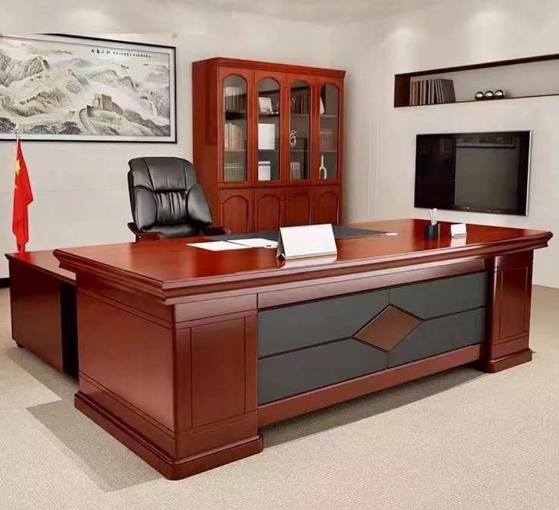
5'x3'x2.5' and 4'x3'x2.5'

LOT # 02, Revolving Chairs
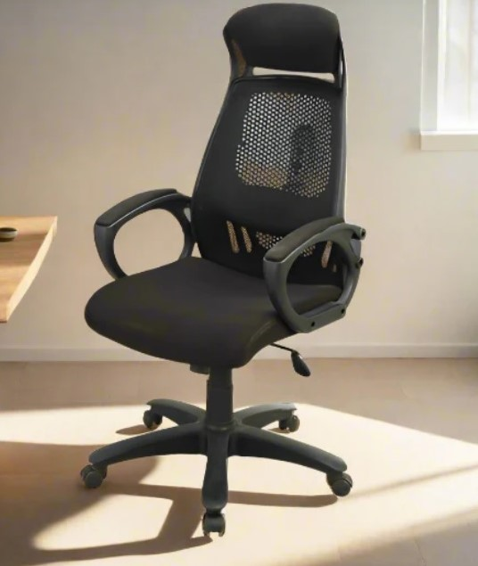
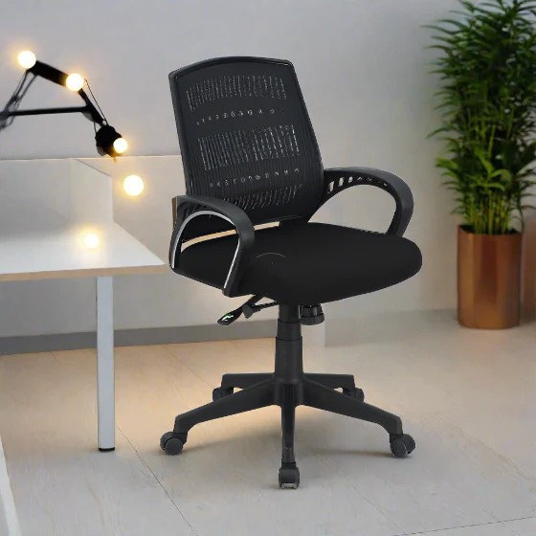

Revolving Chair BOSS-B-514 or equivalent and BOSS B-543 or equivalent

LOT # 03, File Cabinet (4 Drawers)

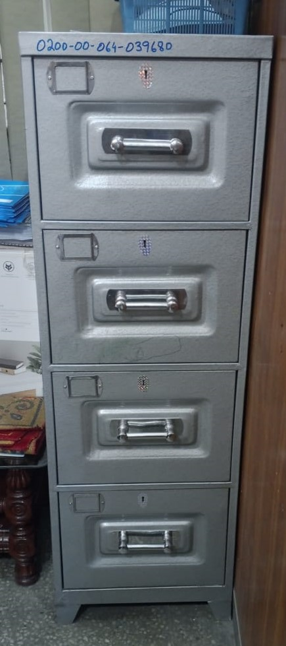

LOT # 04, Visitor Chairs
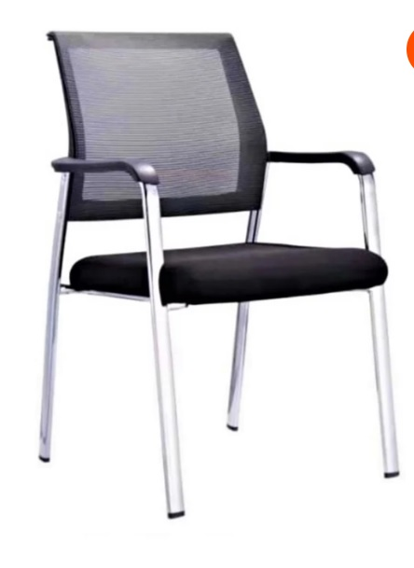

LOT # 05, Central Table with top glass (Qty-16)

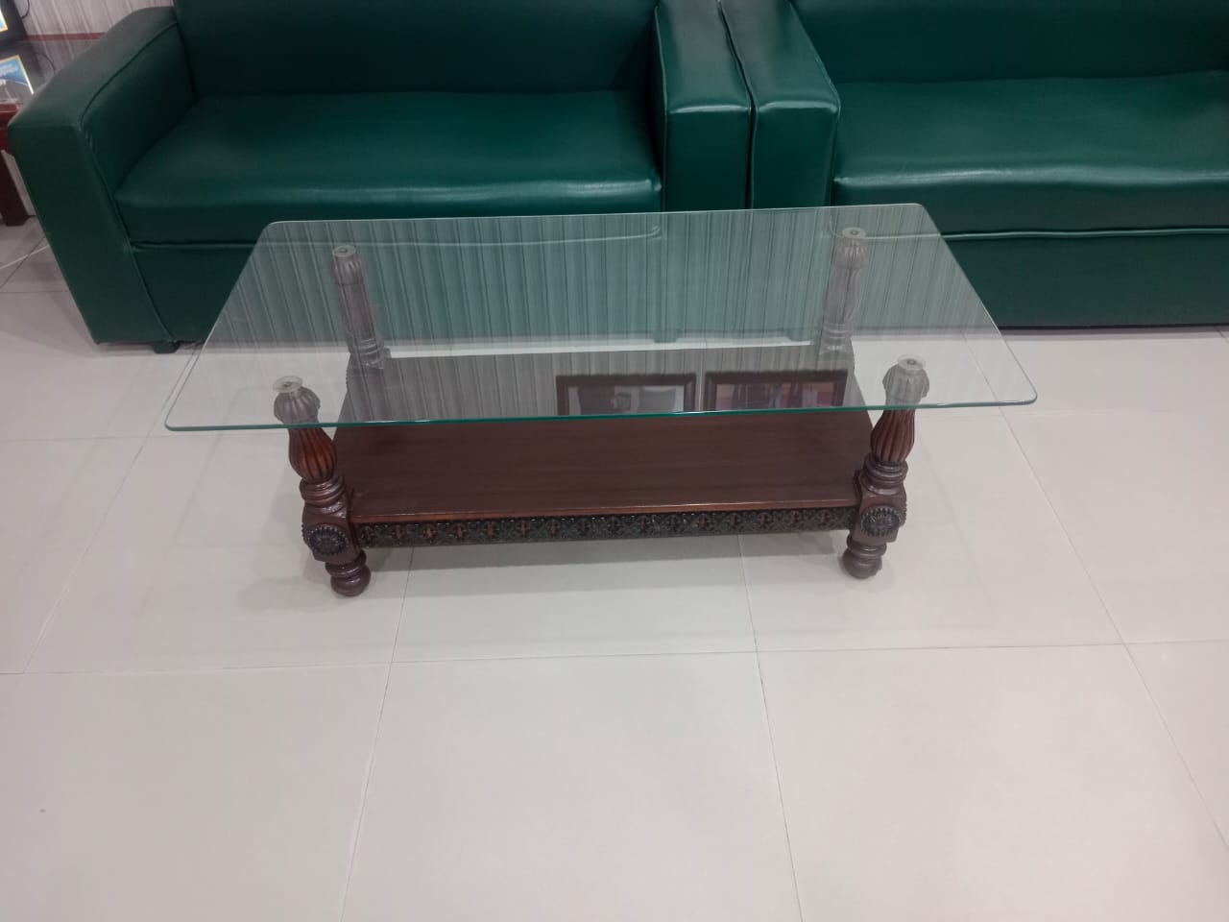

LOT # 06, Sofa Set 5 Seater, 3+1+1 (Qty-16)
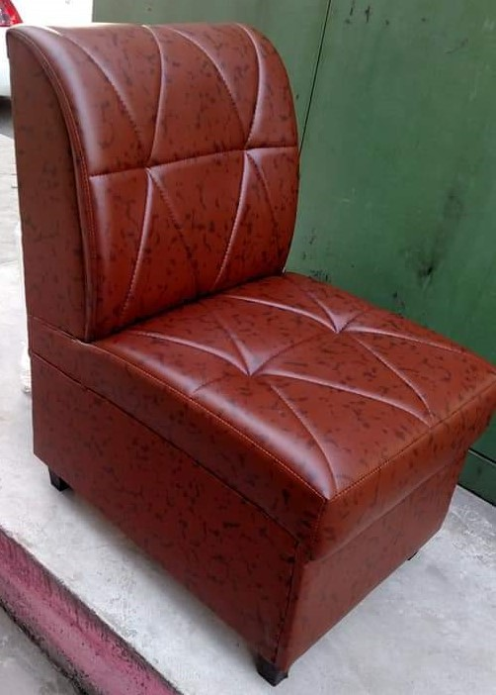

Revolving Chair Cushioned (BOSS-B-543 or Equivalent)

[SECRETARY]
Zonal Procurement Committee (ZPC),
HRA&P Department,
State Life Insurance Corporation of Pakistan
Central Zone Lahore, 4th Floor Building No.6,
4-Ghazi Ilm -ud- Din Shaheed Road (Lytton Road), Lahore.
Phone # 042-99210594
Cell no. 0335-1412976

