STATE LIFE
Insurance Corporation of Pakistan
Multan Zone

Deposit Slip ADVANCE TENDER FEE Rs.15,000/- PPRA

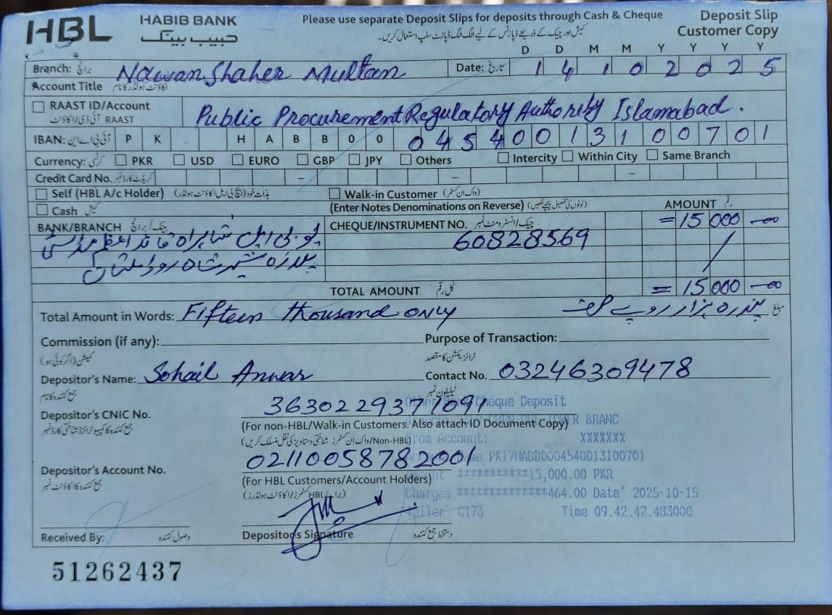

STATE LIFE
Insurance Corporation of Pakistan
Multan Zone

TENDER NO. HRA&P/MUL/004/2025 DATED 15-10-2025
Renovation work (Granite Tiles Flooring, Electric work, Ceiling Fans, paint work, Curtains, False ceiling etc…at State Life Building NawanShaher Multan
Sealed bids are invited from well-reputed firms registered with GST/NTN, under Single-Stage Single-Envelope Procedure, for the ʺRenovation Workʺ at State Life Building Multan as mentioned in our Tender Documents, at State Life Building Chowk Nawan Shahar Multan. Detail of Date & Time of Tender is as under:
Last Date & Time for Submission of Tender Documents on E-PADS | Tender’s Opening  Date & Time | Bid Security
04-11-2025  03:00 pm | 04-11-2025  03:30 pm | 3% of Bid Amount

Tender document containing all relevant details is available free of cost at address given below, and also can be downloaded from State Life official website www.statelife.com.pk and EPADS Portal www.eprocure.gov.pk

The sealed bids should be submitted through E-pads on or before 04-11-2025 at 03:00 pm and bids will be opened on the same day at 03:30 pm in presence of bidders or their representatives in the office of undersigned.

For further details the undersigned may be contacted during working hours in person or telephonically on phone No. 061- 9200678
Syed M. Waqas Raza
Secretary – Procurement Committee
HRA&P Department
2nd Floor State Life Building
Chowk Nawan Shehr
Multan. Ph: 061-9200678

