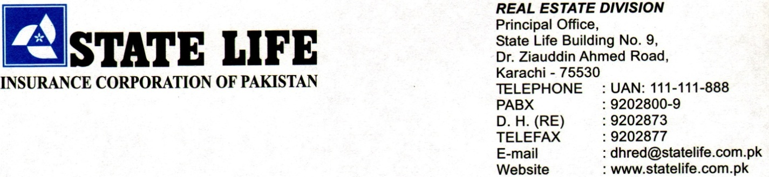
Corrigendum
Invitation to Bid
Sub: Rehabilitation & Installation Fire-Fighting System In State Life Building No. 11, Abdullah Haroon Road, Karachi.

Tender EPADS Ref #P106942

State Life Insurance Corporation of Pakistan (Real Estate Division) invites Electronic bids from the Contractors / Firms, registered with Income Tax and Sindh revenue Board for SST and active taxpayer of the Federal Board of Revenue.
2. Electronic Bidding Documents containing detailed requirements, terms and conditions is available for the registered bidders on EPADS at (www.eprocure.gov.pk)
3. The e-bids, prepared in accordance with the instructions in the bidding documents, must be submitted through EPADS on or before 15-10-2026 at 11:00 am. Manual bids, shall not be accepted. The e-bids will be opened on the same day by using EPADS at 11:30 am.
4. Contractor (s) is advised to submit original bid Security along with copy of Bidding Documents on or before closing time on tender i-e 11:00AM on dated: 15-10-2026.
5. In terms of Rule 48 of Public Procurement Rules, 2004 Grievance Redressal Committee (GRC) is constituted for subject procurement. Notification of said GRC is provided on the procuring agency’s www.statelife.com.pk and on EPADS at (www.eprocure.gov.pk).

Engr. Hasan Kashif (Deputy Manager-RE)
5th Floor, State Life Building# 9, Karachi.
Office: 02199204939

